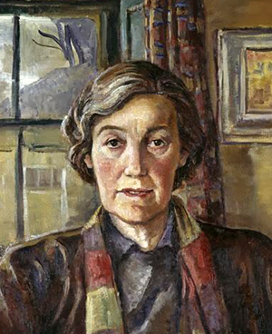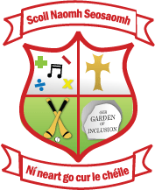

Name artist : | Evie Hone
Nationality : | Irish
Famous artwork for inspiration : | 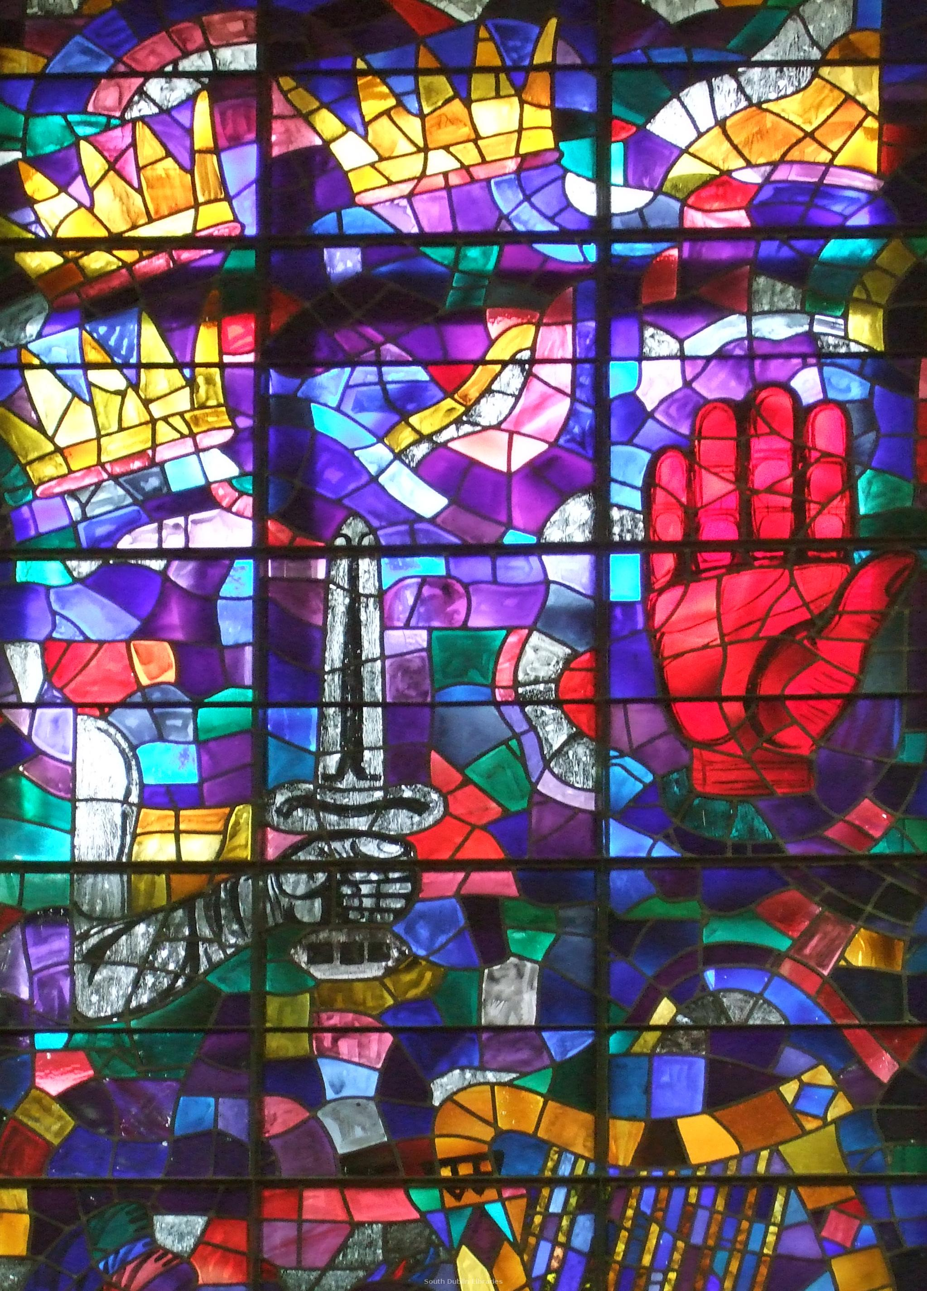  My 4 Green Fields
Materials to use : | Coloured tissue paper, construction paper (black), clear contact paper, scissors, glue
Some more artworks : | 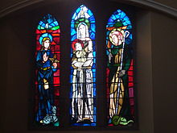  Stained glass at St. John the Baptist church (1955) – The Holy Family

