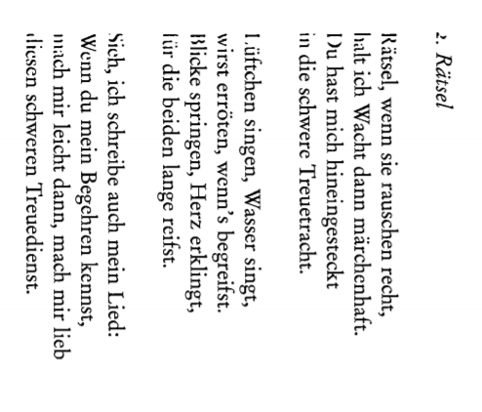

Miklós Radnóti
Enchanting
With fluttering eyes
Sitting in the light,
Rose tree's jumping
Through the fence,
The light is leaping,
The clouds gather
Lighting bolt comes
And it's talking to me
Up in the height
With wild thunder
With a thunder.

The blue of lakes down
Are fading, and
The surface flooding,
Come into the house,
Take off your clothes,
See, it's raining,
Take off your shirt,
Let the rain wash
Our hearts together.

