Carbonara
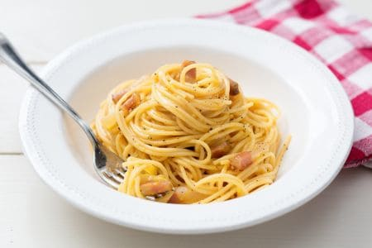
Ingredients
Spaghetti 320g
Guanciale 150g
Egg yolk 6
Pecorino Romano (cheese from Rome)
Fine Salt
Black Pepper
Preparation
Put a pot with salted water on fire to cook pasta. Remove rind from the “Guanciale” and cut it first into slices and then into strips.
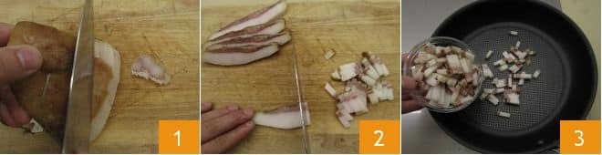
Put the little pieces in a no stick pan and brown them for 15 minutes to medium flame, pay attention not to burn them otherwise they release a too strong aroma.
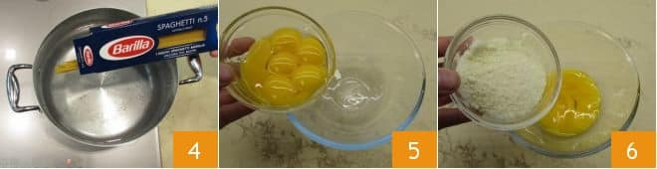
Put the spaghetti in the water and cook them for the time indicated on the package. In the meantime put the yolk in a bowl, add most of the pecorino provided by the recipe to garnish the pasta.
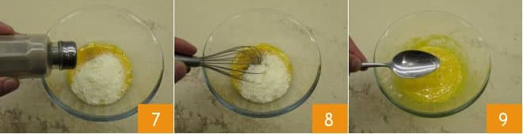
Season with black pepper, mix everything with a hand whisk. Add a tablespoon of cooking water to dilute the mixture and mix.
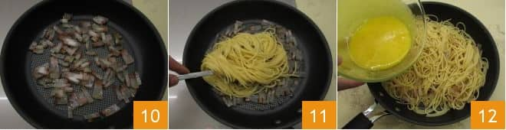
In the meantime the” Guanciale“ will be ready, switch of the fire and keep it aside.

Drain the pasta directly in the pan of “Guanciale “and salt it to flavor it. Remove from fire and put the mix of eggs and pecorino in the pan.
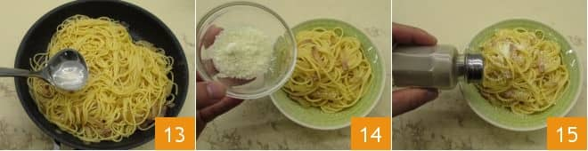
Serve immediately the “Spaghetti alla Carbonara” adding the remaining pecorino and ground black pepper.

