Hunting stew
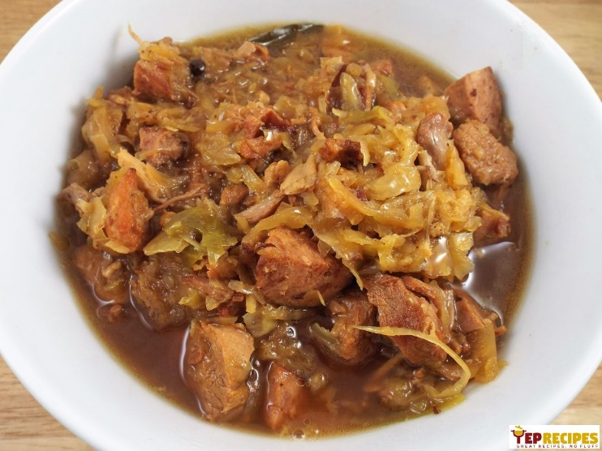
80 dkg cabbage
20 dkg veal
20 dkg pork (without bones)
10 dkg bacon
15 dkg sausage
Fat
2 dkg flour
50 ml red wine
4 dkg tomato concentrate
2-3 dried mushrooms
2 dkg dried plums
Salt, pepper, sugar, garlic, marjoram, onion
Cabbage press, chop, add wet and chop mushrooms and plums without drupelet cut on stripes. Inunadion boiling water with salt. Cooking under cover. Next to discover the cover for a 1 minute and cooking about 50 minutes on small fire under cover. Veal wash, remove small vein, cut in cube with bacon and peel, wash onion. Bacon partly melt, add veal, fry, add onion, lightly fry, add a few drop water and simmer in small fire under cover. Sausage peel off shell, cut in halfsilence, fry. Fat to warm up, mix with flour, fry, add cabbage, veal, sausage, tomato concentrate , wine and spices, simmer 3-5 minutes, to flavor.

