Sauerkraut and meat stew

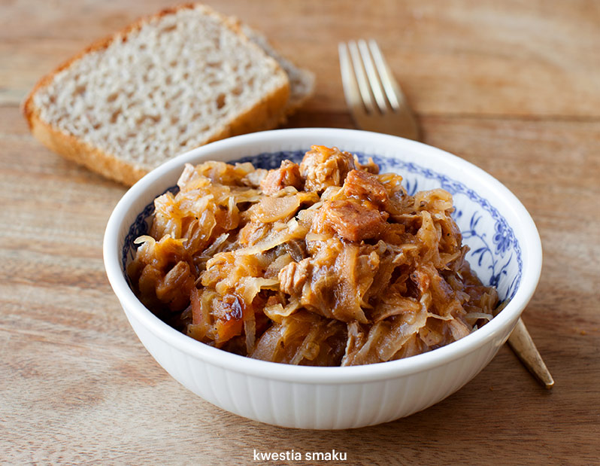
Ingredients:
1.5 kg of sauerkraut
3 sausages
2 onions
100 g of bacon
200 g of beef steak
4 tablespoons of tomato sauce
3 bay leaves
1 tablespoon of marjoram
allspice
salt
black pepper

Preparations:
- rinse sauerkraut with water and remove the water
- shred sauerkraut, put it in a large pot with bay leaves and allspice, add hot water
- stew until it's soft
- sautée onions, add chopped sausages, fry
- to a pot with boiling water add beef and bacon (chopped in cubes), cook for 20 minutes
- add meat, onions and sausage to sauerkraut
- add marjoram, salt, pepper, and tomato sauce
- mix the ingredients
cook for an hour on a low flame

