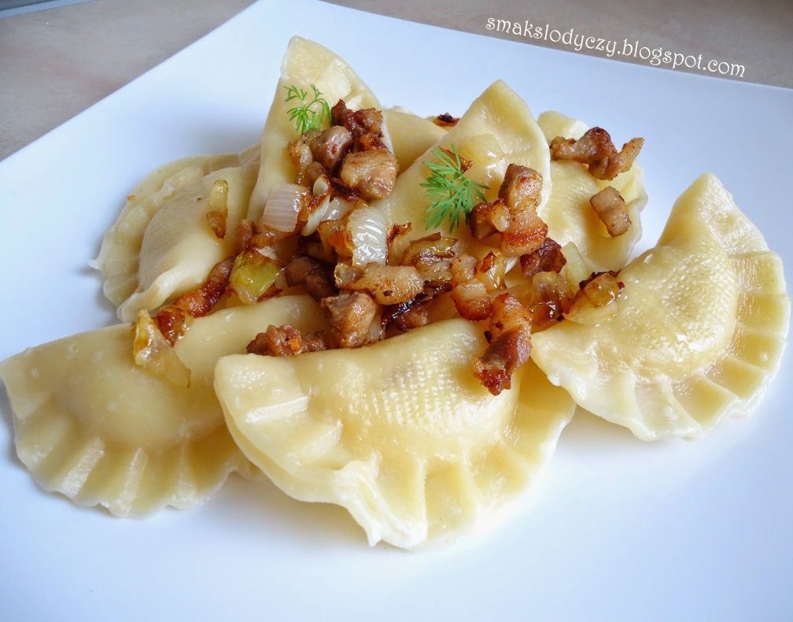
Pies Ruthenian
Ingrediends:
On cake:
400 I play {gramme} flours
1 egg
3/5 glasses cold waters
Salt
On stuffing
750 I gramme of potatoes
250 I gramme of cottage cheese
2 onions
1 clove of garlic
2 spoons of butter
1 spoon of oil
Salt, pepper
Manner of making:
Stuffing: Potatoes to peel and to cook in salted water. Onions to peel, to chop and to fry on butter together with crushed garlic. To connect with milled cottage cheese, rubbed with potatoes. To season to taste strongly to taste salt and with pepper.
Cake: From flours, of vitelluses and waters and particles of salt to knead cake to produce it by about 5 minutes. Then thinly to pin, with large glass to cut out circles. On every from them to put after tea-spoon stuffing and exactly to stick together. To cook in large quantities salted of boiling water with particle of oil to moment till will sail out on top.
*Serve with fried bulb
Time preparations: 60 of minutes

