Amatriciana
Ingredients for 4 people:
- 300 gr of bucatini
- half medium onion
- 150 grams of bacon
- 300 grams of fresh tomato pulp or canned
- 40 g of grated pecorino romano
- 3 tablespoons of olive oil
- Salt
- Pepper
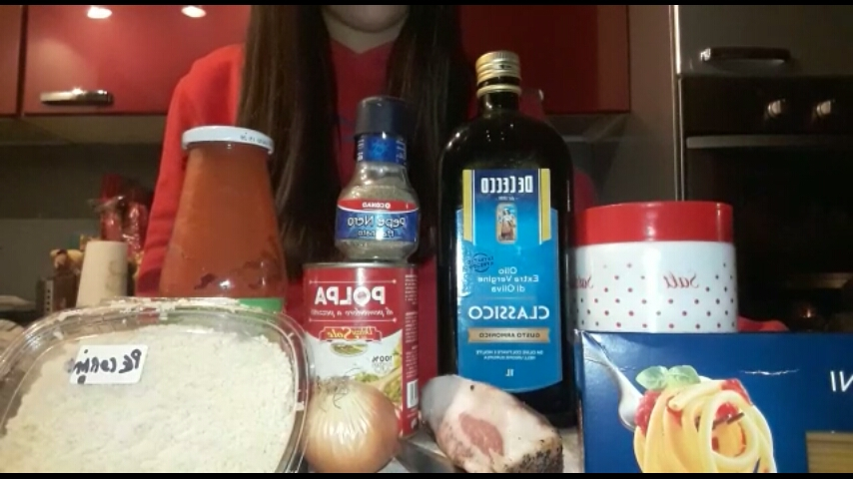

- Cut the bacon into cubes and chopped small onion half, while these two ingredients separately

- To heat the oil in a frying pan to medium heat and let cook until the bacon cubes and the onion cubes will become translucent.. United off the onions and lower the flame to a minimum.- Let cook for several minutes until the onion starts to brown.

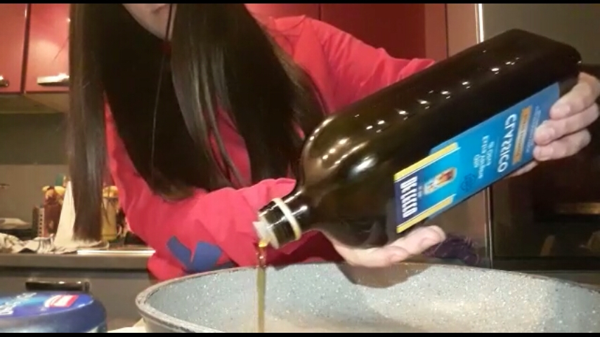

- Pour the tomato pulp in a pan and shuffled well. Cook over low heat. Salt, pepper. It 'best not to exceed with the salt at the beginning, especially if you use the bacon may be salty enough of her.
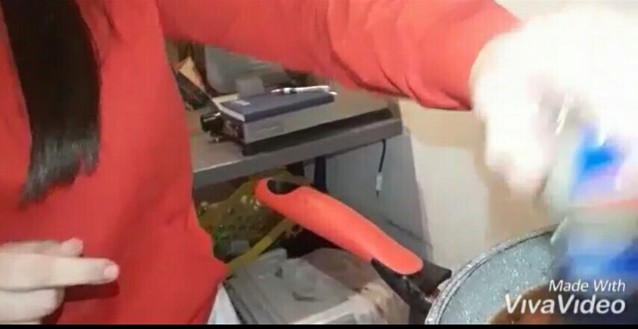

- Boil pasta in abundant salted water. We are used traditionally bucatini or perciatelli, but it is clear that the sauce is delicious with practically all types of pasta too long or short.
Drain the pasta and pour into pan. Stir well and sprinkle with half the grated pecorino. Stir and serve sprinkled with the remaining pecorino.

