Bucatini all’amatriciana

## Ingredients

* 400 g of bucatini;
* 200 g of cheek lard;
* A glass of dry white wine;
* 400g of Tomato sauce;
* 100g of Pecorino romano;
* Salt.

Procedure:

1. To realize the recipe of bucatini all’amatriciana, take the cheek lard and cut it into slices not too thin; then put them in a frying pan and saute them as long as they take color;
2. Pour a glass of wine, let it evaporate and pour the tomato for a few minutes;
3. In a pot with abundant salted water, toss the bucatini and cook them; drain them, pour them into a bowl and dress with the sauce.

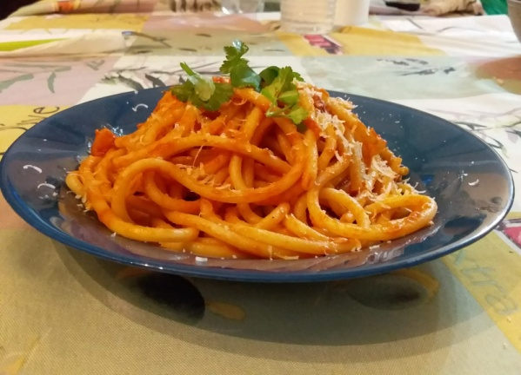

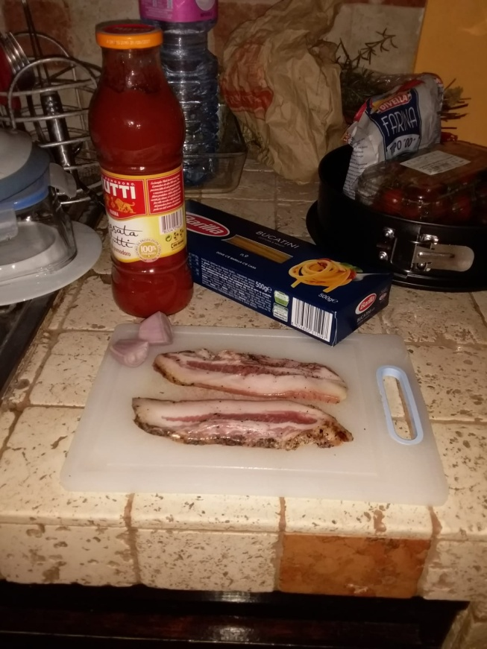

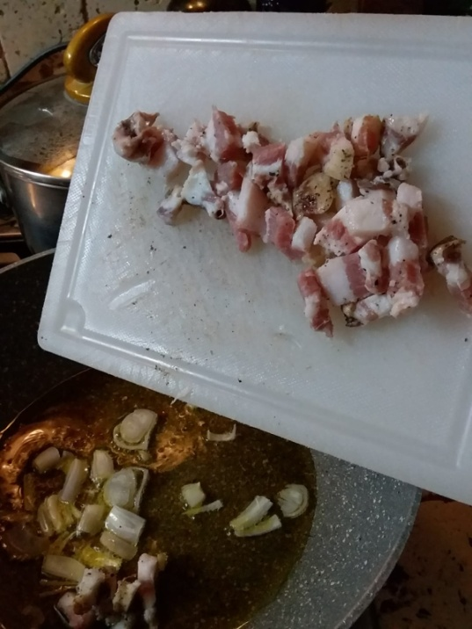

1. 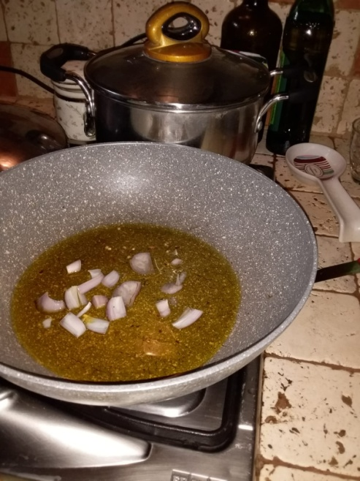
2. 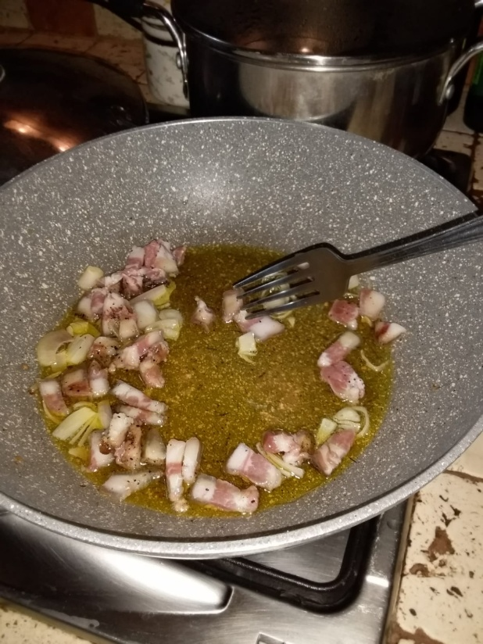
3. 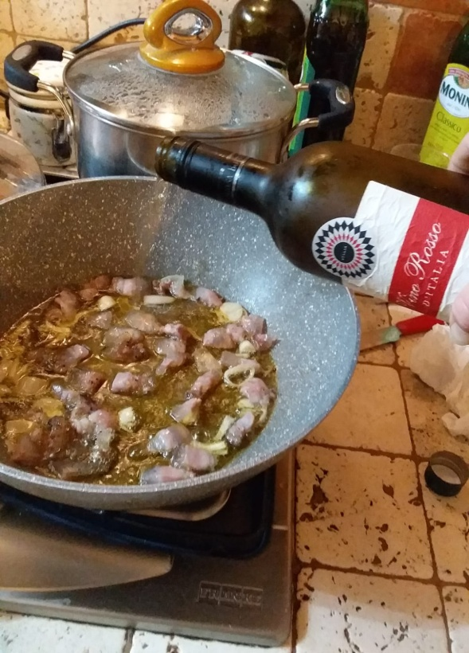
4. 7)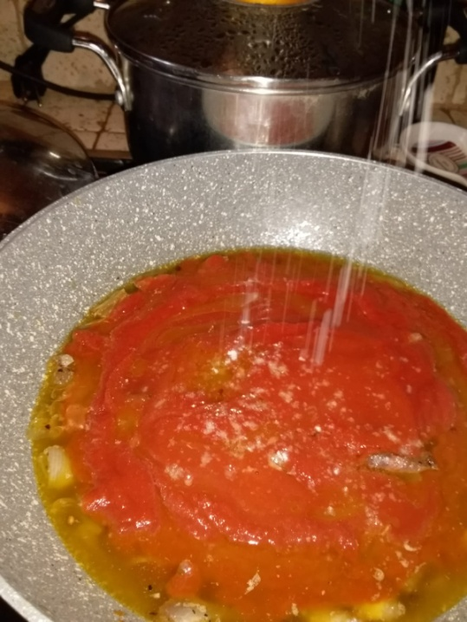 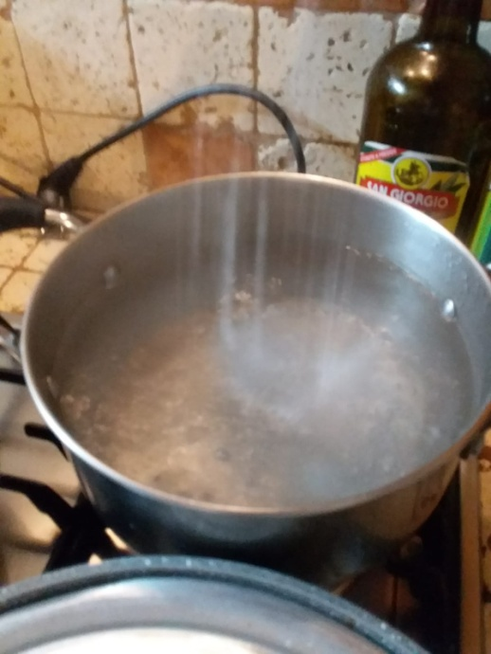

8)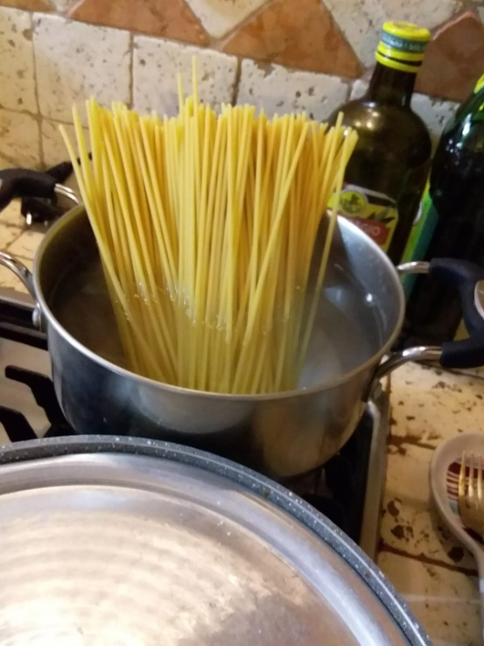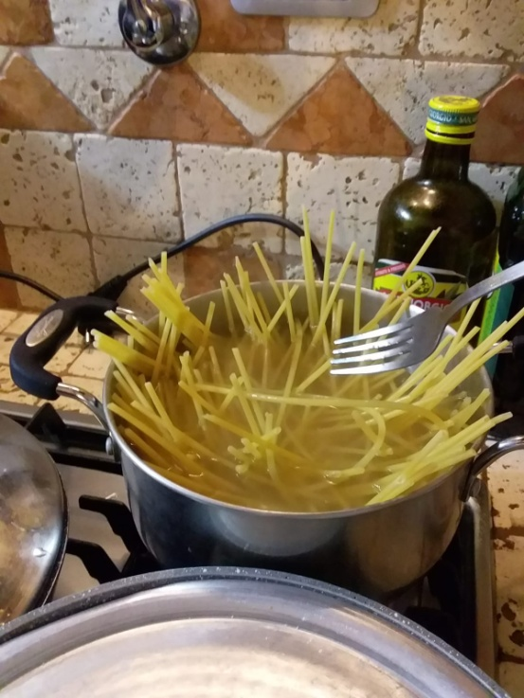

9)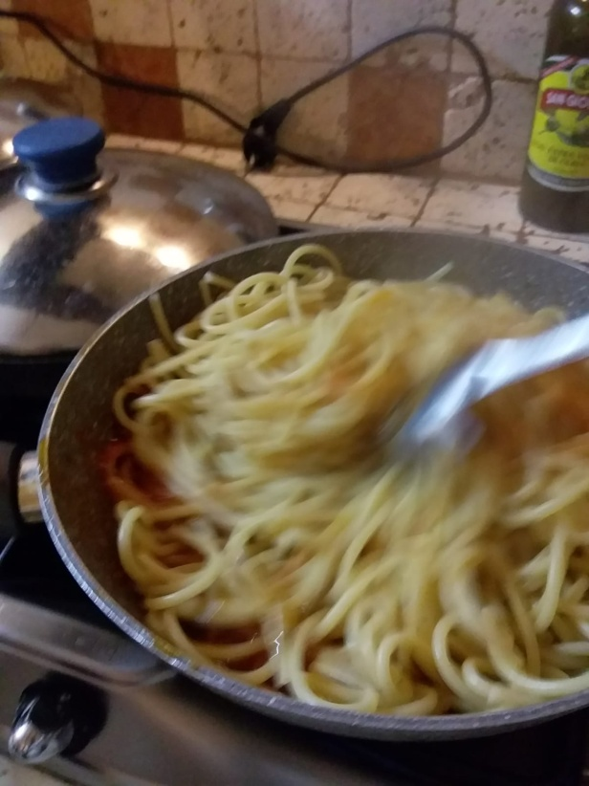

10)