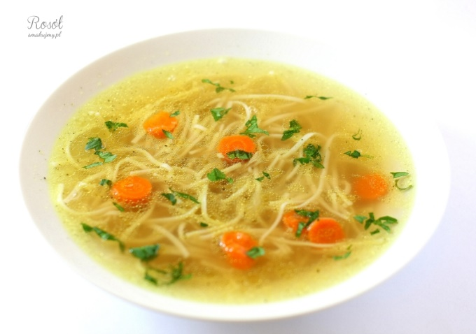
Chicken soup
Ingredients:
1 chicken
2 parsleys
3 carrots
1 onion
1 stock cube
salt
pepper
25 dag of pasta
Preparation:
Wash the chicken and put it to a pot with the water (about 3 litres of water). Then put the pot with meat on the gas stove and heat it. When the water starts boiling put the cut vegetables, stock cube, pepper, salt and boil it about 4 hours. When the soup is ready add boiled pasta. To make good look of your chicken soup add finelly cut carrot.

