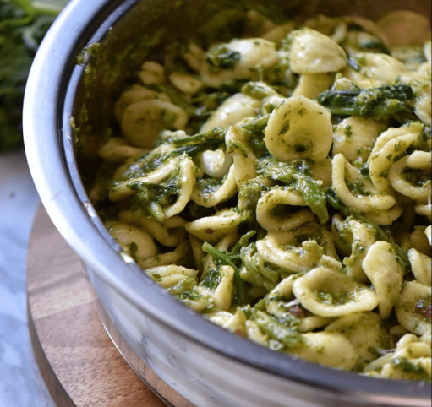
Italian Broccoli Rabe Orecchiette Pasta Recipe
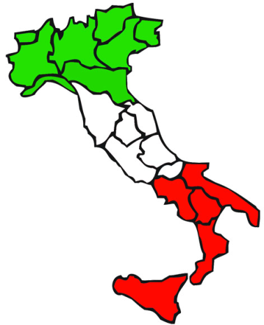
Orecchiette. Little ears. This pasta is immediately recognizable and associated with the Puglia region of Southern Italy, aka, the heel.
My father is from Pugluia, so when we go to see my grandparents we often eat this pasta with them.
This is my Grandma’s secret recipe!!

Ingredients
- 2 pounds broccoli rabe approximately 2 bunches, trimmed and washed
- 1 pound orecchiette (dried pasta)
- 1/2 cup extra virgin olive oil
- 2 garlic cloves (sliced)
- 6 anchovy fillets (chopped)
- pinch red chili pepper flakes
- 1/4 cup Parmigiano-Reggiano Cheese (grated)
- 1/4 cup Pecorino Romano Cheese (grated)
- salt and pepper
- grated cheese to garnish top

Instructions
- Over high heat, bring a large pot of salted water to a rolling boil.
- Add the broccoli rabe and cook until tender. This should take 4-5 minutes.
- Drain broccoli rabe in a sieve. Gently squeeze out excess moisture. Coarsely chop and set aside.
- Bring large pot of salted water to a rolling boil. Please note that you can use the same water to cook your pasta. My personnel preference is to start with a fresh pot of water.
- Add the pasta and stir. Cook pasta according to package directions or until “al dente”.
- While the pasta is cooking, heat the oil in a large frying pan over medium low heat.
- Add the garlic and anchovy fillets.
- Mash the anchovy with the back of a spoon for about 1-2 minutes.
- If using, add red pepper flakes and stir for 30-60 seconds.
- Add the cooked broccoli rabe and stir to combine. Adjust seasonings and heat through. Set aside and keep warm.
- When pasta is done, drain, reserving 2-3 ladles of the pasta water.
- Return pasta to the pot; add the broccoli rabe mixture and some pasta water to adjust the consistency.
- Add the cheese and toss together.
- Plate pasta and garnish with more grated cheese.
- Serve immediately.
Buon appetito

