Happiness- helping animals

Winter is a difficult time for garden birds. It is hard to find them anything to eat because everything has snowed over. Searching in the cold consumes valuable energy. In the garden covered with snow blankets we can often meet sparrows, mazurkas, tits, woodpeckers, jackdaws, rooks, blackbirds, fieldfare and their cousins. Many birds will not survive the harsh winter conditions - low temperatures and precipitation. You can feed them to help them survive the winter.

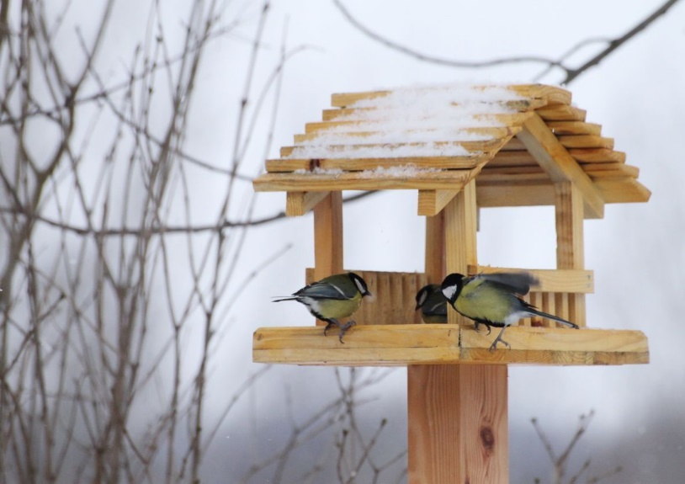
in winter a good way is to attach the feeder with a roof, for example on the windowsill and leave food in it. when the little birds come to feed they will have an additional shelter thanks to the roof.

birds can be left:
seeds
sunflower
or special food in the bag from which they extract the seeds

