CIAMBELLONE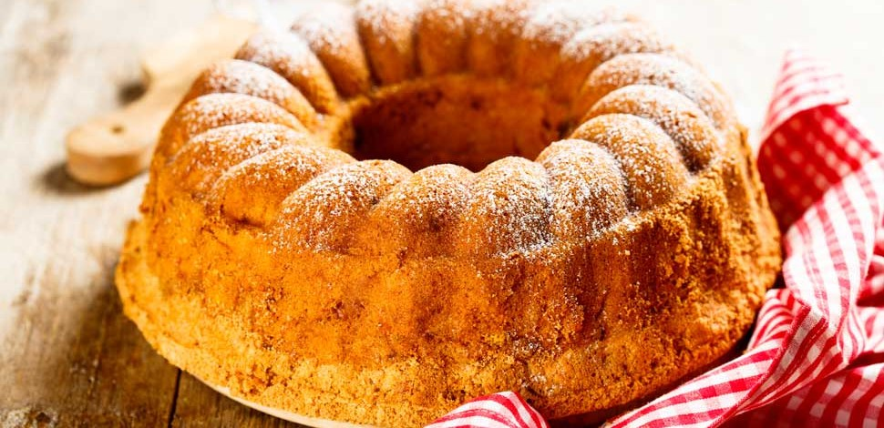
INGREDIENTS: flour: 300 grams
Sugar:150 grams
Cocoa:80 grams
Eggs: 3
Extravirgin olive oil: half glass
Milk: half glass
Lemon: 1
Baking powder: one sachet
INSTRUCTIONS:
mix the eggs with the sugar with an electric mixer;
gradually add the milk then the oil and finally the lemon peel, only the yellow part (well washed);
add the flour, making sure that no lumps are formed, and then add the yeast;
grease and put some flour on a baking pan and pour in half of the mixture;
add the cocoa to the remaining mixture and mix well until the cocoa is well mixed. Also pour this part of the mixture into the pan;
bake for 45 minutes at 180 degrees;
at the end of cooking let it cool before cutting it and serve it warm or cold!

