CASATIELLO

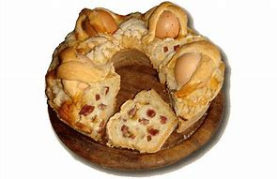

INGRIDIENTS:
600g of flour 0
300g of water
10g of brewer's yeast
40g of lard
salt
pepper
150g of salami of Naples
150g of Pecorino cheese

Mix all the ingredients and cover the dough with a cloth and let it rise for 4 or 5 hours.
Roll out the leavened dough.
Cut cheese and salami into cubes, fill the dough and roll.
Put the dough in a pan for donuts, previoulsly greased with lard.
Leave to rise for 2 hours.
Bake at 180 degrees for 50 minutes.
Enjoy your Casatiello!

Aika P, Giulia S 3D

