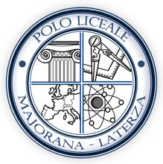
Subscribe to DeepL Pro to edit this document.
Viiww.DeepL.com/Pro for more information.

PROGETTO ERASMUS Frederick 2nd: a multicultural bridge from 13th to 21st century.

FEDERICO II
History and legend of a great emperor

History and philosophy teacher: Prof. Elvira Rochowansky

The teaching proposal is part of an Erasmus project in which the Liceo Majorana Laterza is collaborating with the Liceo Adolf-Schmitthener-Gymnasium in Neckarbischofsheim (Germany) and the Liceo Classico Statale Umberto I in Palermo.

Third year of high school (language course) | A.S: 2018/2019 | Subject areas involved in the project | History, Philosophy, Drawing and Art History,  Italian, English, German, Maths
Workshop activities  related to historical disciplines (CLIL) | 1)Padlet creation:  An impossible interview with Frederick II (https://padlet.com/elviraroch/dmwqa03msfts)  2)Creation of a card game  (with multiple-choice questions)  3) Construction of Frederick II's identity card  4) Production of a report |  | 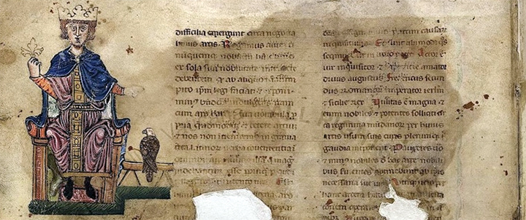
Objectives
Humanistic-historical-artistic axis
Use the lexical and expressive heritage of the Italian language according to communicative needs in various contexts.
To use the cultural and methodological tools to deal rationally, critically and responsibly with reality, its phenomena and its problems, also for the purposes of lifelong learning.
To use the sectorial languages of foreign languages to interact in different fields and contexts of study and work, enhancing team-working strategies to intervene in organisational and relational contexts
Using language skills to convey cultural content and to enhance cooperation and social skills in different foreign languages (English and German)
To use historical knowledge to understand and interrelate information in a perspective of comparison between cultures, linking the local dimension with the global one.
To use iconographic and documentary sources as tools for in-depth knowledge acquisition and historical elaboration.
Use historical, literary and artistic knowledge to provide tools for reading the personality of Frederick II in its European dimension
To use the knowledge related to the environmental and artistic heritage to promote awareness of the artistic and natural heritage of our territory, also from a comparative point of view towards the project partners (the places of Frederick II in Apulia and those in Sicily and Germany).
Using historical knowledge to turn it into playful teaching material. Playing cards, impossible interviews, more usable in sharing with pupils from other schools in the project (Historia ludens)
To use and produce visual and multimedia communication tools also with reference to the expressive strategies and technical tools of online communication.
Establishing links between local, national and international cultural traditions both in an intercultural perspective and for the purposes of study and work mobility.
Scientific-mathematical axis
To relate general historical knowledge to developments in science, technology and techniques.
Using the language and methods of mathematics to organise and evaluate qualitative and quantitative information.

Teaching Unit in History (III B Languages)
Prof. Elvira Rochowansky
A.s. 2019/2020

Frederick II: history and legend of a great emperor

Topics:
Biography and historical context
Culture, law
The personality of Frederick II
The political vision of Frederick II
The relationship with Apulia, Sicily and Germany
Religious tolerance and the relationship with the Arab world
Cultural eclecticism
The castles
Science and magic
Curiosities (fake news?)
The legend Stupor mundi or Antichrist?
Updates

Tools (historical disciplines):
The tools used are related to multimedia and non-media research, some found in the school library,
Use of multimedia supports such as interactive whiteboard, computers, paper sources, magazines, books

Multimedia material and bibliographical sources
Alessandro Barbero: Federico II, A history of sharing, https://www.youtube.com/watch?v=glt7o_Q5qHw
Raiscuola: Federico a bridge to the East (https://www.youtube.com/watch?v=_Z08R3qOq2k)
Blog site on Federico: www.stupormundi.it

Bibliographic sources:
Giardina, Sabbatucci, Vidotto, Nuovi profili storici, Editori laterza,2006
Medieval Dossier: Frederick II, History and Legend of a Great Emperor (Year I, number 1/1998)
D. Abulafia: Federico II, un imperatore medioevale (G. Einaudi editore),2015
Manual
M.L.Troccoli Verardi in the volume Castel del Monte (Editore Adda) with the study 'A book of stone'.
Raffaele Licinio, Castel del Monte, Edizioni del sud, 2001
Federico, Myth and Memory, Edisud (Apulia Region 1994)

Worktop
- Introductory lesson on the figure of Frederick II and guided discussion to bring out questions, curiosities, considerations as a field of investigation from which to recover documents and sources
- Reading and research of all the historical, cultural and literary elements concerning the figure of Frederick II (also in a multidisciplinary perspective) through the indicated sources.
- Creation of group activities divided by topics and thematic interests (culture, politics, life and personality, curiosity, science and magic)
- Comparison of sources, reading and interpretation of historical and legal documents and iconographic sources
- Elaboration of textual analysis, historical data, reflections.
- Interaction with research and activities proposed by the two partner high schools in the project
- Sharing of materials and products made (playing cards, padlet, identity card)

Application phase | First and second term
Times | October-May
Activated experiences | Reading  Group work  Documentary investigations  Computer lab
Methodology | Lectures and dialogues, group and inter-group work, guided research, internet, cooperative learning, group presentations.

Each student developed a series of knowledge ranging from the personality of Frederick II to other aspects of his biography, politics, castellation, cultural eclecticism, etc.. From the questions the pupils asked themselves, a padlet https://padlet.com/elviraroch/dmwqa03msfts) or an Impossible Interview with Frederick II was produced, the answers were then discussed in a final report.
From the information, the students drew up an identity card of Frederick II, which allowed them to choose data and contextualise them.

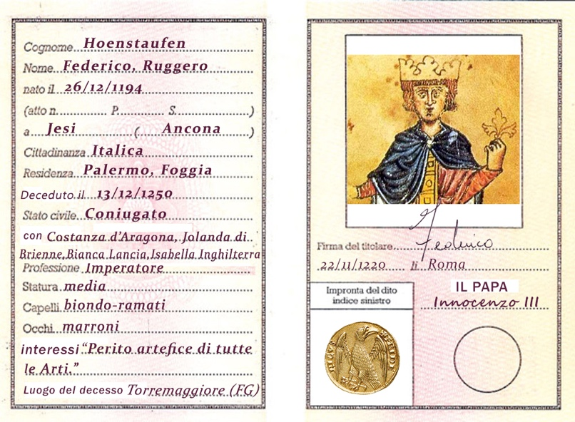

Playing cards written in English were made, also thanks to the collaboration of children in the class who are particularly skilled in computer graphics. This material constituted a useful didactic tool to play with historical information during the meetings with the other classes and high schools (German and Sicilian).

Playing with cards
The Cards of Frederick II (a kind of Trivial on Frederick II)
Game dynamics: There are two sets of 20 cards in each deck, 40 cards in total. In one set of cards there are questions (where the number of the right answer is indicated), in the other set there are multiple choice answers, with more than one answer choice. It is a team game (two or more teams) that allows you to enhance your historical knowledge while having fun.
The game is very simple and allows not only to memorise dates, but also to offer the cue for the problematisation of contexts, developed through the reflections that teachers guide in the debriefing (after the deepening of contents). The construction of a chronological tool through a playful approach facilitates the teacher's work in building awareness of historical problems and processes and, therefore, the interpretative meaning of historical time, taking into account that the vehicular language is English (even the questions and answers on the cards are in English) and the team game helps team working.

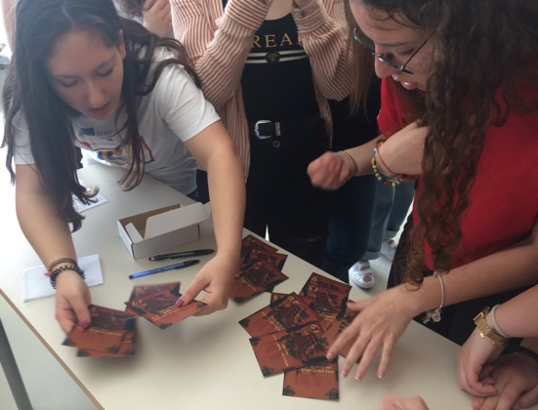

Final report
Write a short descriptive text on the figure of Frederick II highlighting

Origins
Ascent
Building the Empire
Relations with the Papacy
Weaknesses
Elements of Strength
Collapse and consequences
An event that particularly impressed you
Who ruled in place of the Swabian dynasty

