Travel Report, Putignano 18.10.2018-22.10.2018
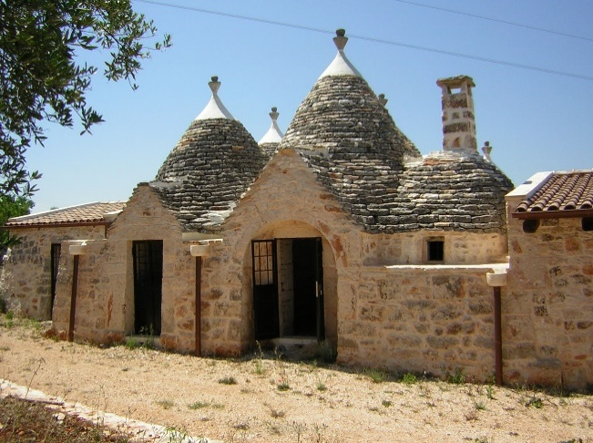
When we arrived on Thursday, 18.10.2018 after the 90 minute flight from Frankfurt to Bari, we drove to the school in Putignano, where we met our host students and many other people. In the evening we went together with the respective host families to Alberello in a pizzeria and ate together. Then we went through the village and looked at the trullis.

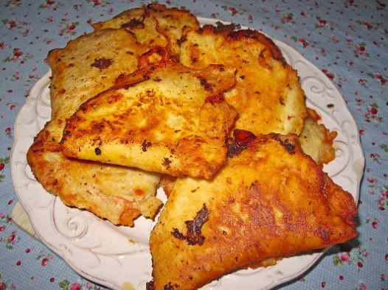
Friday morning we went directly to school, where we met the other students from Sicily. Together we worked on the website and the Erasmus logo, we had a lot of fun together. In the evening I had dinner with my host family. There were many more relatives of the family, all wanted to get to know me. We ate Panzerotti and everyone got along well.

On Saturday it was time to make a video in which we answered questions such as "Why are you participating in the Erasmus project?".
Besides as well, both German-speaking and Italian students have each created a quiz about their home country.
Saturday night I was with my host family in Bari to visit the city, then we went bowling.

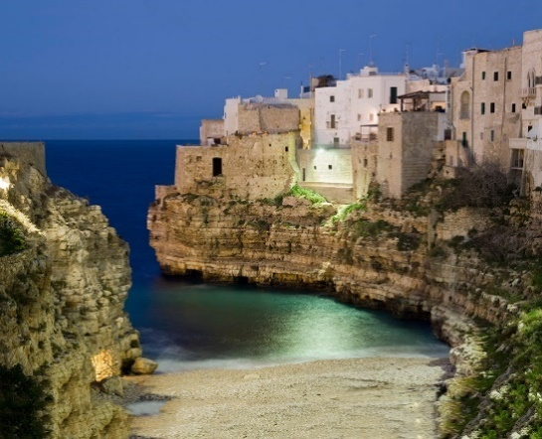
On our last day, Sunday, we had free time, which means that we all sleep long. Around noon we went together with the host families to Monopoli to the sea. In Monopoli we also had lunch together. In the evening we all went to Polignano, where we had a fantastic view of the sea and where there was something like a funfair.

And so our journey came to an end and we flew back to Germany on Monday morning.

