The documents
Documents are one of the most important types of sources of the Middle Ages. In contrast to the “era of files” of modern times the Middle Ages can be characterized as the “document era”. In documents and (later) files the economical, poetical and juridical business activities of the time have been reflected.
The term “document”
“A document is an executed and authenticated paper observing certain forms about a record of juridical nature. Therefore, it is a juridical product, not a production of historians, or of another human will of documentation”. The definition of the former Lübeck city archivist Ahasver von Brandt (1909 – 1977) has meanwhile won general recognition by the science of history.
Documents have got their deciding importance for the community is based on juridical records. According to Ahasver von Brandt it is considered as a word of truth: “It makes no difference whether it deals of constitution, administration order, jurisdiction and legislation, war and peace and alliance order and task, act of grace and privileging of single persons or of groups in the state sphere – or whether it deals laws and rules of the town constitution, the rural living order professional associations, guilds and corporations, the ecclesiastical institutions and communities in the community life – or whether it deals with legal acts with other persons by last will and legacy, marriage, purchase and sale, debt and donation in the private life: their all is due to juridical acts”. (von Brandt)

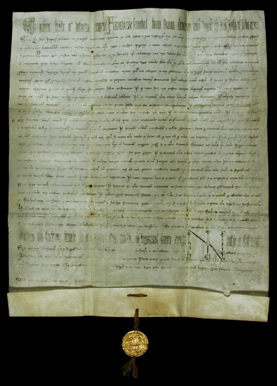

Statutum in favorem principum

Udine, Mai 1232
Parchment, attached gold bull;
H: 48.5 cm / W: 40.5 cm
Halle (Saale), City Archives,
document collection U1, no. 1
Picture credits: Halle (Saale), City Archives: VI.A.3

Apparatus of forms of a medieval document

1 | Introduction protocol
a) | Invocatio | Invocation of God , partly depicted by Chrismon
b) | Intitulatio | Name and title of the issuing person, often with a devotion formula
c) | Inscriptio | Naming of the receiver, often with greeting formula (Salutatio)
2 | (Con)Text
a) | Arenga | General foundation of the juridical act explained in the context
b) | Promulgatio/  Publicatio | Promulgation formula, declatory act of the issuing person to the receiver
c) | Narratio | Naming of the valid legal basis
d) | Dispositio | Expression of the declatoring act, material contents of the juridical acts; the real juridical act
e) | Sanctio | Sanction for violation
f) | Corroboratio | Specification of the means of authentication
3 | Eschatokoll
a) | Subscriptiones | Signature of the issuing person (signum) and if necessary of the witnesses (recognitio)
b) | Date | Naming of the day and the place
c) | Apprecatio | Blessing (or benediction)

For the fixing of the seal there were different possibilities often it was done by snapping off the lower edge of the parchment (plica). At the points of perforating a thin strip of parchment or a chord was drawn through of which the seal was fixed – in imperial documents a golden seal (Goldbulle). For that a filling material like wax was enclosed with two gold foils.

Richly decorated letter C, symbol for the name of Christ

