Erasmus+ preparatory meeting travel report by Clara Bullmer
Thursday, 18.10.2018
We met at 4:50 at the train station in Neckarbischofsheim and went to the airport by train. The plane started at 9 o’clock and landed at 11:00. From the airport we went to the school in Putignano. There we met the teachers and students, who participate in the Erasmus project. Our guest students showed us their school an d took us with them to their classes. After we got to know each other, we discussed that every school will make a Logo-sheet with a computer. Then one of the three logos will be chosen to be the official logo.
In the evening we all went together with our host families to Alberobello and ate pizza. After dinner we walked around and looked at the trulli.

Friday, 19.10.2018
Because the Sicilian Students came on Friday we first played games to get to know each other. After that we talked about what we know about the other country and what we would like to know,in the process we also talked about the similarities and differences between Italy and Germany. Into the bargain we made separated in two groups on „LearningApps“ quizzes about our homelands, which the group answered. In the afternoon we discussed with the teachers where we will create our website and how we will get people to look it up. After that we looked at the wInning site together and tried it out by uploading pictures and descriptions of different things.
In the evening we first walked around in Putignano and then ate Panzerotti in Noci.

Saturday, 20.10.2018
We filmed a video where we said why we participate, what we are looking forward to and how we would motivate other students to participate. Then the organizer of the Federicus festivals showed us pictures of the last festival and told us what they planned for the next one. We talked about how we students can get involved in the festival.
At midday we had lunch with our host families. In the afternoon we went to Bari at the harbor and had dinner there.
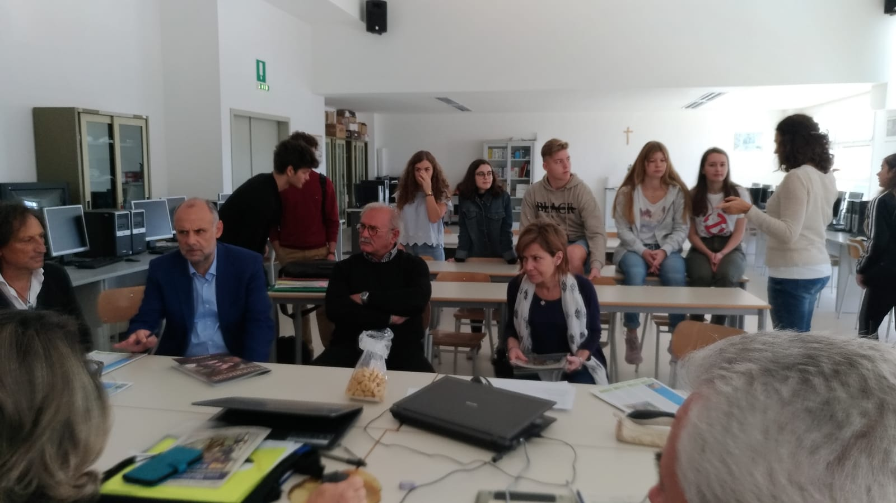

Sunday,21.10.2018
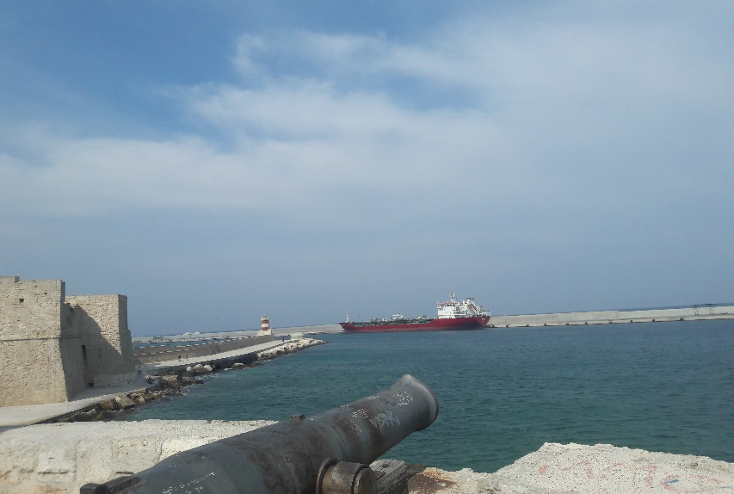
Am At Sunday we had free time so we went to Monopoli at the sea, where we went swimming. After that we at a typical Italian lunch. Then we went to Polignano where we met the others.

Monday,22.10.201
At Monday we said goodbye to our host families in the morning and went to the airport where we flew at 10:30 back to Germany.

