SICILIAN PASTRIES OF ARAB-NORMAN ORIGIN
CANNOLO
Sicilian cannolo is one of the best known specialty of the Italian confectionery. Anciently, it was prepared for the Carnival, but today cannolo is habitually prepared and consumed. It was born in Caltanissetta. The recipe was invented by some women that lived in a Saracen castle in Caltanissetta.
It is composed from a fried pasta (called scòrza) and it has a stuffing made with ricotta cheese of sheep, sugar and flakes of chocolate; it is studded with a bark of orange.

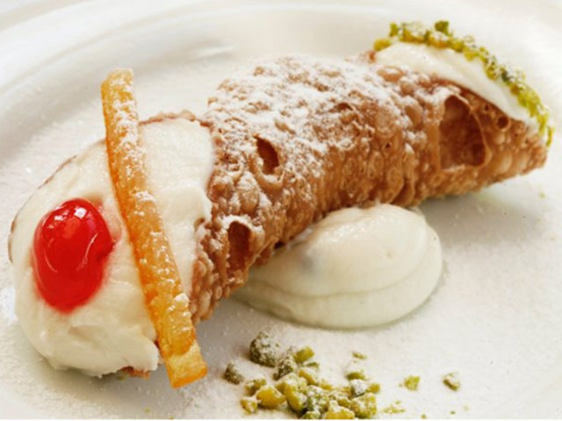

SFINCE DI SAN GIUSEPPE
The sfince is a big fried “bignè” stuffed with cream of ricotta, candied pumpkin and drops of chocolate; it is decorated with flakes of pistachios, cherries and candied orange. It was created many centuries ago by the nuns of the Monastery of the St. Francis’s Stimmates. Sfinces were covered with honey for the Party of St. Joseph, on March 19, but later they became one of the dainties delight in Palermo and today you can find them on the whole year in all the Sicilian confectioneres.
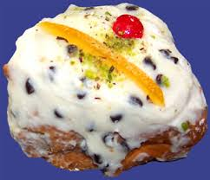

BISCOTTI DI MANDORLA
The “pastas of almond” are one of the symbols of the Sicilian confectionery. They are diffused in different forms in the whole island: they are small and candid to Messina, they have the form of a “S” to Catania and Agrigento, they are mixed with the pistachio (to Bronte), or the nuts (in the zone of the Nebrodis and the Etna). A lot of them are simple, others are decorated with almonds, cherries and barks of orange candied. The inside is always made with minced almonds, sugar and egg-whites.

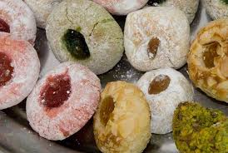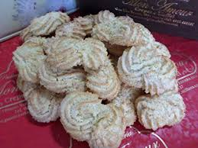

CASSATA SICILIANA
The cassata is a typical Sicilian cake. It has its origins in the Arabs, that brought in Sicily the sugar reed, the lemon, the cedar, the bitter orange, the mandarin and the almond. Later, thanks to the nuns of the Convent of the Martorana Church in Palermo, the old wrap of short pastry was replaced with a new wrap of real pasta, called “martorana”, a mixture of flour of almonds and sugar, colored of green with extracts of grass. It is decorated with candied fruits.
