3.grade Ramberg school, Norway.

For this period we set aside a week to work with the UNs Sustainable Development goal number 7, Clean and Affordable Energy.
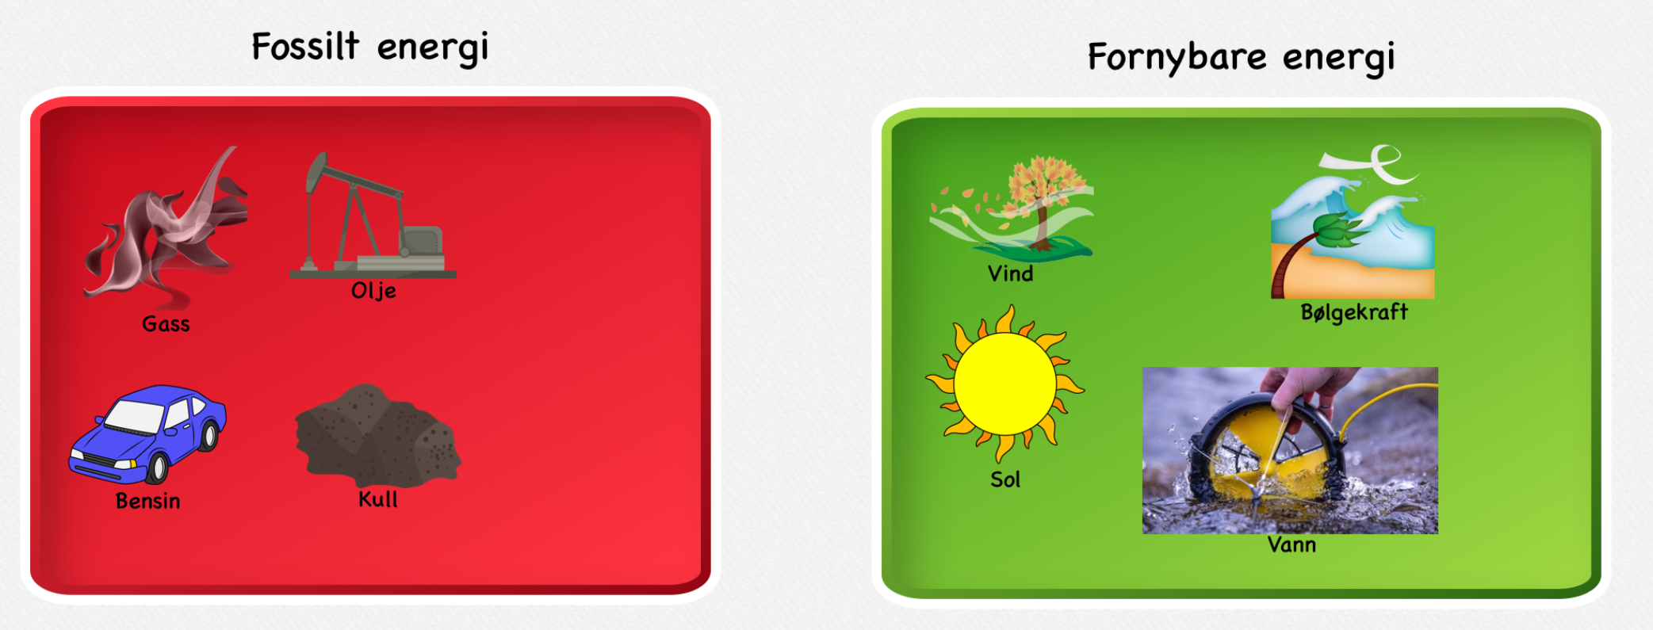
We learned about fossil and renewable energy sources. We used images for the different types, and put them in the correct category.
We made windmills with decorated paper and a stick. We used it outside and could see how the wind easily turned the blades. We also put a small waterwheel underneath a small waterfall in a creek.
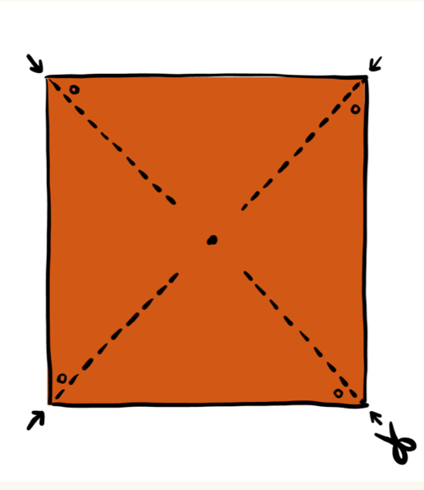
We read factual texts and answered questions. We also talked about what we can do in our everyday lives to help. How can we save energy and how can we reduce our energy consumption.
