6th grade project, Ramberg

The Island

We used two weeks on this project. The first week we worked only with this, in the second week we taught different aspects of Sustainable development, but we also had some other subjects.

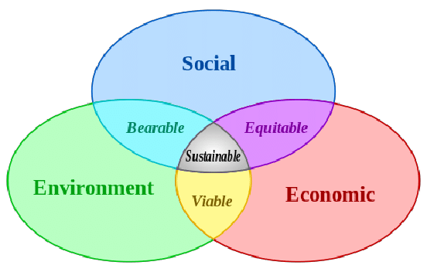
On the first day we focused on teaching the children the difference between the three circles. They needed this for their work with “The island”.

On their second day we introduced “The Island”.
The island should be a good place to live for everybody. It had 100 000 inhabitants, the children had 100 000 NOK to use for social purposes, on the next day they would have 100 000 to use on the environment and the third day on economic matters. They received a list of what different services would cost for 10 000 people. (the numbers were imaginary) They had to discuss the importance of the different services – they could not afford them all.
They worked in groups of six.

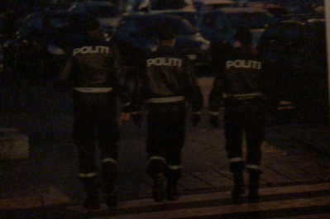
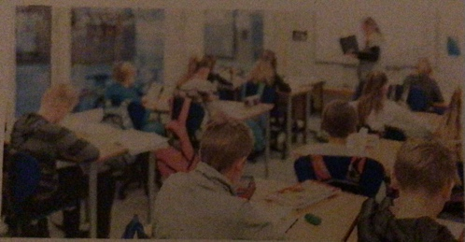
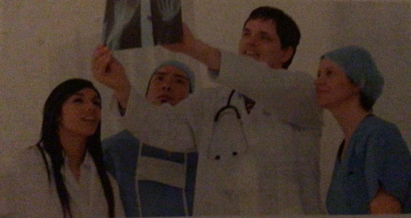
The pupils had to decide how many approximately would go to school, would need doctors, sporting arenas, police, gyms, and so on. They placed photos of these services on their island (made of paper). They also had to present a budget.

Doctors Schools Police

On day three they had to do the same with the environment. Did they want factories, national parks, cars, busses, farms.
On the fourth day we worked with the islands expenses, will the people be vegans or meat eaters, where will they work, do they want to travel by bus or car, where will their electricity come from, who should pay taxes (and how much).

The last day of our Island project, all groups presented their island for the rest of the class - focusing on sustainability.

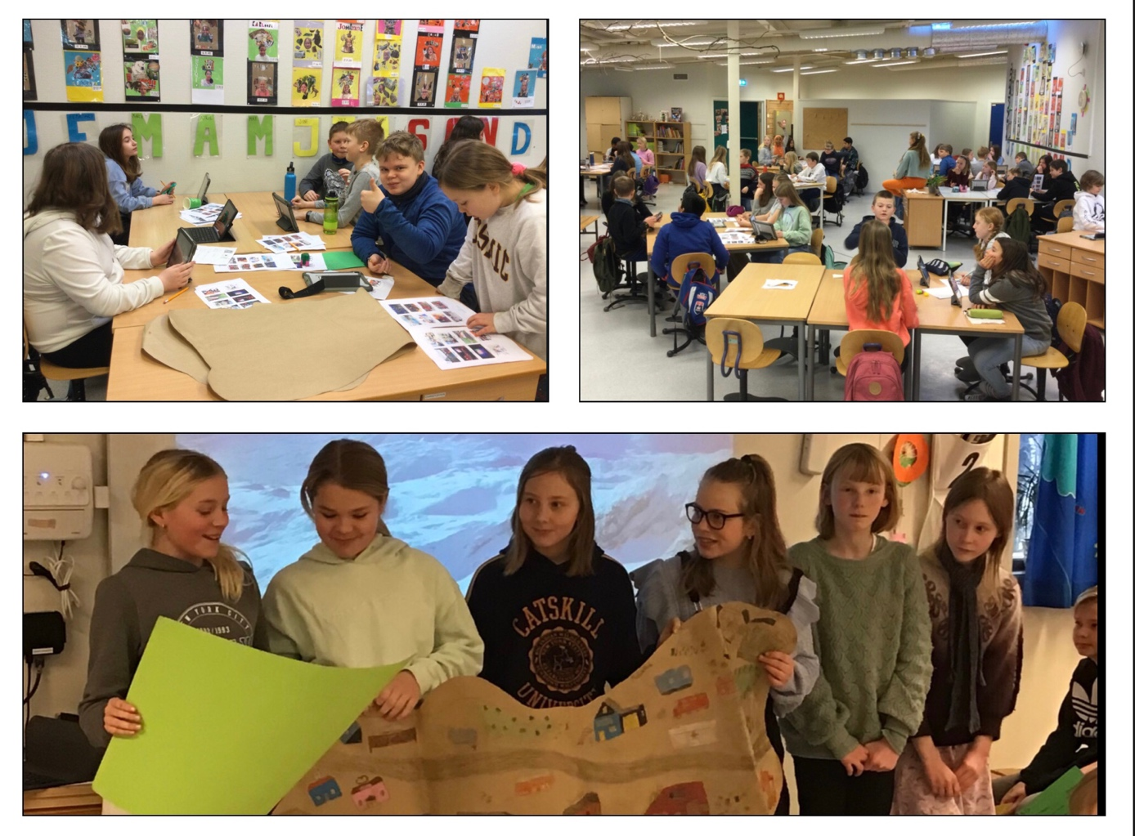

The pupils had many good discussions

• How many hospitals do we need?
• Will it be possible to have only busses, what about ambulances and police cars?
- Do we need kindergartens for all children?
- Is it necessary to have a sporting arena?
- Do we want to grow our own food?
- Are the Human Rights considered in our choices?

The following week, we worked with sustainability in general.

We also made an ice art exhibition in the forest behind the school. Art made of ice and things we found in the forest.

