
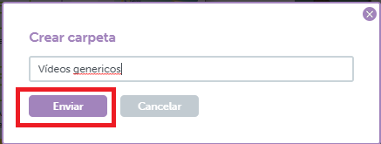
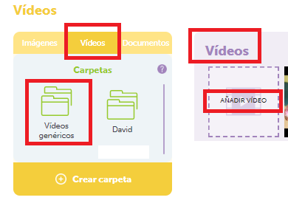
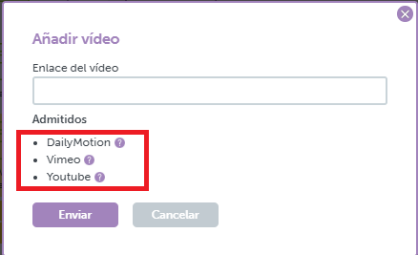
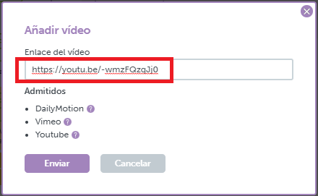
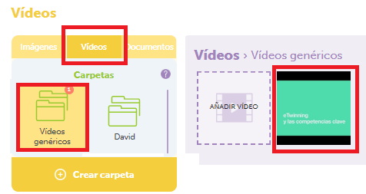
UPLOAD A VIDEO TO TWINSPACE

You must first upload your video to you tube in hidden mode. Only people with the link will see your video

1.-Access the TwinSpace and click on the Materials tab
2. - On the left side of the window that appears, create a folder and give it a name, for example Generic videos:
.
3. - The folder appears on the left side of the window
4.- To upload the video, select the Generic Videos folder, click ADD VIDEO and follow the instructions that appear. Note that you can upload only videos previously hosted on You Tube, Vimeo or DailyMotion.

In this case I select one that I have hosted on YouTube. I copy the address to share the video https://www.youtube.com/watch?v=jtYW77VkU-E and paste it in the corresponding field.

5.- Click send. The video will already appear in the selected folder.

