A CLIL Unit – Gragnano and the Valley of Mills
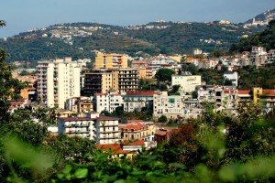
Approaching the topic
1 How much do you know about Gragnano? Do the quiz to find out!
Quiz
1 Gragnano is a small…
- town
- city
- village
2 Gragnano is in the ….of Italy
- centre
- south- west
- south- east
3 Gragnano is in tthe province of…
- Salerno
- Caserta
- Naples
4 Gragnano is famous for the production of
- cars
- olive oil
- pasta

2. Look at the pictures. What do you think the topic is about?

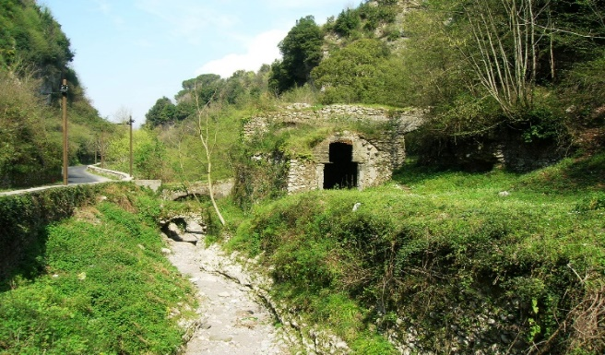
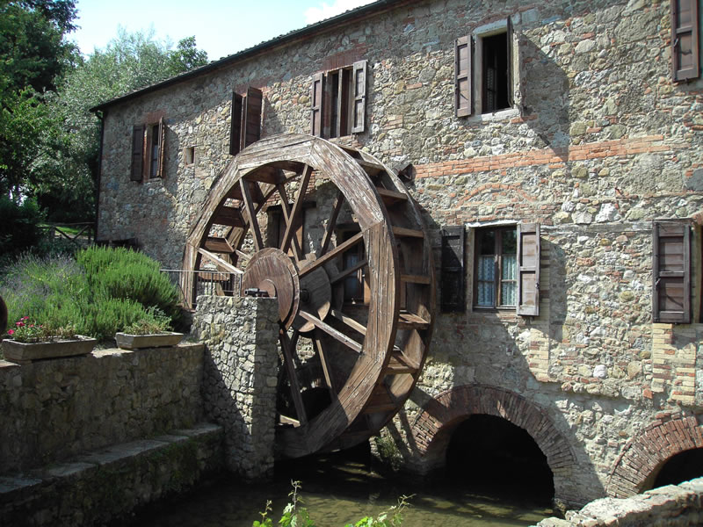

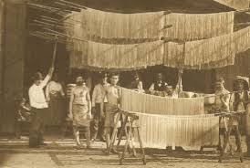
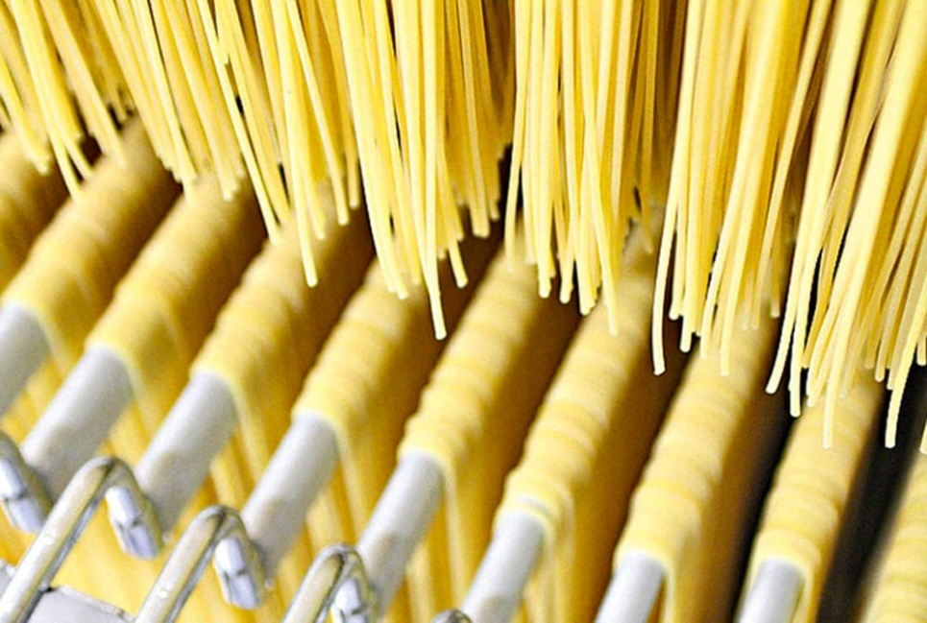

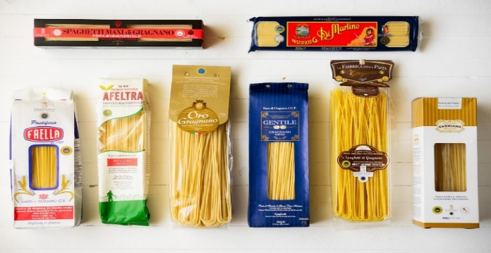

3. Key words
Match each term (1-7) with the right definition (a-g)
- mill
- valley
- stream
- pasta
- pasta factory
- logo
- plain

- a food made from flour mixed with water and sometimes eggs
- a symbol or other small design adopted by an organization to identify its products, uniform, vehicles, etc.
- a building equipped with machinery for grinding grain into flour.
- a low area of land between hills or mountains, typically with a river or stream flowing through it.
- a small, narrow river.
- a place where pasta is made
- large area of flat land with few trees

4. Now complete the sentences using the words from ex.n° 1
- The valley originates from the release of waters into a tufa …
- One of the… is called Vernotico.
- The Valley takes its name because there are a lot of … in this area
- There were about 30 mills in the valley that were used to grind …
- Nowadays,there are still a lot of … in Gragnano
- Each pasta factory has its own …
- There are numerous shapes of …

5. Read the text and try to guess the meaning of the words in bold If yoy can’t, use a dictionary
The resources of our land
The Mills
The Valley of Mills in Gragnano is home of abandoned mills, which were once part of the area's pasta production industry.
The ruined buildings date back to the 13th century. The tumbledown factories include flour mills and sawmills, which remained active until the early 20th century. There were about 30 mills in total that were active over the years. They milled durum wheat and transformed it into semolina to produce pasta. They exploited the water of the stream Vernotico,they were water mills. Because of new sources of energy, the Valley of Mills was left deserted
The old workhouses are now in a state of neglect. The valley remains a popular spot with hikers.
6.Answer the questions
- What kind of mills were there in the valley?
- How many mills were there?
- What’s the name of one of the streams which flow through the valley?
- Why was the valley abandoned?

7. Some history
The production of pasta started early in Gragnano. In the XVI century the first guild of Vermicelli-makers (Vermicellai) was established
Production continued to develop until the XVIII century.
The city was redesigned with the 1843 urban plan, in order to promote the flow of breezes that were fundamental for the success of the drying process.
Gragnano's main street,Via Roma, was laid out to capture the mountain breeze.
Pasta makers hung spaghetti on drying rods like laundry, There were around 100 pasta factories employing a good 70 % of the active Gragnano population. Pasta was transported to the north of Italy thanks to the railway station inaugurated in 1885.
During the Second World War the pasta factories reduced their production because there were many other Italian pasta factories to compete with.

8.Now watch the video and then complete the text
https://videos.mysimpleshow.com/18aKP8WGP6

Gragnano, a small town near Naples
It is located in the south-west of Italy. It's at the foot of Monti Lattari
There are about……. inhabitants. They speak Italian but local dialect is common
The Lord Mayor and the City Counsellors rule this town
It is famous for the production of pasta. There are about…….. pasta factories that …….. pasta all over the world
The most common popular dances are ……… . and tammorra
This town was founded by ……….. and takes its name from the family Grania. Here they used to …… grain
For many decades this town has had a prosperous……………thanks to pasta production.
Nowadays it faces the…………and other challenges from national and international …………
9.Work in pairs and discuss …
- why pasta production industry is important for our town
- Pasta di Gragnano is marketed PGI. Do you know its meaning?
- how you would make the valley a tourist attraction. Give suggestions

10.Go Beyond
Find more info on the net about Gragnano following the guidelines, then create your own presentation
- the King who inaugurated the railway station in Gragnano
- the cities the raliway connected
- the reason why many pasta factories closed down during Mussolini government
- the date when The European Commission declared Gragnano The European City of Pasta

