SLOVENIAN TRADITIONAL FOOD
The Slovenian traditional food is influenced by the diversity of Slovenian landscape, climate, history and neighbouring cultures.
KRANJSKA KLOBASA (Carniolan sausage)
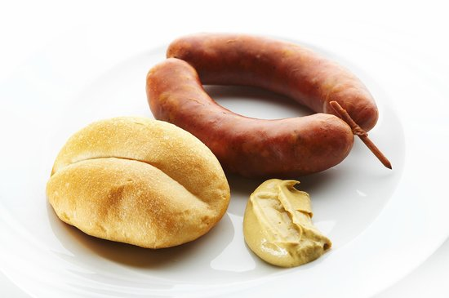
Kranjska klobasa comes from Gorenjska and is based on the rich heritage of processing pork into meat products. It contains at least 75 to 80% pork and at most 20% bacon. It may contain as much as 5% water, the sea salt from Sečovlje, salt pans, little garlic, saltpetre and black pepper. No other ingredients are permitted. The sausages are hot smoked and heat-cured at about 70 °C (158 °F)
POTICA
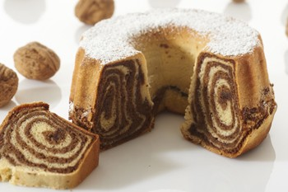
INGREDIENTS
LEAVENED DOUGH:
- 1 kg flour
- 30 g fresh yeast
- 3-4 egg yolks
- 300 ml of lukewarm milk
- 120 g butter
- 1 teaspoon salt
- 2 tablespoons sugar
- lard for greasing a baking dish

FILLING:
- 600-700 g walnuts
- 200 g honey
- 50 g sugar
- 100-200 ml milk
- 1 egg
- cinnamon, dash of rum or homemade brandy
STEPS
The dough must be prepared in a warm room. Mix the flour with a teaspoon of salt and mix the yeast with a teaspoon of sugar and two tablespoons of flour and 50 ml of lukewarm water or milk. Leave in a warm place to rise. Make a hole in the middle of the flour; add whisked eggs, yeast, melted butter and sugar into the hole. Add the lukewarm milk while stirring. Beat the dough for 15 minutes or until bubbles appear and the dough separates from the bowl. Sprinkle some flour on the beaten dough; cover the dough with a cotton cloth and leave in a warm place to rise. To prepare the filling, crush or grind the walnuts and pour some hot sweetened milk over them. Heat up the honey until it liquefies. Add the honey and cinnamon to the walnuts. Leave the filling to cool off. Add one or two eggs to the filling and mix thoroughly. Roll out the dough until it is ½ cm thick and spread the warm filling over it. Roll tightly and put it in a greased mould. Leave the potica to rise slowly. It will also rise during baking. Before baking, cover the potica with a whisked egg. Bake for an hour; when finished, leave it in the mould for 15 minutes to cool off. Sprinkle the potica with powdered sugar if desired.
GIBANICA (moving cake)
INGREDIENTS (FOR EIGHT PEOPLE):
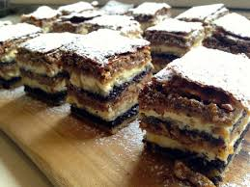
- butter (for the baking tray)
- 400g of flour
- 1 pack of baking powder
- 1 pack of vanilla sugar
- 4 big apples
- rum (if desired)
- cinnamon
- 500g of curd cheese
- 100g of grinded walnuts
- 100g of poppy seeds
- 2,5dL of milk
- 2,5dL of fresh cream
- 3 eggs
- sugar (if decided that it’s not sweet enough)

STEPS:
We preheat the oven to 180 degrees. In a bowl we mix flour, sugar, baking powder and vanilla sugar. We separate the dry mixture into three parts.
We grease the baking tray (30x25cm). We peel the apples, grate them and soak them with rum and cinnamon (if desired). We pour the 1st third of the dry mixture onto the baking tray (1.1) and then spread the 1st half of the grated apples over it. On the apples we smear half of the curd cheese. Over that we put half of walnuts and half of poppy seeds. After we have completed all of that we put the second third of the dry mixture over it. Then we repeat the step marked as 1.1. Lastly the final third of the dry mixture over the entire gibanica.
In another bowl, we mix milk, eggs and fresh cream. The liquid is then poured over the top of the previously created gibanica. After it has completely spreader over the dry components, we penetrate the whole cake with a pointy long object. We repeat that everywhere on the cake, until it is completely soaked.
We bake the cake for 40-45mins. After taking it out of the over we need to wait for it to cool. We recommend serving it with ice cream.
MOČNIK
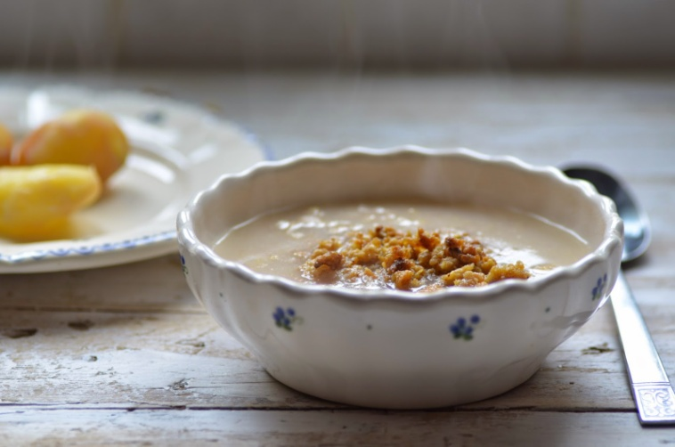
INGREDIENTS
- 2,5 cups of milk
- ¾ cup of flour
- ¼ cup of water
- Salt
- Sugar

STEPS
Add a pinch of salt and sugar to milk. Then put that on the stove to heat it up. In the meantime, mix flour and water in a smaller bowl and try to make small lumps. Then take the mixture and add it to the milk. If you want to make it thicker add more flour. Stir it all together on a lower heat till the mixture boils. If you want, you can also add cocoa on top.

IDRIJSKI ŽLIKROFI
The popularity of idrijski žlikrofi shows no signs of waning and they are among the traditional Slovenian dishes whose production and consumption are growing strongly. According to some figures, around 50 tonnes of them are produced and consumed each year.

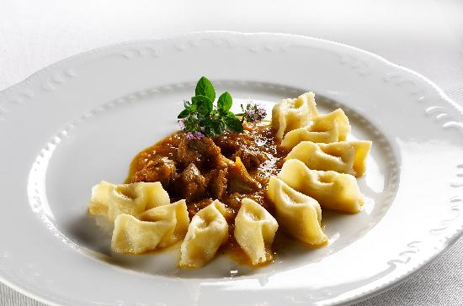
INGREDIENTS
DOUGH:
- up to 300g white flour,
- 1-2 eggs,
- oil,
- water or milk as necessary.

FILLING:
- 500g potatoes
- up to 50g minced lard or chopped smoked bacon
- up to 50g onion.

Seasoning: chives, black pepper, salt, marjoram.
STEPS
Mix together the ingredients for the dough, which should not be too hard. Knead the dough until it becomes flexible and elastic and does not stick to the hands or the board. If the dough is cut it must be dense and without air holes. Form the dough into a loaf and leave to rest for 30 minutes. Then roll it out thinly.
In the meantime, prepare a filling from boiled and peeled potatoes. Mash the potatoes when still warm. Season with salt. Fry and chop the smoked bacon and add to the potatoes (alternatively use cracklings or minced lard). Mix in the fried onion and seasonings. Mix well and knead until the mixture is soft. Form the mixture into hazelnut-sized balls.

AJDOVI ŽGANCI/BUCKWHEAT ŽGANCI
Žganci can be found all over the country but is prepared differently in each region. The essence of žganci, however, stays the same. It is rich in energy giving carbohydrates. It is one of the essential ingredients of traditional cuisine that in its time corresponded to people’s possibilities and needs.
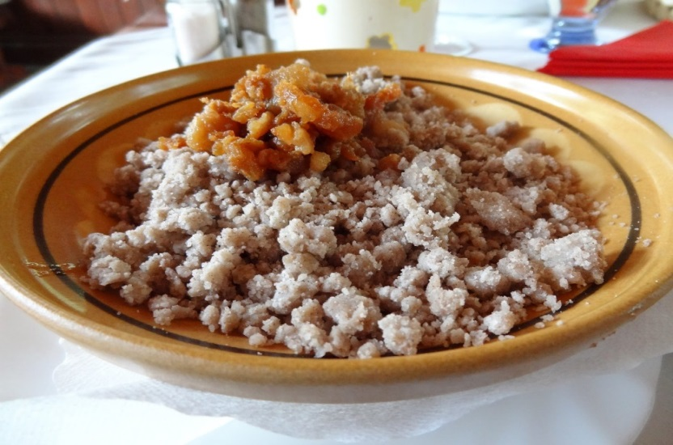
INGREDIENTS:
- 1 kg of buckwheat flour
- 100 g of cooking oil
- 150 g of cracklings
- Salt
- Water

STEPS:
Boil 3 litres of salted water. Pour the flour into the boiling water to form a lump. As the water quickly covers the lump and boils, lower the temperature. Make a 2–2.5 cm hole in the lump with the handle of a wooden spoon. Cover the pot and let it simmer for 40 minutes. Remove from heat. Strain off the žgančevka and save it for later. Stir the lump thoroughly. If the žganci appears too dry, add some of the decanted žgančevka. Scoop from the pot with a wooden spoon and crumble into a bigger bowl with a fork.
Top with lard and cracklings, stir, cover and let it sit for a few minutes.

POVITICA
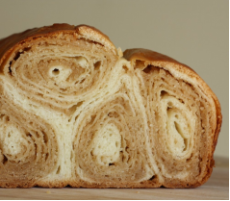
INGRIDIENTS FOR 10 PERSONS:
FILLING:
- 500g of cottage cheese
- 2 eggs
- 2 spoons of sugar
- 150g of soften butter
- 4 spoons of heated cream
- 2 pinches of salt

DOUGHT:
- 500g of flour
- 3dl of water
- 1 egg
- 2 spoons of oil
- a pinch of salt
STEPS:
Firstly, we mix all of the ingredients for dough in a big bowl and form a loaf from them. We apply oil coating and leave the loaf for around 30 minutes.
On the working surface we lay a big sterile tablecloth and sprinkle it with flour. Next we roll out and stretch the loaf which we prepared in the beginning.
Continuing we mix all the ingredients for the filling in a bowl and spread them on the dough evenly. With the help of the tablecloth, we make a roll from the dough, which we cover with butter.
Povitica is baked for 40 minutes on 180°C.

