**Ceramic tiles and their history**

**.Portuguese Ceramic Tiles.**



**.Cátia Sanches.**

**.Highlander Marley.**

**10ºZD**

**ALGARVE**

**2016/2017**

**Index:.**

* Cover
* Index
* Geometric transformations
* Ceramic Tiles over the centuries
* Patterns

_ a comment of Manuel Cargaleiro

* XX century evolution in the use of patterned Tile

_ Ana Salazar

* 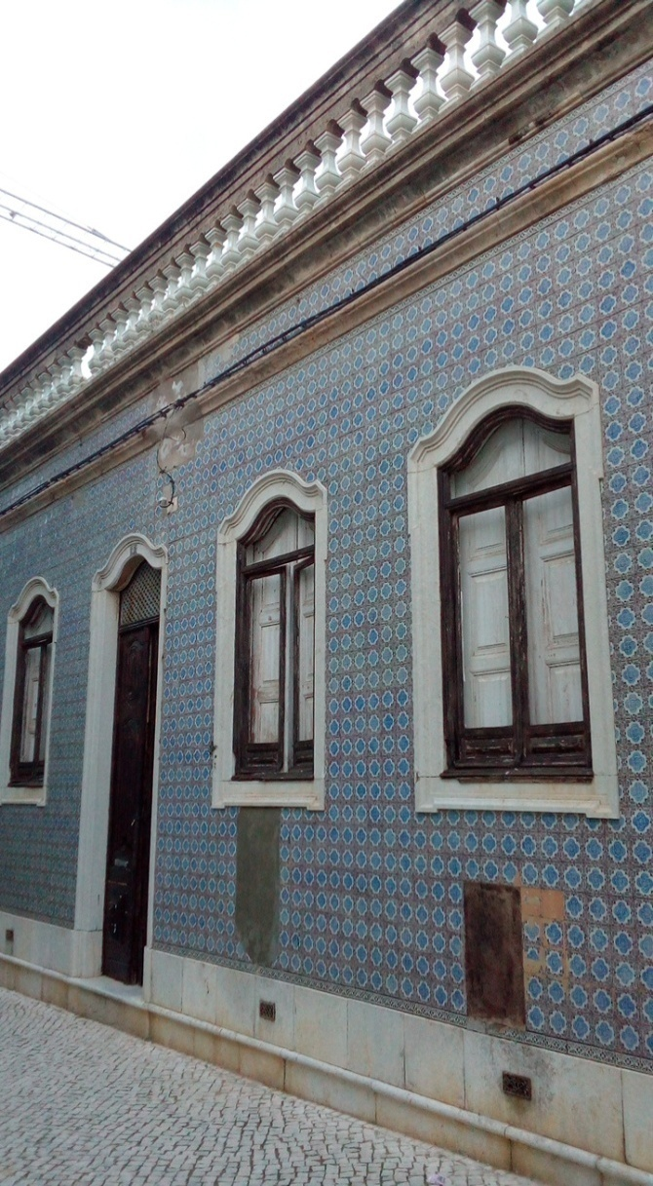Bibliography



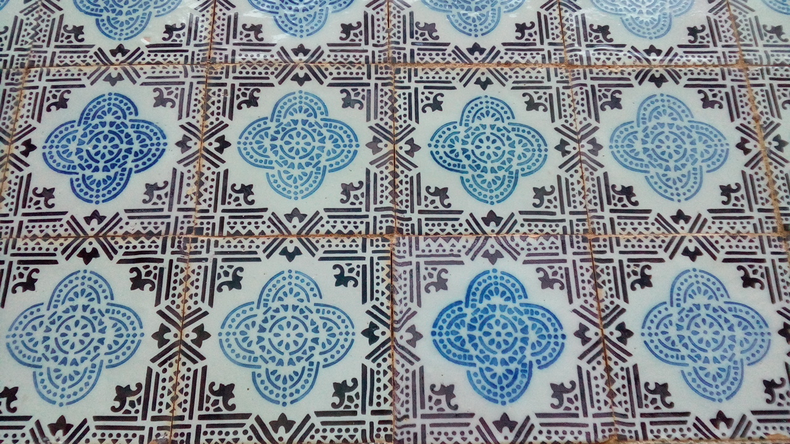**Geometric Transformations**

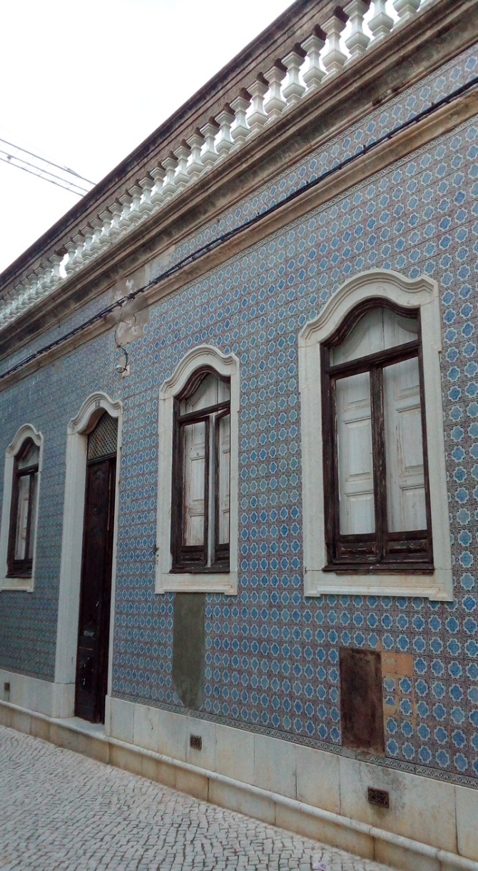

In this case, this present’s every geometric transformations such as translation, rotation and symmetry.

**Ceramic tiles over the century**

The art of the glazed tile or “azuleijo”_ a word originated from the Arabic al-zuleycha, meaning small stone_ is a legacy of Islamic culture left to the peoples of the Iberian Peninsula after the Reconquest.

In the 14th and 15th centuries pieces of mosaic of different forms were used in the south of spain. When the arabs were finally expelled from the Península, the Spanish kings continued to use glazed tiles in their constrution, at the close of the 15th century, the Seville and Málaga workshops exported their “mudéjar” or Hispanic-Arabic tiles to Portugal.

At the beginning of the 16th century in Portugal the ceramic tiles were no longer imported from spain, this period marked the beginning of a national output.Portugal´s loss of independecen in the 16th century along with the Spanish occupation was to lead to a Great expansion in the production of glazed tiles where different influences were seen:. Italian,Flemish and Andaluzian. This was the resulto f trade links enjoyed by this country facing the sea. Phillipe II lived in Lisbon for 2 years and began construting numerous buildings, the role of the glazed tile became more and more decorative and the repetition polychrome motifs produced a geometrical carpet effect, covering whole walls, inside these buildings.

Untill the beginning of the 19th the glazed tiles was used as an interior decoration for both reliougous and private buildings, occasionaly in the gardens appertaining to a private pallace as well. The period of the Napoleonic wars coincided with a serious economic crisis which, according to many, corresponded to a declining in the art of glazed tiling. In fact production virtually came to a standstill and was only to pick up following the signing of na economic treaty between Brazil and Portugal. It now wished to please a new bourgeois clientèle which covered the façades of their homes with ceramic tiles, thus provinding colo rand cleanliness to the sombre streets. Such a tendecy grew stronger throughtout the 19th and 20th centuries.

**Patterns**

.A comment of Manuel Cargaleiro.

“Patterns have no history, they are so old they go back to early man.

When man began to repeat the first symbols he began to make patterns. Patterns exist in everything, everywhere. In Autumn they are formed by the patterns of the leaves from plane trees, eucalyptus leaves, fig leaves.

Nature makes patterns.

I’m always finding patterns and thinking about repeating them. To me, a pattern is doing always the same thing, but always doing it in a different way.

Man as remembered and repeated patterns for thousands of years.

In repetition there must be Invention.

That is Creation.

What a great pity it is that patterns have become so debased nowadays.

Patterns on houses should be approached with thought and care. Lovely as they are, it is a waste just to copy XVII century patterns, it´s better to create others of aesthetic value in keeping with our times.”

**XX century evolution in the use of patterned Tile**

**.Ana Salazar.**

Ana Salazar Styliste- Symbole de la Movida lisboete; In 1991 she was given a licence for a Project “moda Cerâmica” (“Ceramic fashion”) and creates patterned wall tiles which are produced by the Recer factory.

These are one unit patterns, each tile having a border, and they are used along with plain tiles in a range of especially chosen colours, normally being applied on interior walls.

The tiles are inspired by Art Deco designs or traditional tilework.

In the series, “colagem” (“collage”), and are made up of various designs from other tiles by Ana Salazar, the technique used being reminiscent of paintings by Joaquim Rodrigo.

**Bibliography**

* Tiles over the centuries(the book 1994);
* Portuguese ceramic tiles-XX century patterns (the book Lisbon 1998, by Teresa Saporiti);
* Photography by Lina Campos(math teacher) in faro, little house in faro decorated with Portuguese XX tiles.