RECIPE OF TURKISH TRADITIONAL FOOD “KISIR” WITH GREEN HERBS

2 cups of bulgur
1,5 cups of hot water
2 tablespoons of tomato paste
1 teaspoon of olive oil
Salt, lemon juice,
Fresh onion, Fresh mint, Parsley

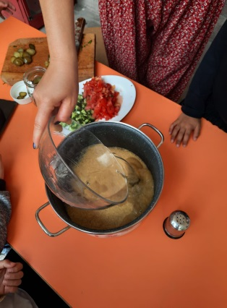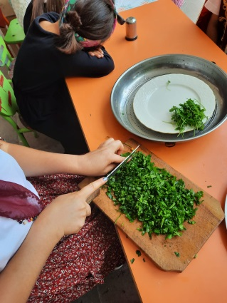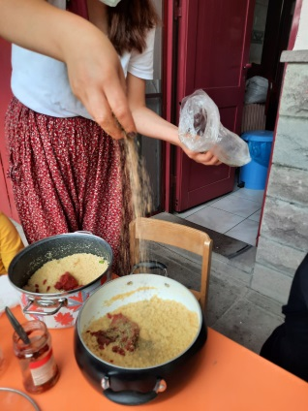

1.Take the bulgur in alarge bowl. Add 1.5 cups of hot water to it.
2.Cover it and wait for the bulgur to swell.
3.Add tomato paste, salt,limon juice,olive oil to it.
4.After adding the chopped fresh onions,fresh mint and parsley and mixing them, it isready to serve.

