30.08.2020. Presentation of Erasmus + program to kindergarten teachers of Szekesfehervar
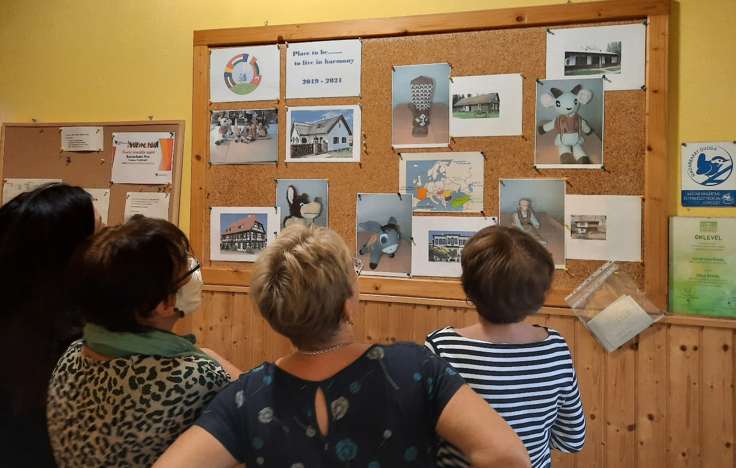

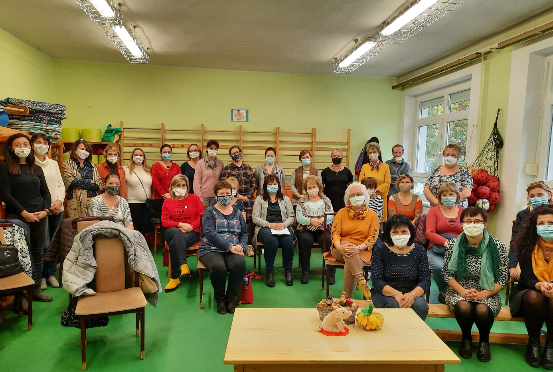

27.05.2021. Exhibition of Europe Village,
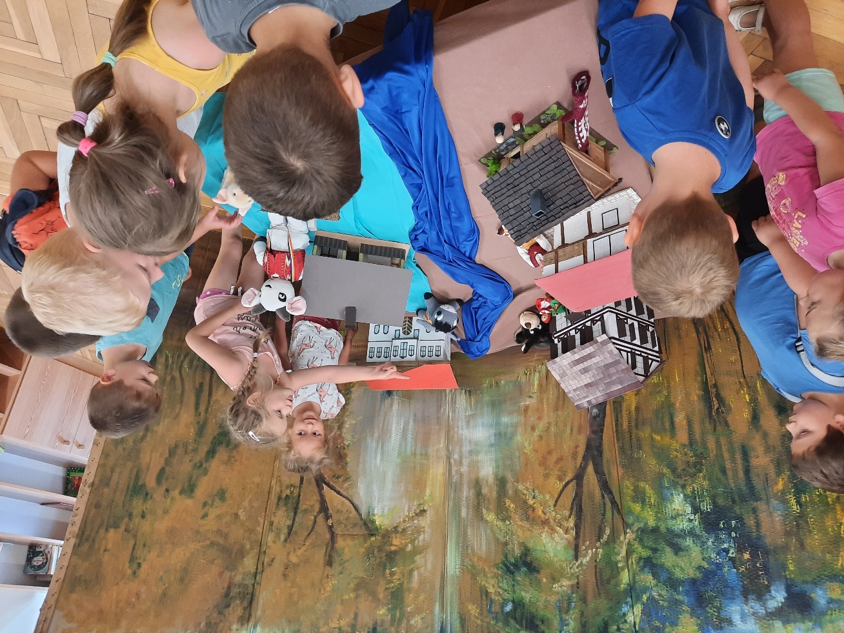
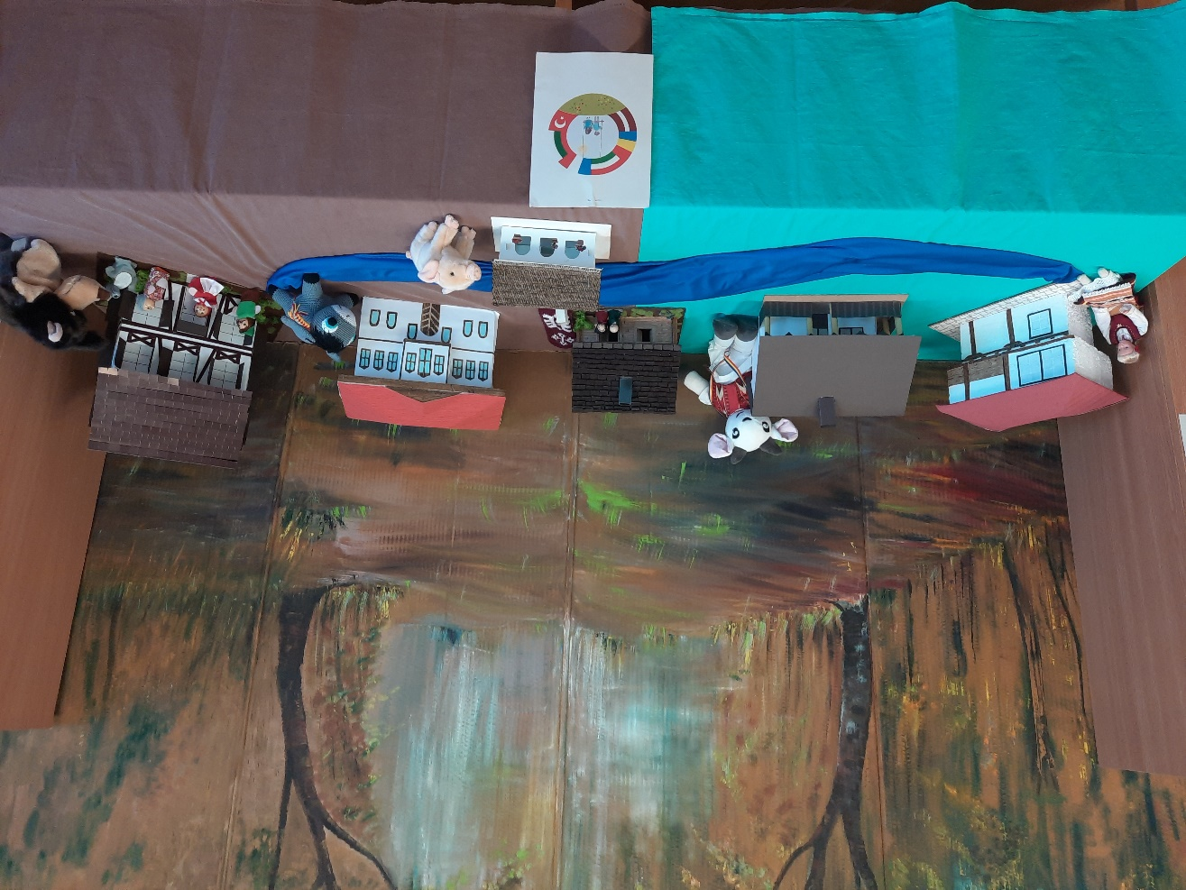

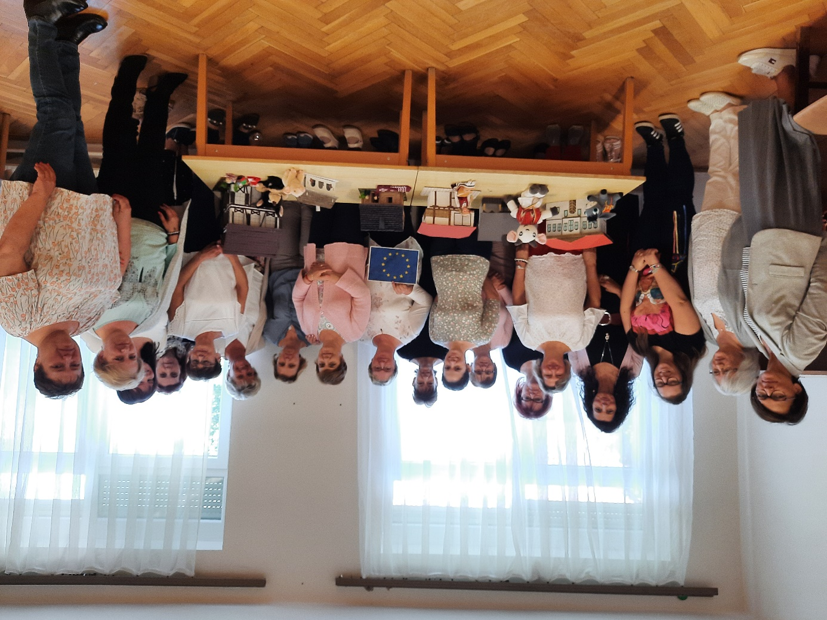

28.01.2022. Presentation Erasmus+ project to parents and kindergarten teachers of Székesfehérvár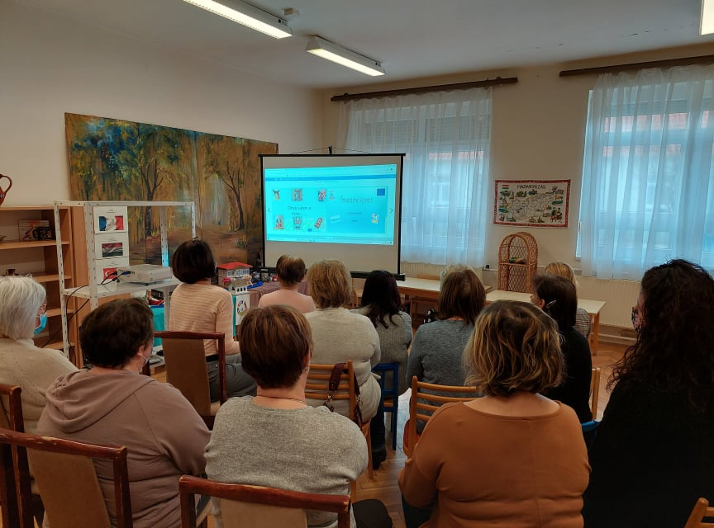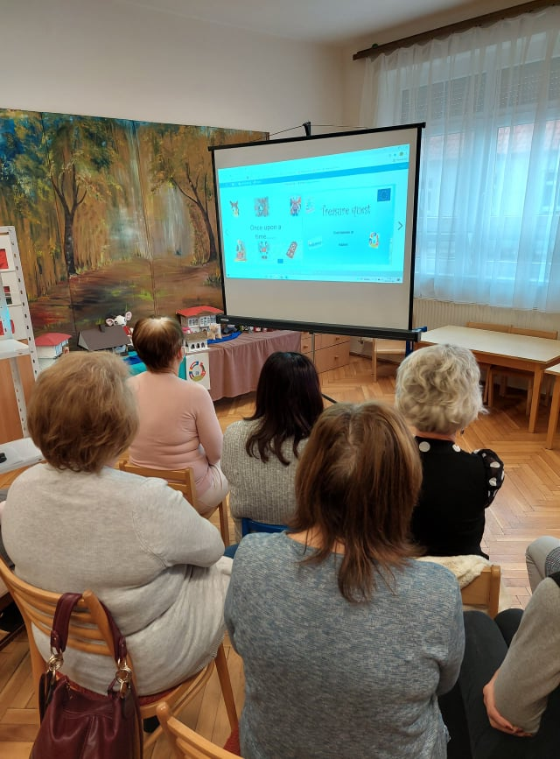

This is the webpage of our kindergarten: https://szivarvany-ovoda.hu/erasmus-2019/

