- Building that effect the climate
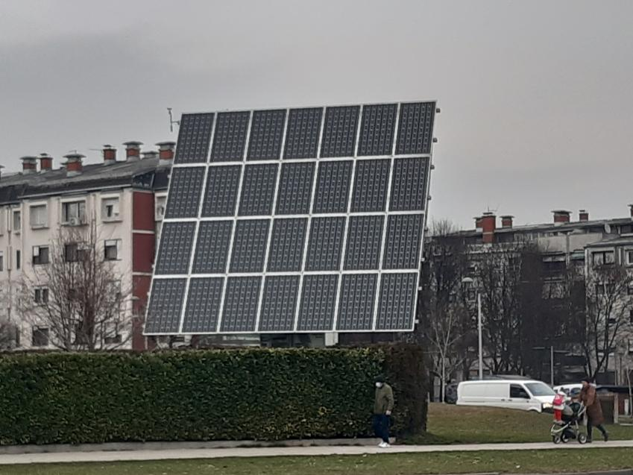
Solar panels are next to houses so that houses can use the energy of the sun because that energy cannot be consumed.

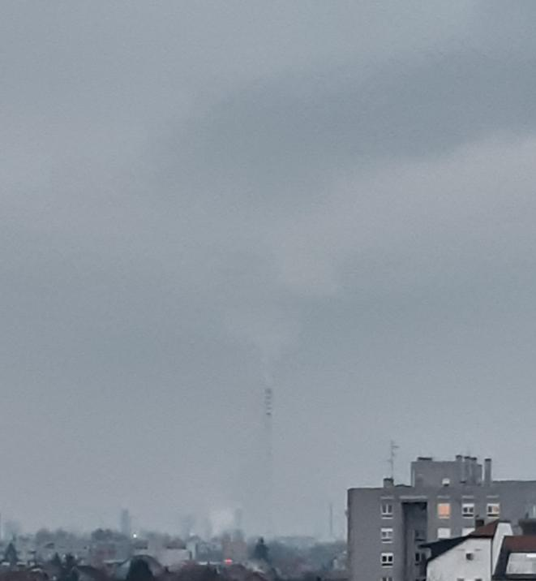
Factories negatively affect the climate because they emit gases that affect global warming.

- Human actions that effect the climat
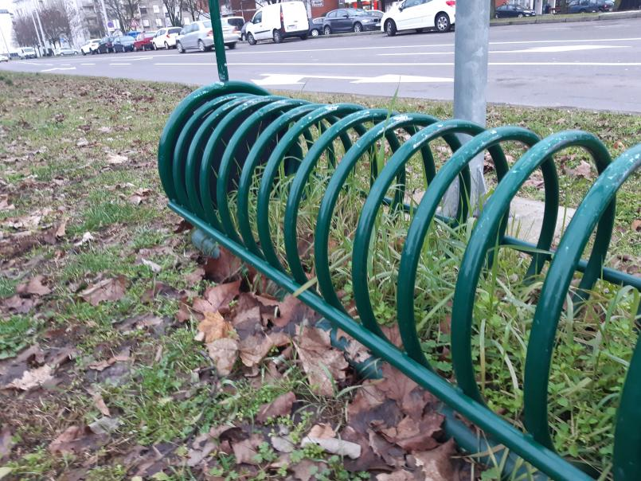
The bike rack encourages people to ride bikes which is much more environmentally friendly than riding a car.

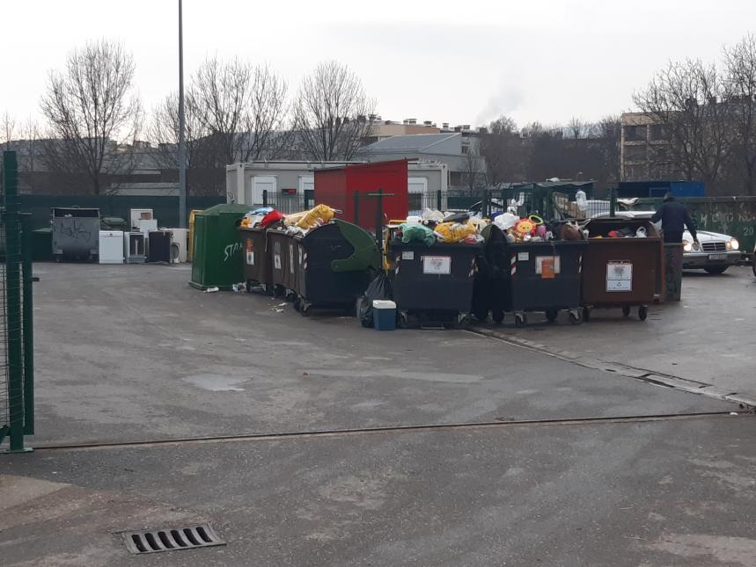
Recycling yards are places where we sort waste so we can then reuse it.

- Systems natural that affect the climat
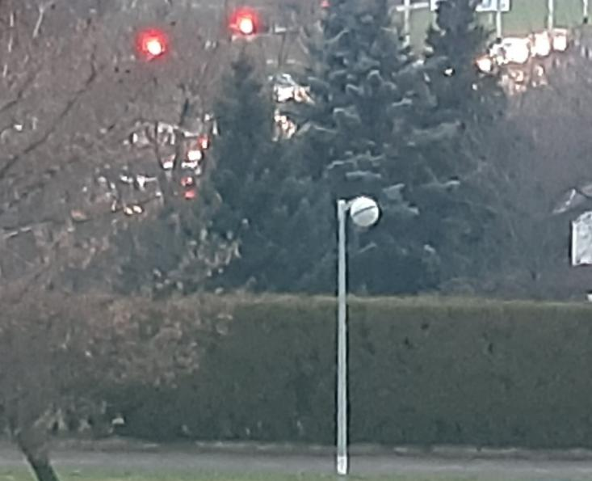
The trees planted in the yard give us extra oxygen and purify the air.

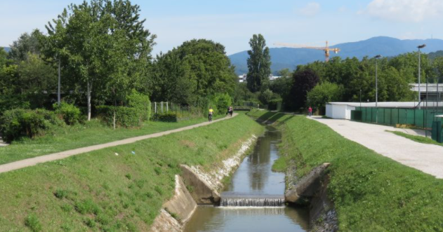
The stream evaporates and then there is more moisture in the air and it is home to many animals.

