The contrast between past times and present.
The photos represent the four civic topics that we are working on in this project: cultural identity
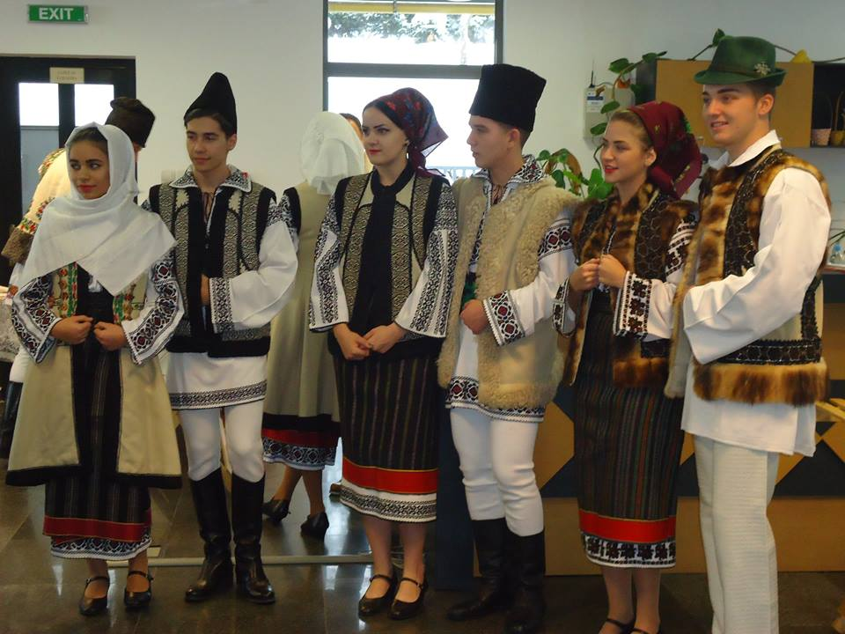
The popular port of Bucovina (northern region of Romania)
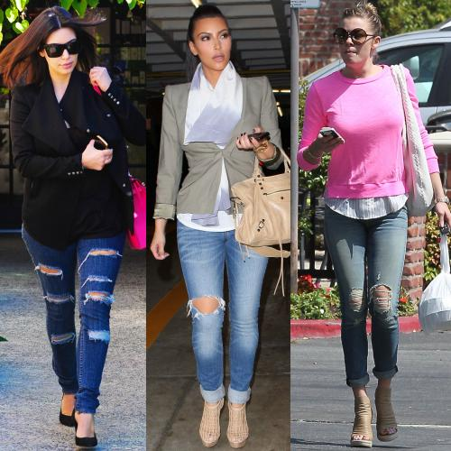
after the 1989 revolution, fashion has changed considerably ...

sustainability
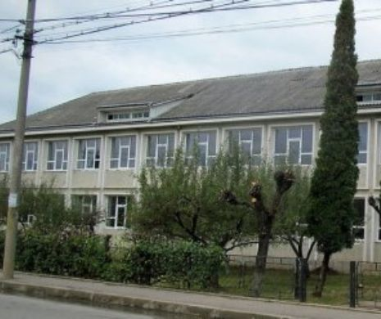
the image represents the building of the general school number 5 from Falticeni
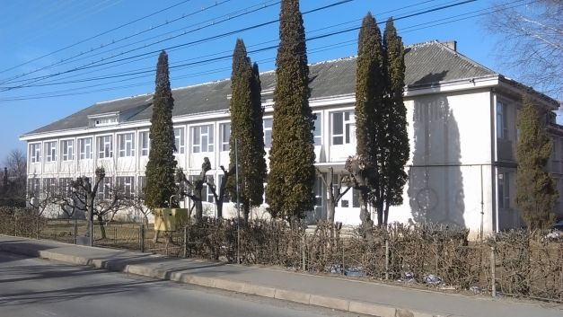
after Romania's entry into the European Union, the school turned into a maternity hospital

technology

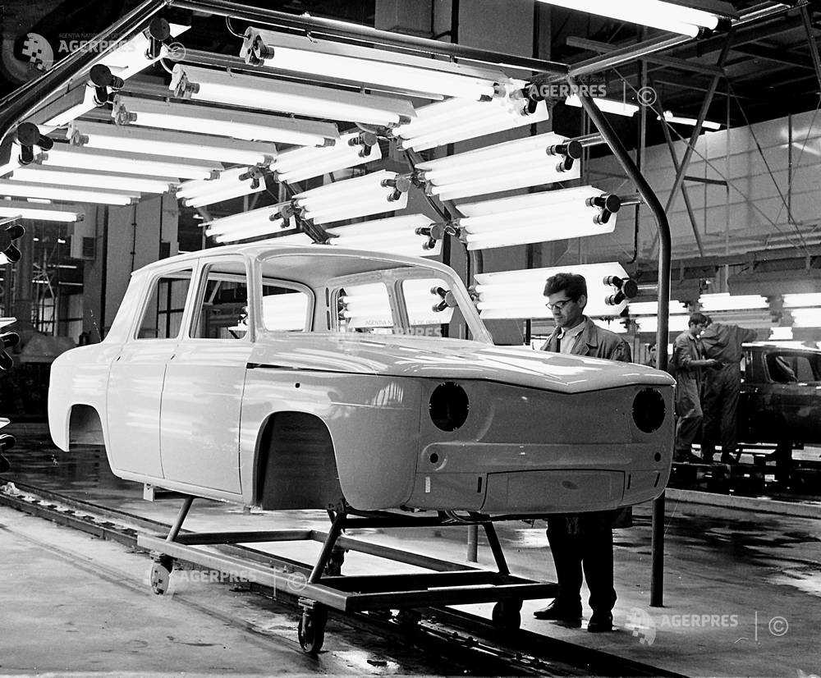
In 1978, the Dacia factory produced the Dacia 1100 model

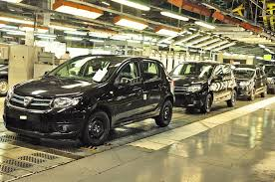
after Romania's entry into the European Union, the factory was taken over by Renault and modernized

tolerance
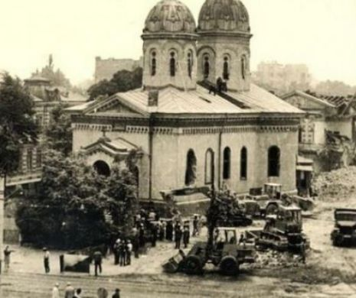
the demolition of the Holy Friday Church in Bucharest under the orders of dictator Ceausescu in the 80s

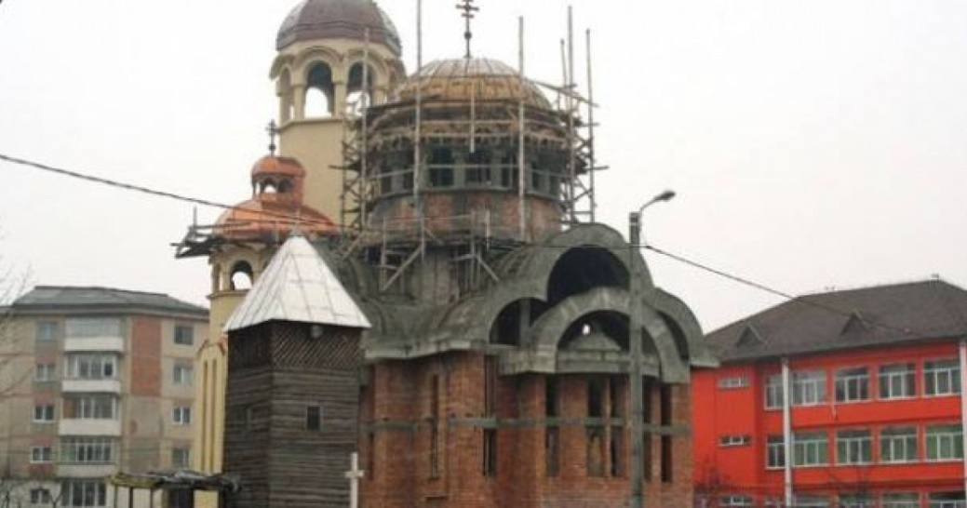
after the Revolution of 1989 in Piatra Neamt over 23 Orthodox churches were built

