1. Choosing the topic of debate - we can make a google doc and each of the students and coordinators can vote for one of the proposed topics
2. Creation of teams - I come up with the following proposal, in alphabetical order of the partner countries, as follows: Government Team (GOV) - Italy, Poland, Portugal, Opposition Team (OPP) - Romania, Spain, Sweden
3. After choosing the topic, the teams will meet separately and share their roles (speaker 1, speaker 2, speaker 3 and Reply - which must be only one of the speakers 2 or 3)
4. From here, the documentation begins. Students will look for materials and communicate with each other, within the team they are part of. Of course, they will also be able to ask for help from teachers for guidance.
5, Regarding the judging, I will send the arbitration rules to the coordinators this weekend. It would be ideal to have students judge, but this choice may not work. In this context, I propose to form a team of judges consisting of the 5 coordinating members from each partner country, except me, who will supervise the whole process and will be available to anyone involved in this adventure with explanations and clarifications. more.

How To Judge World Schools Debate

Basic Understanding
World Schools Debate is a unique and dynamic form of debate, unlike any other practiced in the United States. World Schools Debate is a dynamic format combining “prepared” topics with “impromptu” topics, encouraging debaters to focus on specific issues rather than debate theory or procedural arguments. This highly interactive style of debate allows debaters to engage each other, even during speeches. This challenging format requires good teamwork and in-depth quality argumentation.

Getting Started
The judge will fill in the sides and speaker information in the appropriate spaces on the ballot. In order to follow along and evaluate arguments, it is highly recommended that the judge take notes throughout the round. The debate proceeds as follows:
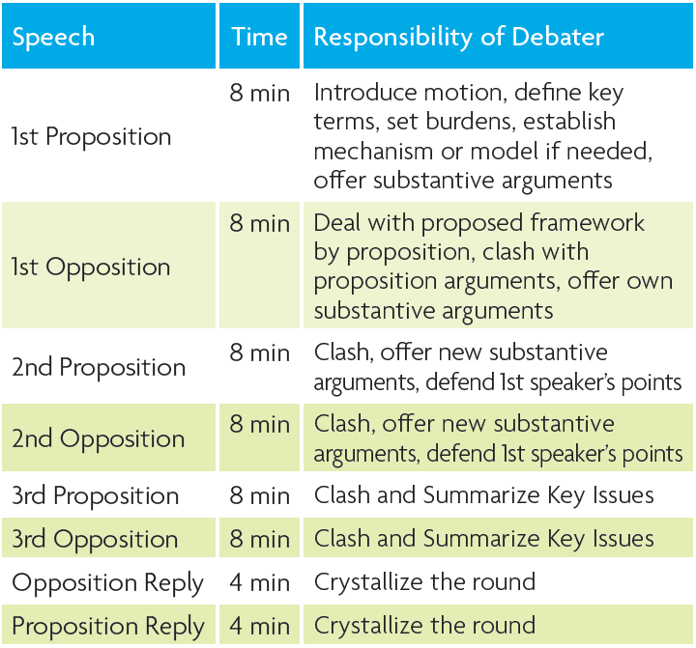

Time for beginners: 5 minutes for Constructive Speeches, 3 minutes for Replies Speeches

EVALUATING THE ROUND

Motions for Worlds Schools Debate are based upon the legislative model. Every motion then begins with the words, “This House”. The debaters are acting as a legislative chamber and debating about what the government would or should do. Motions are debated in a general sense, and are not about extreme or isolated examples. Additionally the debaters ought to imagine that the house is a worldwide governing body that governs all or most of the countries worldwide. Another way of looking at it is that the house represents what each country’s government and/or people would or should do.
The motions debated in the World Schools debate are either motions or propositions of value or policy. A proposition of value will ask debaters to qualify if the topic of the motion is; good or bad, or has done more harm than good, or is better than some other alternative. A policy motion will ask the debaters to create an actual policy that will improve or solve a certain economic, political or social situation given in the motion to be debated. The Proposition team will bring forth a reasonable policy that will solve the problem that is given or being discussed in the motion. The Opposition team can choose to engage with the efficacy of the Proposition team’s “model” or “mechanism” that they’ve given to solve the problem or the Opposition team can offer a solution of their own which they will argue actually solves the problem(s) better than the Proposition team’s mechanism or model.
Finally, the Proposition and Opposition teams should engage with the debate on a principled level and a pragmatic level. The pragmatic level deals with how if we propose or oppose the motion what practical implications will that have in the real world. This is where the use of real world examples plays heavily into the debate. However, in addition to that, the debaters should challenge the assumptions and values of the policies and scenarios that are being discussed in the motion on a principled level.

FILLING OUT THE BALLOT
At the end of the debate, the judge will indicate on the ballot which team won the round and assign speaker points. The first three speeches are scored on a scale of 60-80 with the reply speech being scored on a 30-40 point scale. The total number of points for each team is then tallied, and the winning team must have more points than the losing team. Ties and low point wins are not permitted. Please follow the directions on the back of the National Speech and Debate Association ballot for instructions on scoring. Judges will not on the ballot why they voted for one team over the other. The ballot can also provide constructive feedback to both teams.

JUDGES
Debates are judged by one or more judges. Each judge makes decision by her or himself. After the debate is over, judges give an oral critique revealing the decision, explaining why one team wins and the other loses. Judges make the decision on the basis of three elements: content, style and strategy.

CONTENT/ARGUMENTS
Content covers the arguments that are used, divorced from the speaking style. It is as if you are seeing the arguments written down rather than spoken. The judge must assess the weight of the arguments without being influenced by the magnificence of the orator that presented them.
Content will also include an assessment of the weight of rebuttal or clash. This assessment must be done from the standpoint of the average reasonable person. The adjudicator's job is to assess the strength of an argument regardless of whether the other team is able to knock it down. If a team introduces a weak argument, it will not score highly in content even if the other team doesn't t refute it. First, if a major team argument is plainly weak, an opposing team which doesn't refute it may well have committed a greater sin than the team which introduced it. In effect the team has let the other team get away with a weak argument. This is not an automatic rule, but is true in many cases. Of course, it must be a major argument, not a minor example which the opposing team correctly chooses to ignore in favour of attacking more significant points. Second, adjudicators have to be careful not to be influenced by their own beliefs and prejudices, nor by their own specialised knowledge.

Style
Style covers the way the speakers speak. As has already been noted, this can be done in many ways, in different accents and with the use of terminology which is not so familiar to you. However, there is not just one, the best speaking style, there are different good speaking styles!

Strategy
Strategy covers two main concepts: the structure and timing of the speech, and whether the speaker understood the issues of the debate. These matters are sufficiently important to justify taking them separately.

