Can you guess?

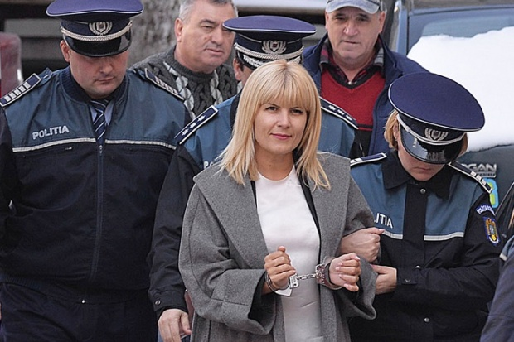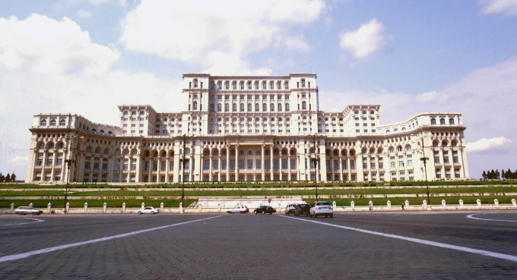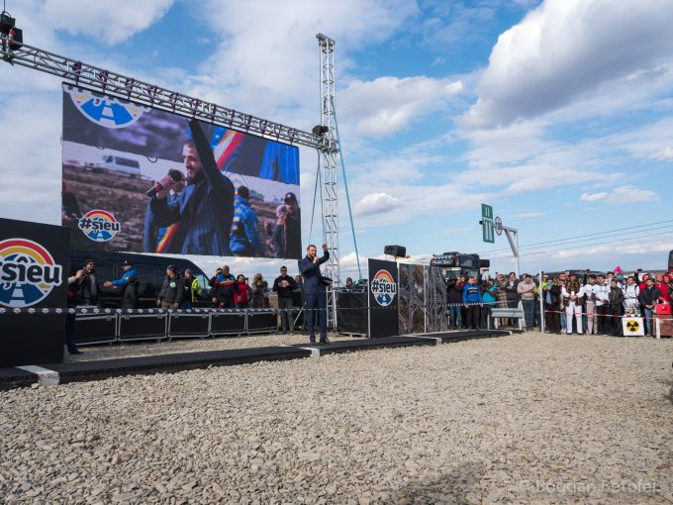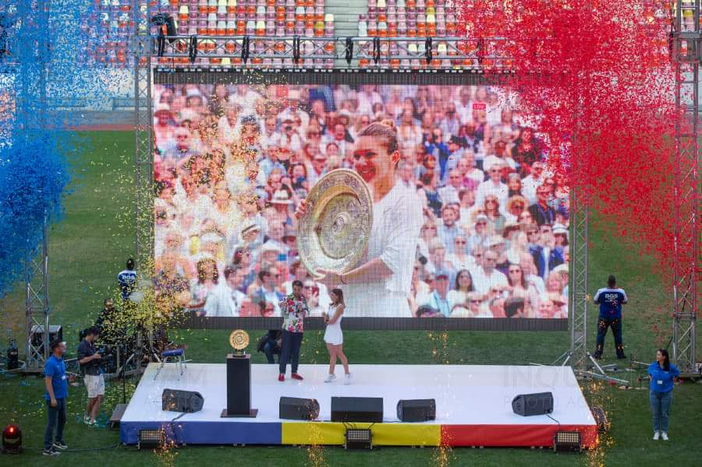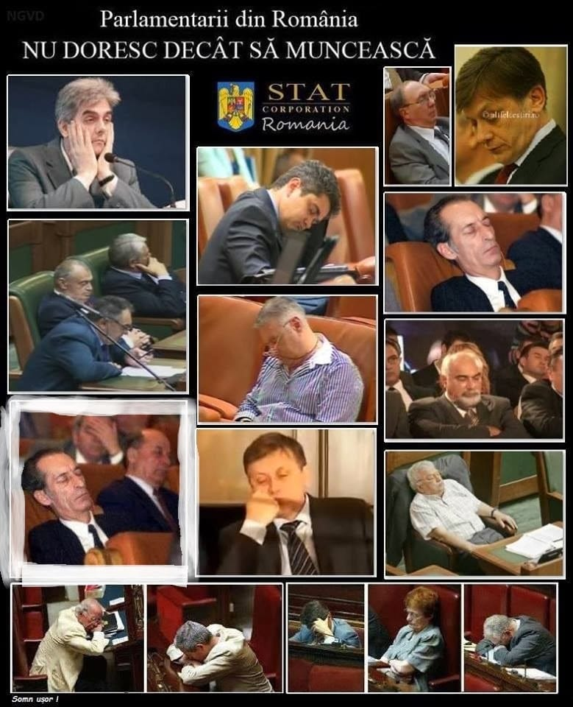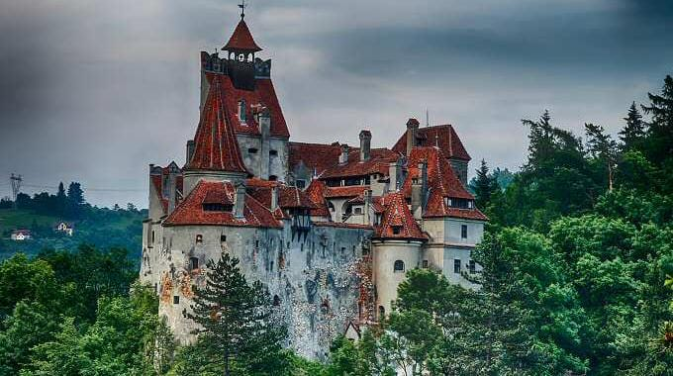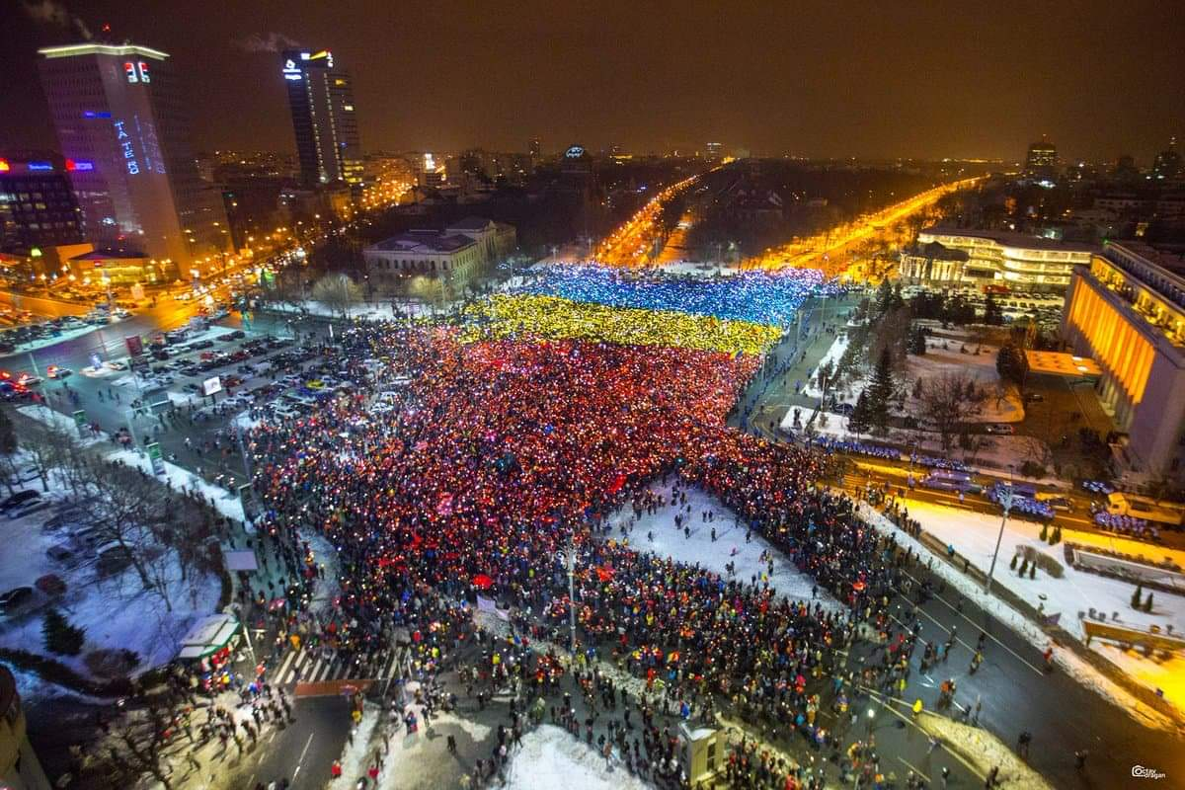For this game, players will be divided in two teams. Team one is team PRO and team two is team BAD. Every team will receive 10 images of Romania and the team PRO has to guess which images represent the good things in our country and team BAD has to find the images who represent bad things. Each team has to say why they picked those photos and what do they think they represent. The team who is closer to the right answers, wins!

