Hi, I want to talk you about theatre in Reunion island. Personally, I started theatre at 7 years old (8 practise’s years), I begun in the city of « Les avirons », I path through several class. But now I do in the city of « tampon » (really farther then « les avirons »). My teacher has a great career behind him, he started with « companionship » in a French company, after that, he created the « saltimbanque » company. And finally, he went to reunion island, here he created the first theatre company in the south of the island. Now he teaches theatre, and I think it’s just the best theatre teacher in the reunion island.
I think we are lucky to be in France, because almost every year we see a drama, it’s the same in Austria? We study theatre too, some classical drama (like « Molière »), but some new too (like « Pommerat »).

Some photos of my last drama (name: vide) :
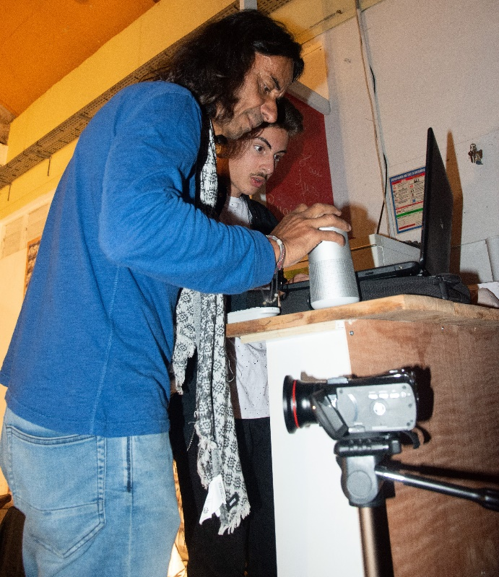 My teacher.
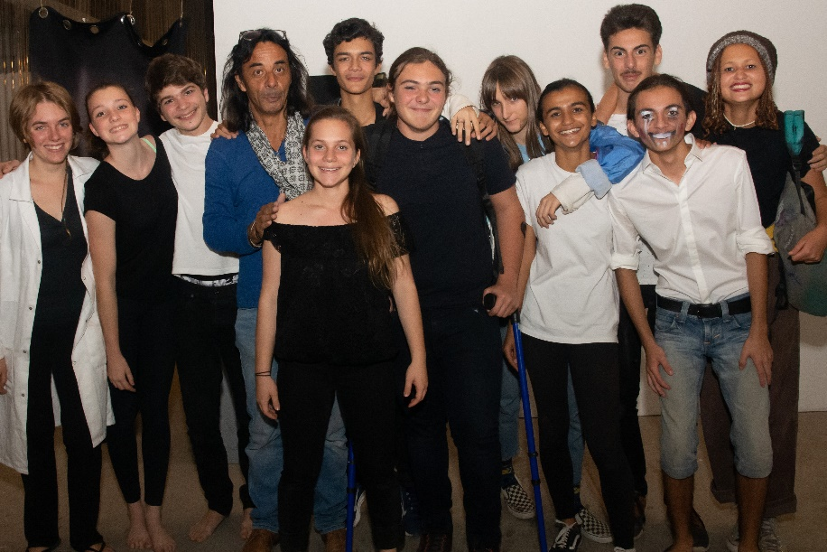 All the company.
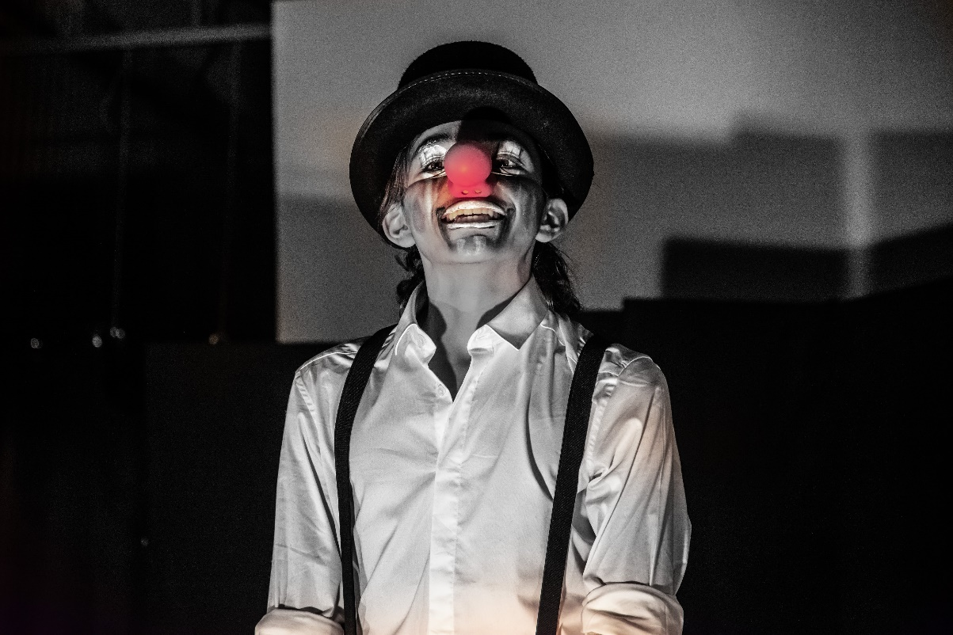
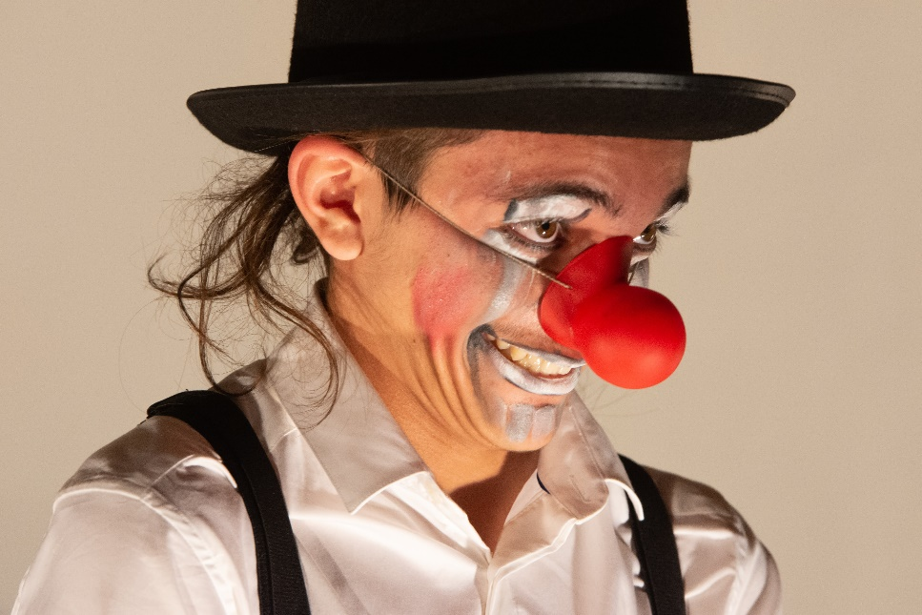
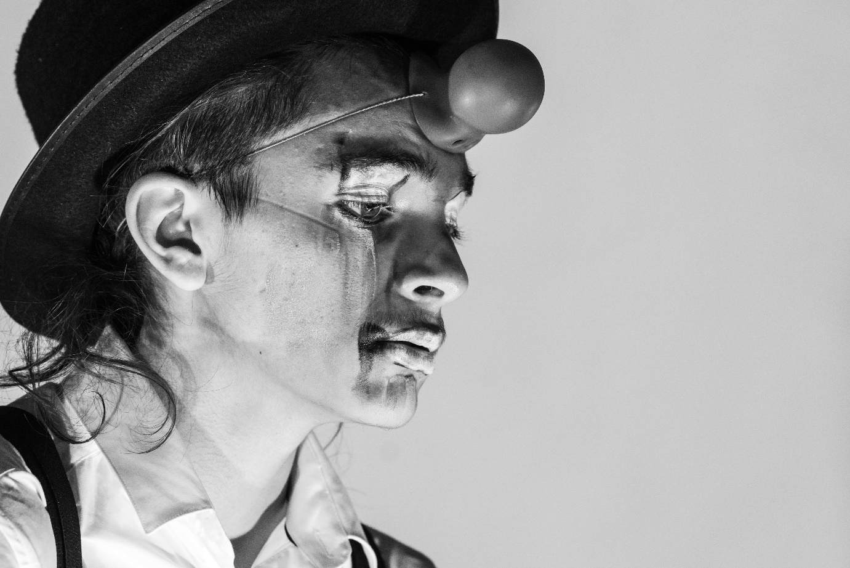
And that’s me.

