ROMANIA | The People’s Palace in Bucharest
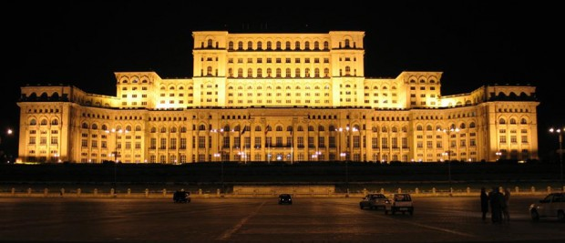 | The People’s Palace, also known as the Palace of the Parliament is the second largest administrative building in the world after the Pentagon. To give you a better idea regarding the building’s size, imagine that its volume is actually 2% larger compared to the Pyramid of Keops. The People’s Palace comprises approximately 1000 rooms, including 4 restaurants, 30 saloons, 440 offices, 2 underground parking lots and 3 libraries.  Tourists are able to visit the Palace daily between 10am and 4pm.

