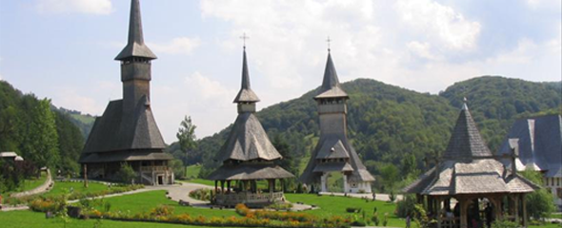  ROMANIA | Barsana Monastery
The village, attested documentary or the first time in 1326 (when King Charles Robert I of Anjou acknowledged and reinstained by a deed in this places prince Stanislau), is host of one of the most beautiful monasteries in Romania: Barsana Monastery, actually a convent with fourteen nuns
Barsana is one of the wooden churches in Maramures, a beautiful synthesis of Eastern and Western European architecture, with Gothic and Byzantine elements. The church was manually carved by some of the most talented craftsmen from Maramures. he frescoes are very similar to those of the painted monasteries of Moldavia. This Wooden Church is the only one with double cornice, the Old Monastery, the tallest wooden building in Europe (62 m tall).
No power tools or nails were used to put this impressive construction together. Its beauty and uniqueness made it one of the eight churches in the region that UNESCO designated WORLD HERITAGE site. The monastic compound is made of wood as well, according to the local tradition. Only Barsana craftsmen are building the compound, under the direct supervision of architect Dorel Cordos. Today you can admire the Maramures gate, the belfry, the church, the summer shire, the house with cells and chapel, the house of the masters, the house of the artists and a more recently arranged museum portraying the Maramures history, culture and civilization.

