CHRISTMAS IN SICILY. NATIVITY SCENES, BONFIRE, SCACCIATA AND ZICCHINEDDA
Christmas in Sicily is rich in sacred, profane and gastronomic traditions.

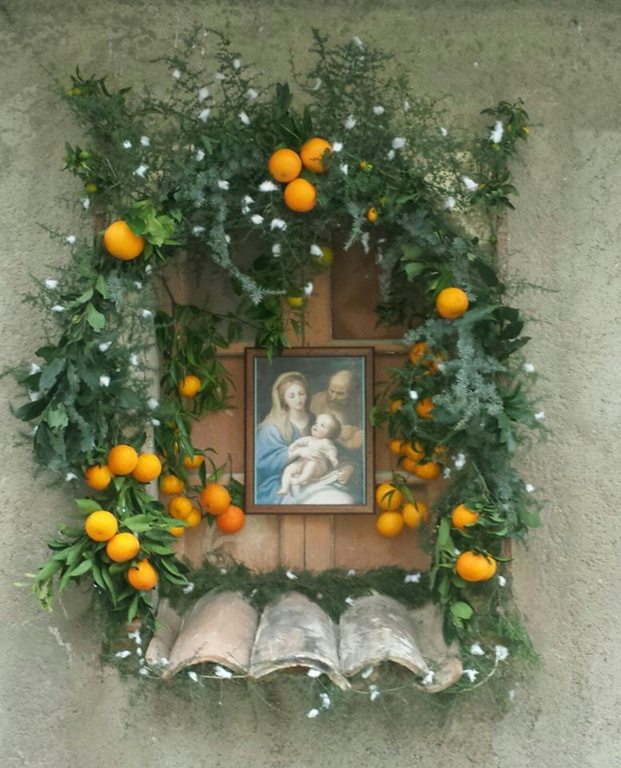 | In the past, after the 8th December, when we celebrated The immaculate Conception of the Virgin, people started decorating the trees and the traditional Nativity scene was prepared.  In the streets the Cona, icons representing the Holy Family were decorated with oranges, dried figs and cedar. The families in the neighbourhood met near the icon from the 16th December to the 24th, for nine days and passed the evenings praying, chatting and telling stories. Only the 6th January children could eat the fruits adorning the icon.

CRIBS
The tradition of Cribs is very much felt in our territory.

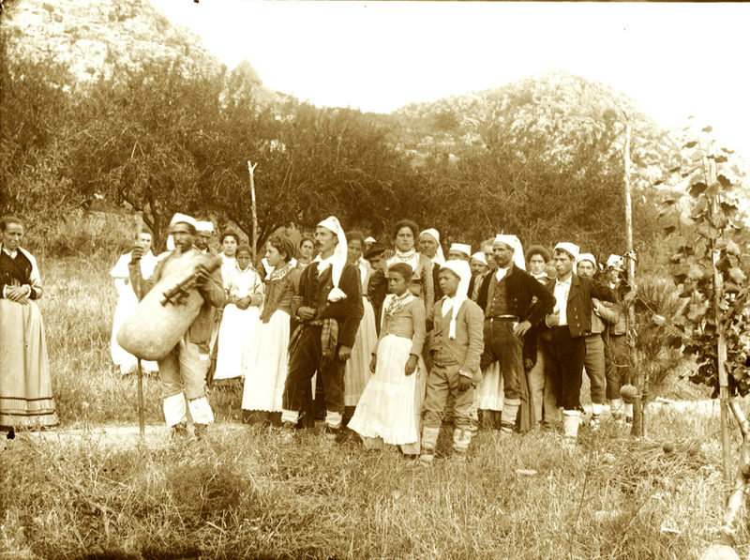 | Some villages are transformed entirely into living cribs, where the inhabitants, hearing the sound of the bagpipes, stage the ancient crafts.  In the photo you can see a group of people wearing traditional sicilian costumes an a ciaramiddaru, the person playing a bagpipe on the left.

Wilhelm von Gloeden (1856-1931)

Lo zucco, the bonfire
Another tradition still alive in many cities of eastern Sicily is that of the Zucco, a bonfire which is lit on Christmas Eve in front of the churches.

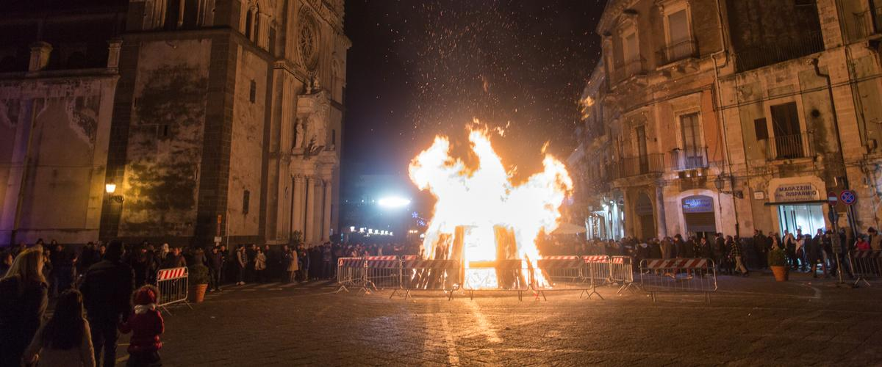
The bonfire in Acireale, an old Baroque town near Catania

This tradition has pagan origins that comes from the fires lit in ancient times during the winter solstice.
In a Christian way it is considered as the fire that warms Jesus or that illuminates the road to the hut.

CHRISTMAD DINNER

The women of the house begin to talk about the dinner months before Christmas.
You start eating when all the relatives get together, but you do not know when you end up.
These are some typical Christmas dishes:

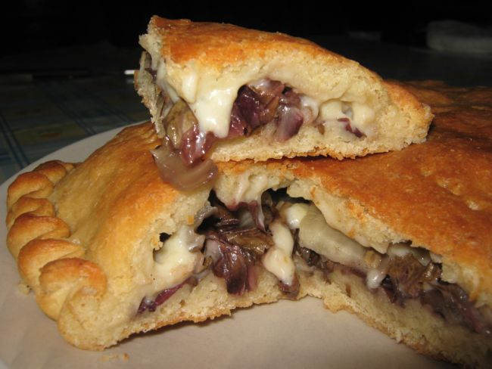
Schiacciata, made of bread, cheese and anchovies.
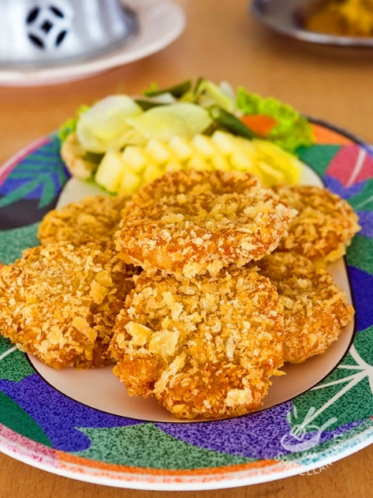
Fried cod
Crispelle, with cheese or anchovies.

Christmas Games

Before the beginning of the dinner people play some traditional games:

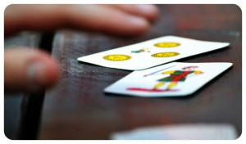Seven and a half
Zicchinedda is a game which became famous the novel "Day of the Owl" by Leonardo Sciascia. The game of Zicchinedda bases its origins in the sixteenth century when the Lanzichenecchi, introduced the game in Italy.

