ROMANIA | The Merry Cemetery, Săpânţa
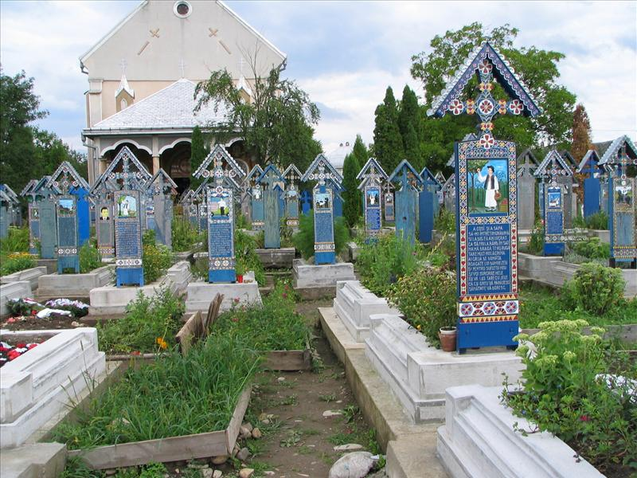 | If you're strolling around in Maramureș, you might as well set your GPS on Săpânța.This place is only about 18km from Sighetul Marmatiei and it is unique not just in Romania but likely in the entire world, because it hosts the only known 'funny' cemetery. You should definitely stop by and not only visit a merry cemetery, but also understand a little more of the Romanian culture, known for its humor and self-irony.  In the village of Săpânța, Stan Ioan Pătraş started carving his first wooden cross of the Merry cemetery in 1935, sculpting bas-relief and writing poems about the deceased. His naive paintings use a bright blue dubbed the “Săpânţa blue”, most probably representing the sky and lots of other vivid colors such as green (representing life), yellow (representing fertility), red (representing passion) or black (standing of course for death). All these colors were obtained from natural pigments, and are well preserved.Walking between the 800 wooden crosses is happy experience. You'll find it hard to hold back a beautiful smile, because every cross will tell you in just a few words the story of a life, of a person, a sad destiny seen through a pair of funny lens.  The villagers from Săpânța defy tragedy - it is said the culture of this cemetery is rooted in Dacian times, in which "passing away" is only seen as passing on to a better and more satisfying life. So if you are in Maramures, stop by and amuse yourself with the stories that all these unique crosses have to tell at the Happy Cemetery in Săpânța.

