ROMANIA | St. Michael's Church, Cluj-Napoca
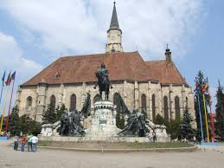 | The St. Michael's Church (Romanian: Biserica Sfântul Mihail, Hungarian: Szent Mihály-templom) is a Gothic-style Roman Catholic church in Cluj-Napoca. It is the second largest church (after the Black Church of Brașov) in the geographical region of Transylvania, Romania. The nave is 50 meters long and 24 meters wide, the apse is 20×10 m. The tower with its height of 76 meter (80 meter including the cross) is the highest one in Transylvania. The western portal is decorated with the three coats of arms of Sigismund as King of Hungary, as King of Bohemia and as Holy Roman Emperor.  The construction was begun probably in place of the Saint James Chapel. The financing of the church was partly done by the citizens, partly from the income of indulgences. (The first related document from 1349, signed by the archbishop of Avignon and fifteen other bishops grants the indulgence for those contributing to the illumination and furniture of the Saint Michael Church.) The construction was completed between 1442-1447, the old tower was built between 1511-1545. The tower that stands today was erected in 1862.The church was converted with the population to Protestantism between 1545-1566. Then the more radical Unitarian patry took it over in the period 1566-1716. At last, it was confiscated in the counter reformation by the Habsburg government supported Catholic Church.

