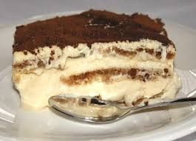
Today Let’s Make Tiramisù

INGREDIENTS:
500 g (1.1 lbs) Mascarpone Cheese
6 egg yolks
250 g (0.55 lbs) sugar
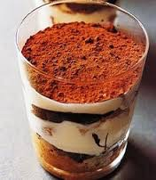
3 egg whites
1 o 2 teaspoons of rum (or other liquor)
A pinch of salt
1 package of Savoiardi (sponge fingers) biscuits (british english) / cookies (american english)
1 cup espresso coffee
Cocoa powder

PREPARATION:
Beat egg yolks and sugar at high speed in a bowl
Add the mascarpone and mix well.
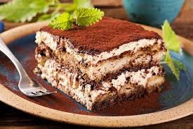
Beat egg whites until foam, adding a pinch of salt and pour into the bowl.
Dip the Savoiardi into coffee and pour in a pan.
Layer some of the mascarpone cream over biscuits.
Repeat all layers.
Top with unsweetened cocoa powder.
Refrigerate at least 2 hours and serve cold.
cooked and eaten!
and merry cristhmas

