 | 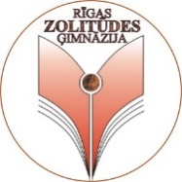 | 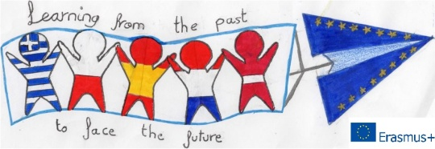

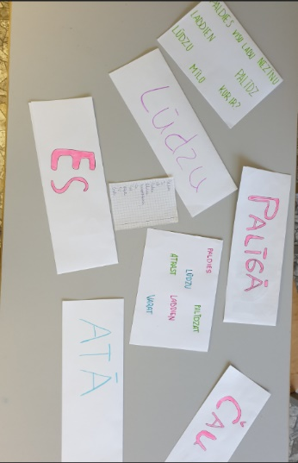
“Learning from the Past to Face the Future”
(2018-1-PL01-KA229-051241_1 )
Most necessary words
English | Latvian
Hello | Čau
Good morning | Labrīt
Good afternoon | Labdien
Good evening | Labvakar
Good night | Ar labu nakti
How are you? | Kā tev klājas?
I’m fine. | Labi
Thank you | Paldies
Sorry | Atvaino
Please | Lūdzu
Cheers | Ar Dievu. Uz veselību.
Bye | Atā

