 | 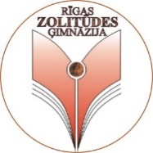 | 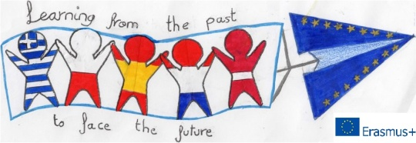
“Learning from the Past to Face the Future” (2018-1-PL01-KA229-051241_1 )

VISIT to RIGA PLAN FOR TEACHERS

TIME: FROM 13th October TO 19th October 2019 (3RD Mobility IN LATVIA)

 | ACTIVITIES
Sunday 13th
 | Arrival, meeting at the airport  13:05 - Greece  13:25 – Poland  21:50 – Spain  13:35 - Netherlands  Going to the hotel by taxi. |  |  |  | Families should be on time!
Monday 14th
9:15 | Meeting at Rimi shop.
10:00 – 11:35 | Ice breaking activities. Workshop on Nametags.
11:40 – 12:50 | Excursion around the school.
13:00 – 13:30 | Dinner at school canteen. |  |  |  | Canteen - 1st floor
13:45 – 14:00 | Division for buses:  1. group – Netherlands and Poland. (at Rimi shop car park)  2. group – Spain and Greece (near school).
14:30 - 16:30 | Going to Lāči (Bread Production Factory). Bakers’ Expedition. (Jobs, tools, history, cooking and degustation).
16:40 – 17:30 | Going home, staying with host families.
19:00 | Restaurant “Balzambārs” (Old Riga)
Tuesday 15th
9:00 | Meeting at school.
9:20- 10:00 | Coffee and snacks. Teachers meeting and project discussion about the visit to Spain. Coordinator’s speech and futher instructions.
10:10 – 10:40 | Workshop on Posters.
10:50 – 11:20 | Workshop on Most popular and necessary words to know in Latvia.
11:30 – 12:30 | Swimming pool.  For those who cannot swim – playing games. |  |  |  | Swimming suits!
13:00 – 13:30 | Dinner at school canteen.
13:45 | Bus to go to Laima (Chocolate Production Factory).  1. group – Spain and Griece with their hosts (at Rimi shop car park).  2. group –Netherlands and Poland with their hosts (near school). |  |  |  | Division for Buses!
14:30 – 16:30 | Excursion to Chocolate World (history, equipment, degustation, etc.).  1. group – Spain and Griece with their hosts and teachers.  2. group –Netherlands and Poland with their hosts and teachers.
17:30 | Going home, free time.
Wednesday 16th
8:00 |  | Meeting near Rimi. |  |  | Choose the most comfortable shoes and clothes!
8:15-11:30 |  | Trip to Venspils.
12:00 – 13:00 |  | Ventspils Creativity House Planetarium and Observatory. Star show.
13:00- 13:45 |  | Lunch
14:00 – 15:00 |  | The Castle of the Livonian Order.
15:30 |  | Hiking near the Sea, visiting Seaside Park.
16:00 – 16:30 |  | Driving a small Old style train. |  |  | Have fun!
16:30 |  | Going home
19:30 |  | Going home, free time.
Thursday
8:15 |  | Meeting next to the school. Going to the train. Buying tickets.
8:37 |  | Train to the centre.
9:00 – 10:30 |  | A guided excursion around Old Town.  - The Monument of Freedom  - Opera House  - Dome Cathedral,  - Saint Peter’s Church,  - Blackhead’s house (+guide),  - Etc.
11:00 – 11:40 |  | Lunch.
11:45 – 12:00 |  | Walking to the Library, sightseeing, crossing the bridge.
12:00 – 15:00 |  | Visit to National Library. Workshop on Graphics and excursion:  1. group – Spain and Netherlands with their hosts and teachers.  2. group – Greece and Poland with their hosts and teachers.
15:30 |  | Going home, staying with host families
Friday
9:15 |  | Meeting place at Opera House. |  |  | Choose the most comfortable shoes and clothes!
10:30 |  | Trip to Sigulda. Buying tickets and waiting for the guide.
11:00 – 12:00 |  | A guided excursion around Turaide castle. Workshops -Visiting the Chief Judge of Turaida.  1. group – Spain and Griece with their hosts  2. group –Netherlands and Poland with their hosts.
12:00 – 12:30 |  | Lunch. Excursion around the town.
12:30 – 13:30 |  | Free time to explore the National Historical Park.
14:00 – 15:30 |  | Visit to Gutman’s Cave. The legend about a Turaida Rose. Hiking.
18:00 |  | Returning to Riga. Evening with host families.
Saturday
 |  | Departure.  06:10 – Poland.  07:45 – Netherlands.  13:30 – Spain.  13:50 – Greece. |  |  | Be two hours before the departure!  We will miss you!

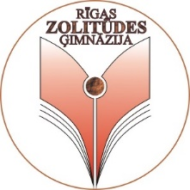
SOME INTERESTING FACTS:

When Latvians talk about their land national identity, nothing would describe it more exactly than a real rye-bread.
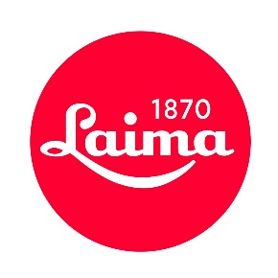
The bakery “Lāči” uses immemorial cultivated master knowledge and skills to bake the bread. The real rye-bread is baked from the steel cut rye meal, the fermentation process takes place in wooden tubs, the fermentation base is created rather with the starter than with the pressed yeast, bread is baked in a real wood-fired hearth and all this gives a unique flavor and nutritional value to the bread.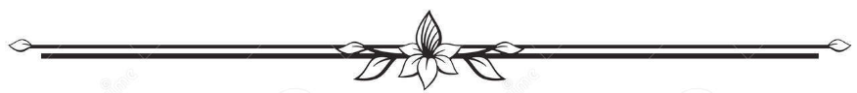
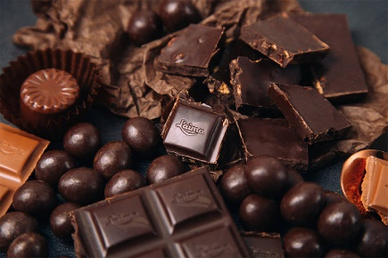
Laima is the largest producer of confectionery in Latvia. Its headquarters are in Riga. It is named for Laima, the goddess of fate in Latvian mythology. Even though the history of chocolate production in Latvia goes back many years, Laima was established in 1925, and still to this day is the leading local chocolate company in the country, which has survived Latvia’s turbulent history. Love is the greatest value of Laima chocolates and the main secret behind its unrepeatable taste and aroma. At present, Laima is one of the few food industry enterprises in Eastern Europe, which produces more than 90 kinds of candy and chocolate products directly on the spot, and by-products from various regions of the world are delivered to the shop premises.
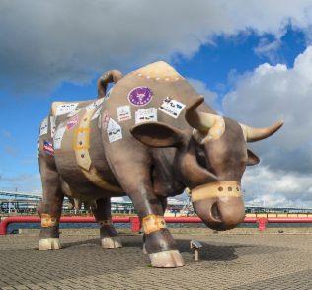
Ventspils. Founded over 700 years ago, Ventspils is one of Latvia’s oldest ports, and the smell of the sea and the wind blowing through your hair are constant reminders of the maritime heritage. The riverside promenade is rich in interesting monuments, and the city is sprinkled with reminders of the Cow Parades, in which artists imaginatively decorate bovine figures. Some are auctioned for charity but over two dozen remain to bring colour and joy to the streets. Ventspils is a busy and hardworking port, but there are also tons of things for kids to enjoy. The Castle of the Livonian Order is a beautifully restored 13th century structure where you can learn about the dramatic history of Ventspils and enjoy art exhibitions and concerts.

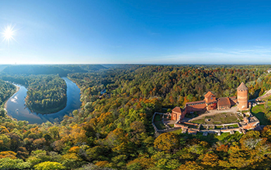
Turaida castle seen from the air, or the opposite bank of the river Gauja in Sigulda, Turaida castle rises above the trees like mighty ship built of red brick. The forepart of this imaginative ship is formed by the northern forecastle's gate tower. Building of the castle was started in 1214, upon directions given by Albert, Archibishop of Riga to his Livonian Brothers of the Sword (soon to merge with the Teutonic Order) at the place where previously had stood the wooden castle of Livs. The castle was constructed largely in the classic red-brick construction of the Baltic crusading orders. At the beginning of the 15th century, when fire arms were invented, the semi rounded western tower was built. After a fire in 1776 it was abandoned and gradually became ruinous. By the beginning of the 20th century, only separate fragments of the defensive wall and some buildings – the main tower, semi-rounded tower and the western section, were left. From the viewing place of the main tower, you can see the unique landscape of picturesque Gauja Gauja valley and the territory of Turaida Museum Reserve.
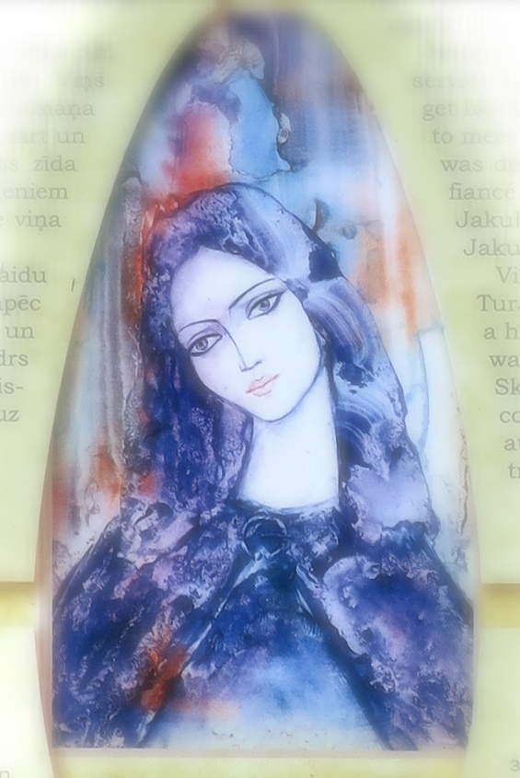
The Legend about Maija – the Rose of Turaida
In 1601 Swedish troops captured Turaida castle. After the battle a clerk of the castle Mr Greif found among the dead a small girl. He undertook to bring up the orphan and named her Maija.
The years passed by and Maija grew up so beautiful, that people named her the Rose of Turaida. Gardener Victor Heil, the finacé of Maija, lived in Sigulda castle. In the evenings they met each other at Gūtmanis cave.
Proposal to Maija was made also by Adam Jakubovsky, who then was in service in Turaida castle. Maija rejected him and Jakubovsky decided to get her by deceit. He wrote a note, as it were from Victor, and invited her to meet at Gūtmanis cave. When Maija arrived, she understood that she was deceived. The girl decided better to die and remain faithful to her fiancé. She had a red silk scarf around her neck and she told Jakubovsky, that it would protect from the sword cut and asked to try. Jakubovsky tried and Maija lifeless fell down at his feet.
Victor Heil found the murdered girl and he rushed in despair to Turaida for help. At the cave there was found gardener’s axe, lost in a hurry, therefore suspicion about Maija`s murder fell on Victor. He was arrested and tried. The course of events changed, when arrived Skudritz, a comrade-in-arms of Jakubovsky, who arrived in the court and told the truth. Victor was justified, but Maija was buried at the edge of Turaida graveyard, where Victor planted a linden tree on her grave.

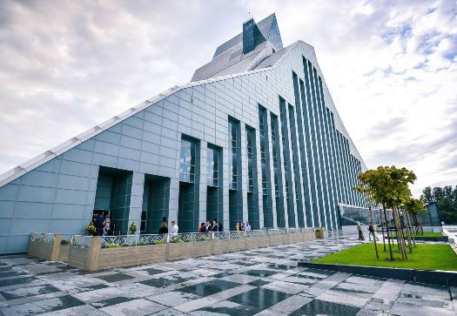
THE NATIONAL LIBRARY is not simply a building, but a repository of knowledge where a vast collection of information can be stored, protected and shared. The building that houses a library is both a structure and a symbol of the human knowledge that it contains and reveres. The new building was opened in 2014.
It was designed by the internationally renowned Latvian architect Gunnar Birkerts to be both a striking architectural symbol for Latvia and a multi-functional structure that meets the needs of a modern information based society. This state-of-the-art structure provides free and easy access to all the library's services, while offering a stimulating setting for research, study and the exchange of ideas. Under one glass roof, the multi-functional facility houses over 1000 reading places, shelf space for the library's entire active collection (over 6 million items), extensive provision for research, a modern conference centre and exhibition area. In Latvian folklore, a crystal mountain symbolizes the height of achievement – something not easily attainable but full of rewards for those who make the commitment to reach its peak. Latvian literature and folklore also speak of the 'castle of light' as a metaphor for wisdom that has been lost, but will rise again from the depths of the Daugava River after the Latvian people have overcome the intellectual darkness of war, invasion and occupation.

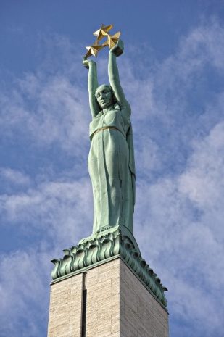
Brīvības piemineklis - the ‘Freedom Monument - is is the most important landmark, the symbol of Latvian independence and statehood.
Designed by Kārlis Zāle and funded through public donations in 1935, the monument survived a fifty year occupation to emerge as a rallying point for mass pro-independence demonstrations in the late 1980’s.
The inscription „Tēvzemei un brīvībai” means ‘For Fatherland and Freedom”. The sculptural reliefs at its base depict important moments in Latvia’s history, while the woman at the top symbolizes Latvia’s freedom and sovereignty. She holds aloft three stars indicative of the three historical districts of Latvia.
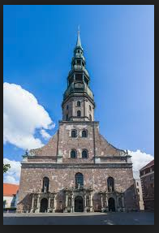
Riga's St.Peter's Church dominates the cityscape as the tallest spire, and as one of the oldest and most valuable monumental architecture edifices in the Baltic States from the Middle Ages. St.Peter's is the tallest of the Riga churches, a significant landmark, and a prime example of the 13th century Gothic style. The church is located in the historic center of Riga, an area that in 1997 UNESCO included on its World Cultural Heritage list. Concerts, exhibitions, a spectacular view from the bellfry platform of Old Town, the river, port and beyond.
St.Peter's was built in1209, and still standing from the 13th century are the side outer walls and several pillars inside. One might say that the church has become a special culture/arts center that provides insight into the mastery of yesteryear - craft and artistry, a catalyst for examination of the development of art and architecture, prompts taking a look at the buildings of today - and (probably) tomorrow - in comparison. The interior's basilicas (3) serve as a good history lesson, and one can behold with wonder various original elements like the tombs, the restored stone and wood epitaphs, and the huge seven-branch bronze candelabra (c.1596).
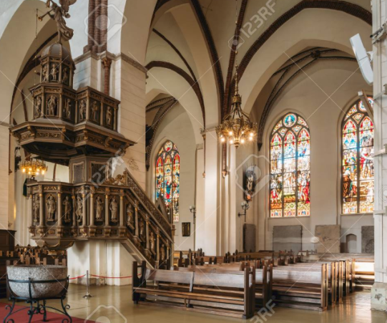
Riga Dome Cathedral Throughout the centuries Riga Cathedral has been the place to meet God. Nowadays, it is the seat of Riga and Latvia Archbishop and Riga Cathedral community church. This house of God is open to everyone who seeks oneself, fellowship, the truth and God.
The foundation stone of Riga Dome Cathedral was laid on July 25, 1211. The last large-scale restoration took place in the late 19th century when the cathedral acquired its present appearance. Today, Riga Dome Cathedral holds services and provide for rich cultural life — various concerts of popular artists take place here.
Riga Dome Cathedral has been one of the major venues for concerts in Riga for hundreds of years. Also today, official services and concerts feature various musical performances.
Riga Dome Cathedral was the central cathedral in the Baltics until Livonia fell to the Grand Duchy of Lithuania in 1561. It has Romanesque, early Gothic, Baroque, and Art Nouveau features and is considered the largest Medieval church in Latvia and the Baltic States.

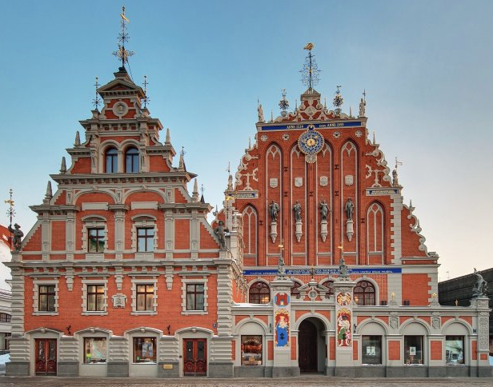
The Black Heads house is located in the very heart of Old Riga. Wonderful, surprising, royal – the house deserves to be complimented. For nearly 700 years the House of the Blackheads has delighted and enchanted locals and visitors. It is among the most splendor buildings in Riga, home to the unique history of the legendary Brotherhood of the Black Heads and the city of Riga. Historically, the building’s function was to promote business activities in the city – it was a place for gathering of traders and shippers for many centuries. The soul of the Black Heads house was its active and joyful "blackheads", who, as young and unmarried traders, were known for their temperament and enthusiasm for the organization of various celebrations and events. Their enthusiasm transformed this building into one of the main cultural venues in the city, which set the pulse of Riga’s societal scene.

