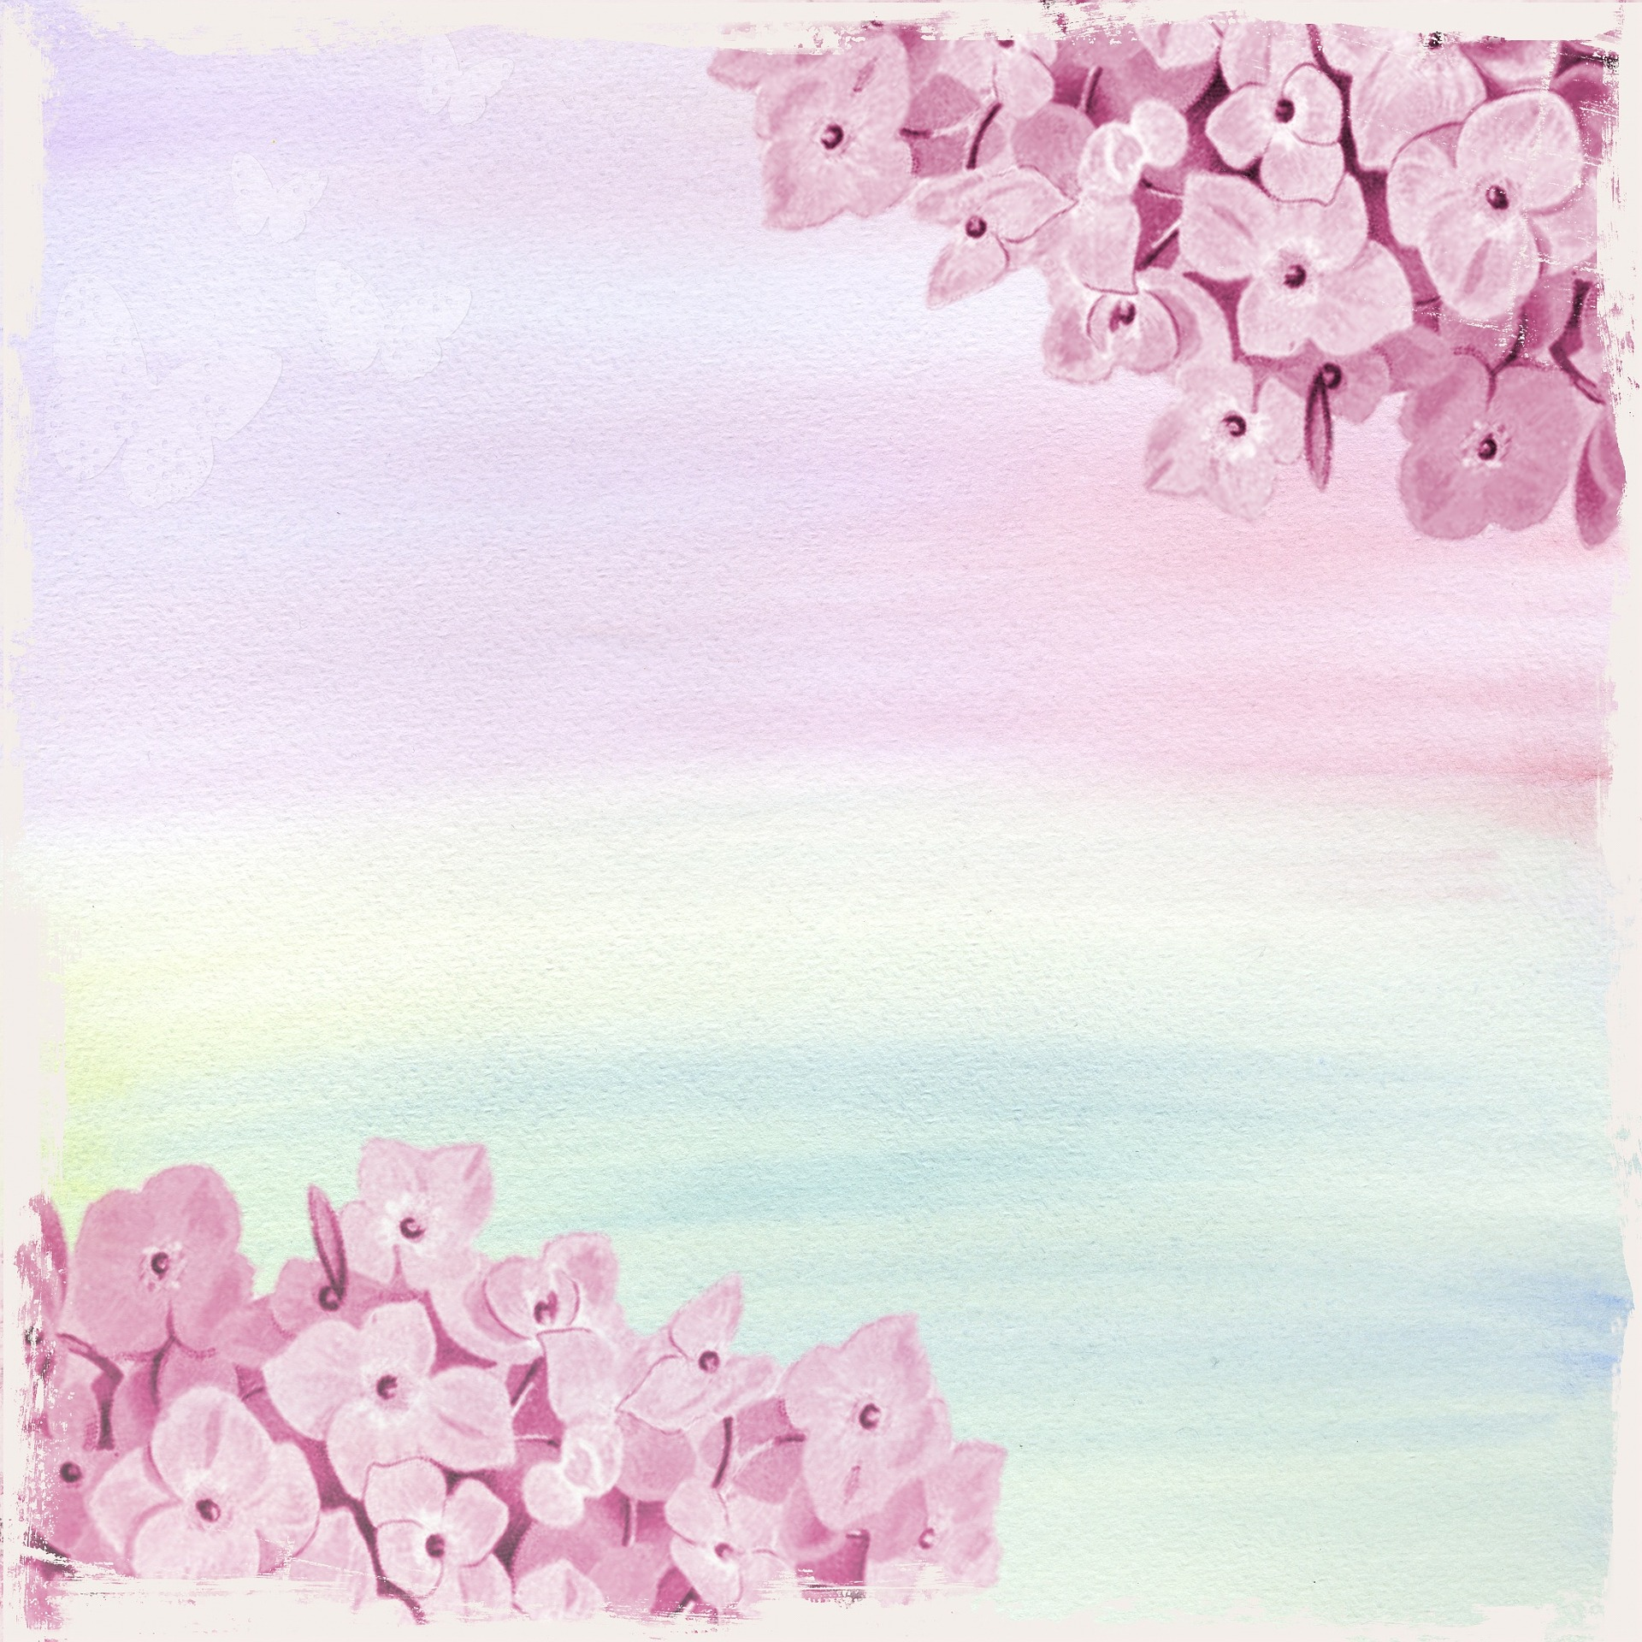
Vision of the Future
My name is Nel. I am 14 years old.
I like going to school but not only to learn.
I like meeting with my friends more
I also like art and music. I like drawing and painting.
I can also sing and dance a little.
I don’t know who I want to be in the future but I think it should be connected with my interest. Maybe I will be an artist?

What can happen in the world in the future?
It is difficult to say. I can guess. I hope that nothing bad will happen. I think that we still can change the world for better. We can look at the history, what happened in the past and not make the same mistakes. People should care more about history and tradition. They shouldn’t forget about that. They should also think about nature and Earth. People can’t forget this is our home where we and next generations will live.

Nel

