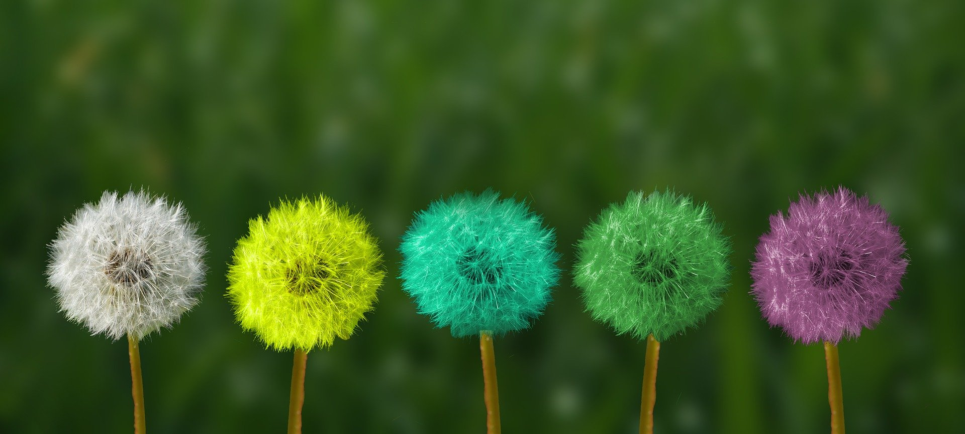
Vision of the future
My name is Natalia. I’m 15 years old. This year I’m finishing primary school and I have a difficult choice to make. I have to choose secondary school and decide about my future. I don’t know which school I will choose. I hope it will be good for me. This is my future.
I can imagine the future world around us. I think there will be lots of new technology, for example robots living in the houses with us. I think people will live longer and safer because scientists will find new medicines. I hope that people won’t destroy the environment and we will have beautiful nature in the future. Natalia

