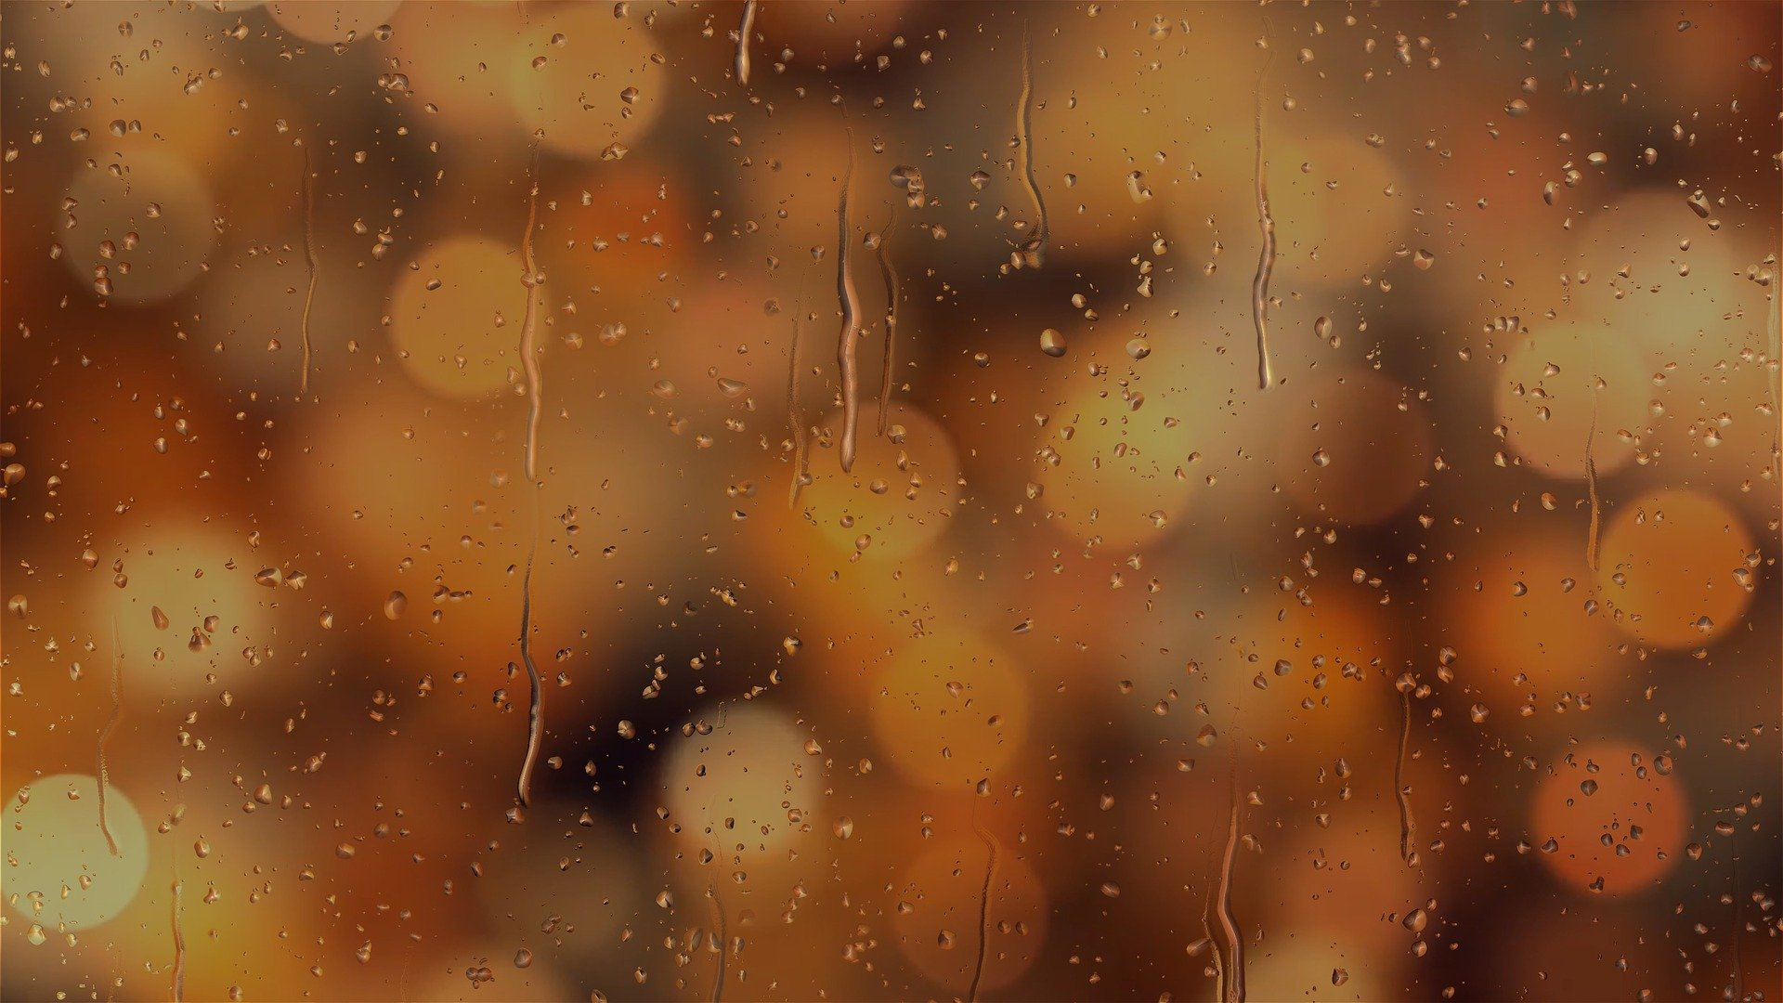
Vision of the future
It is difficult to talk and write about the future because we don’t know how it will look like. What will happen to us and our families tomorrow or in 20 years. We can also think about the world. What will change? How different will it be in a few years? This is one thing we can be sure about the future of our world. It will be different. It is even changing in the second when I’m writing this short essay. Firstly, I think that people will use technology more and more. Technology is present in our life now but I think there will be more of it every next year. It is sad but I think that people will be addicted to using technology, such as smartphones. I think it will be getting worse. Secondly, technology can have some good points. Maybe scientists will discover new medicines for the worst diseases and help save life of millions of people? Thirdly, I hope that we won’t forget about our past and traditions. They are very important for us if we want to build the future.
Kinga

