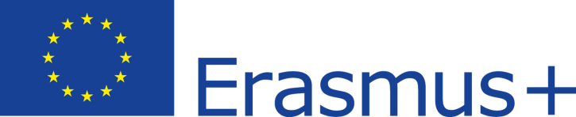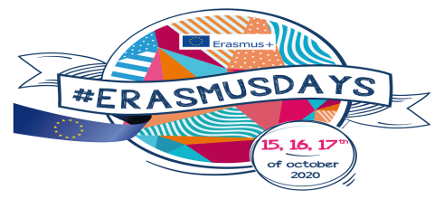
Erasmus+ project 2018-1-PL01-KA229-051241_1 ‘Learning from the past to face the future’

Mykanow Primary School
Virtual Mobility Agenda
12-16th October, Mykanów, Poland

Dear Friends
In new reality we are unable to meet in person. Even via video chats is not easy as some students or classes are being delegated to temporarily study at home. We understand the situation is hard for each of our schools - for students parents and teachers.
Polish students and teachers appreciate the time you would like to devote to experience some of our school life here in Poland, in our humble school in Mykanow.
We would like you to enjoy what we have all prepared. With wishes of success fulfillment and health, we strongly hope for us to meet one day.

Monday 12th Oct - Welcome to our school in Mykanow
Please watch our short videos presenting the school and the area nearby. The photos were taken on different occassions in our school (also before the covid health restrictions). Some of the material used was recently recorded by our pupils of class 6 - who are activelly taking part in the project actions at school.
Virtual Mobility – welcome to our school https://gopro.com/v/WyXVZXNbwkg8n
out and about Mykanow - https://gopro.com/v/4y0wO6baDy0Rn

Tuesday 13th Oct – Some info about Poland
The presentations were prepared by Malwina’s class who did the lions share of the project last year. At present time they are highschool students not in our school anymore. Therefore we can at least show you what they consider as a great place to be here in Poland. With their power points they have presented places where we would like to take you for a trip. If only you could be here with us.
Folder about us
Czestochowa and its area
Cracow
Lodz (Łódź)
Warsaw
Wednesday 14th Oct – history day
Let’s focus today on our history. Check our history timelines to see the important moments for our motherlands. Did our nations experience anything incredible and great or terryfying or sad at a similar time. Do we share some crucial historical events?
https://www.timetoast.com/timelines/2306218

Thursday 15th Oct – Swedish input
Due to unfortunate coincidence Swedish school - Atlas Skolan Linkoping could not participate in the project. But according to the major Erasmus rule of friendship and sharing, we want to learn about their country as well.
Check our Polish-Swedish history and others prepared on various topics concerning geography, cuisine, traditions, religion, etc.
Friday 16th Oct – time to say goodbye
Erasmus+ is a great way of making new friends, broadening horizons, understanding cultures, similarities and differences.
To all who have participated in mobilities it is an unforgettable memory of people, sights, landscapes and flavours. With a feeling of gratitude for what life brought to our pupils during the visits we would like to express our huge thank you.
Let’s farewell videos and watch our pupils’ presentations: Natalia and Victor (visiting Latvia)
https://gopro.com/v/gvzy7LrLLn97a Natalia

