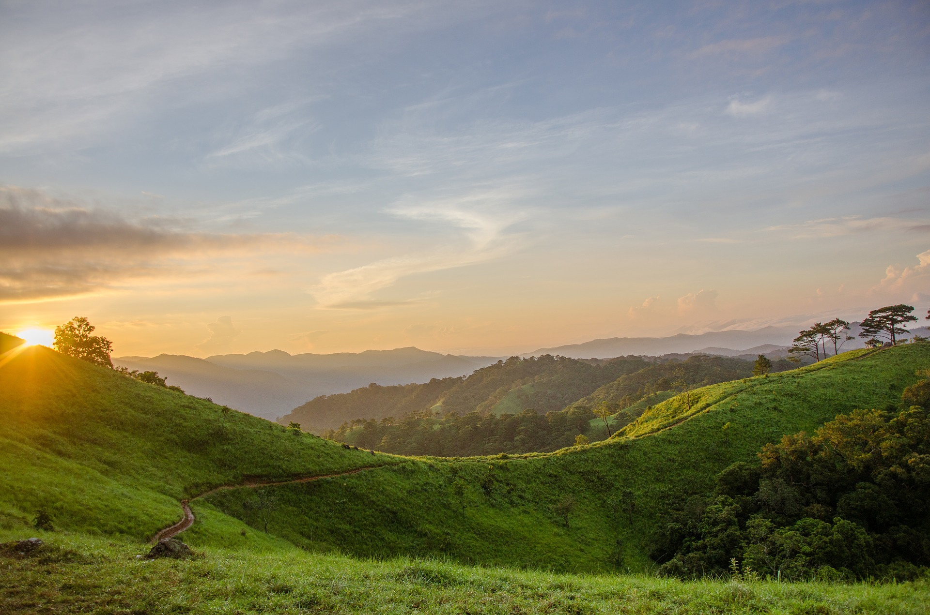
Vision of the Future
Hi! My name is Szymon and I am 13 years old. I live with my mum and older brother. We have many animals at home and in the garden and I love them. I also like learning English and reading comics. I don’t like doing and watching sports. As you can see from this picture I like nature and beautiful views.
I want to tell you about the future of our environment. I hope that it will be better than it is now. I think that more people will start to take care about the nature, animals and plants. People will stop to destroy the environment. They will be more aware that the good future of nature is also a good future for us.
I hope that in the future we will still have beautiful places like this.
Szymon

