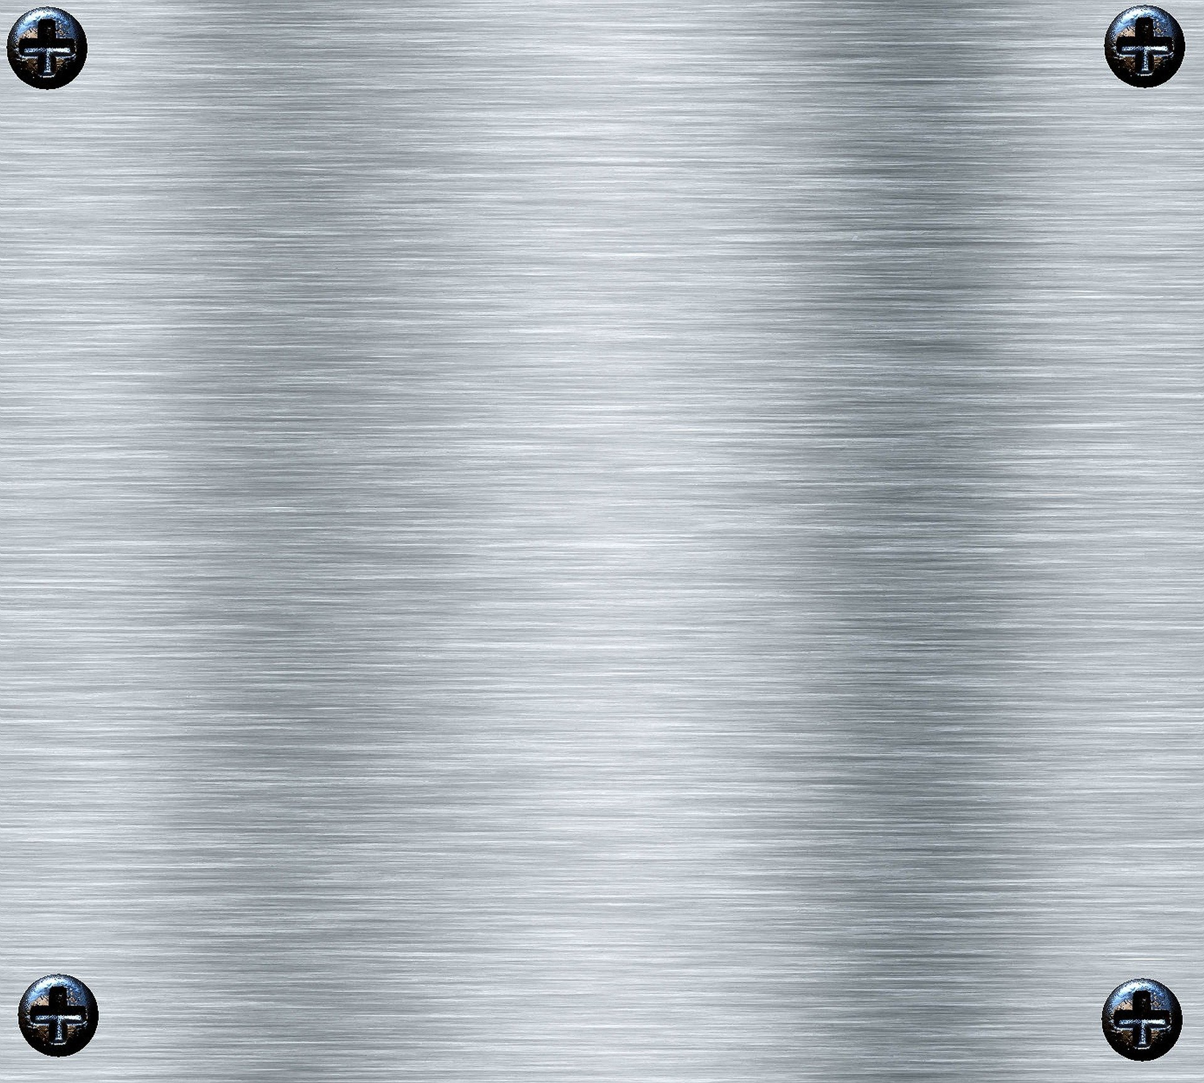
Future…
Hello! My name is Paweł. I’m 14 years old. I live in a small village near Częstochowa. I have one sister, Martyna. We love music, travelling, meeting new people and learning new things. Me and my sister took part in Erasmus+ exchanges. She was in Greece and I was in Latvia. It was cool! We loved it! We and our parents were very sad that we can’t host students from abroad this year.
What about the future?
For me I would like to connect my future with music. I can play a few instruments for example the piano, the saxophone and the guitar. I in an amatour music band but in the future I would like to be a professional musician. I want to go to the music school but my parents don’t like this idea.
For the world I would like the best future. I want the pandemic to stop and world to be normal and happy again. I think that in the future people should be happier and wiser.
Paweł

