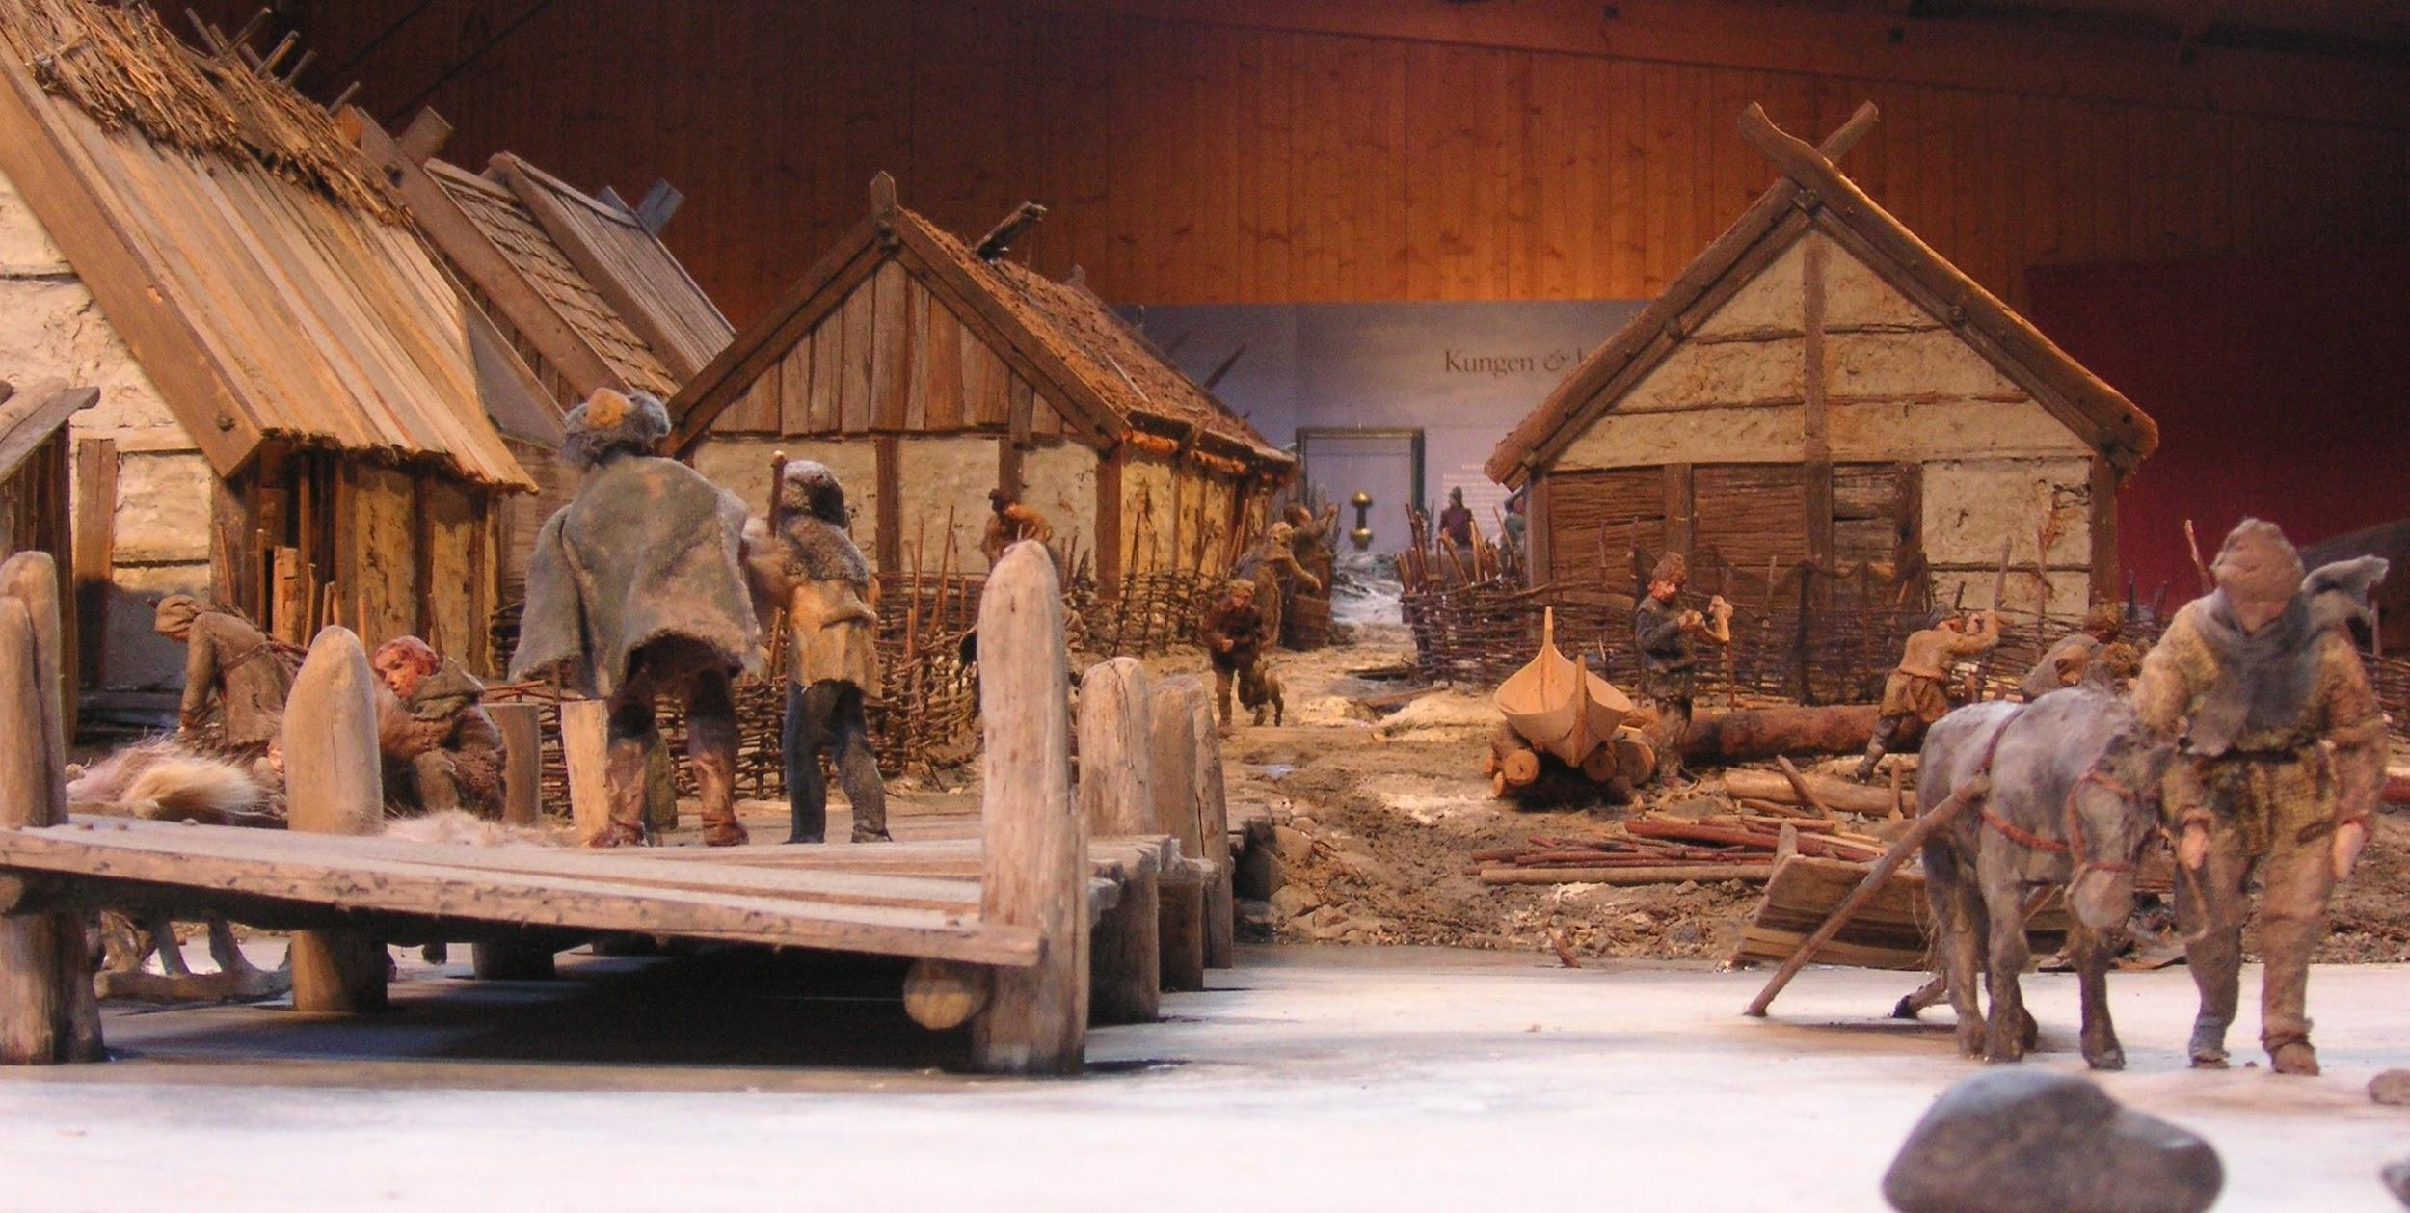
Birka
When we study history about the vikings we read and watch films about the city Birka which is also called “Sweden’s first town”. Birka was on an island in the Stockholm archipelago (this was before Stockholm existed).
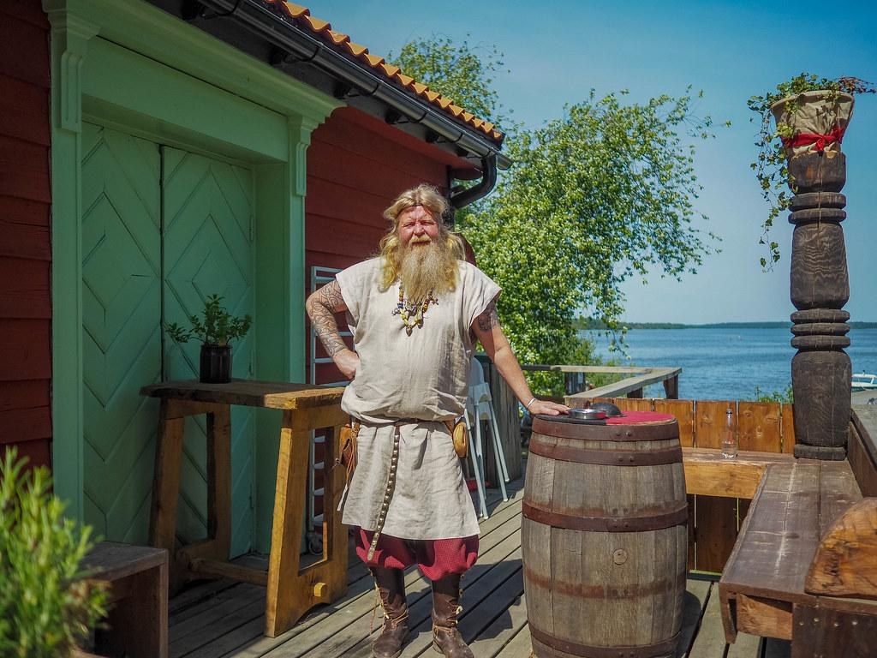
In the middle of the 700s the town and trading place Birka was founded. It was the king of that area (Svealand) who wanted to control trade in the north of Scandinavia.

For 200 years Birka was a great town and an important place for trade in the northern Europe. At that time Birka had 700-1000 inhabitants, which was a lot at that time.

Archaeologists have found things like arabic silver, eastern European pearls, glass, ceramics and fine fabrics from a lot of places in the world. It was traded for iron, hides, horns, furs and other things from the north.
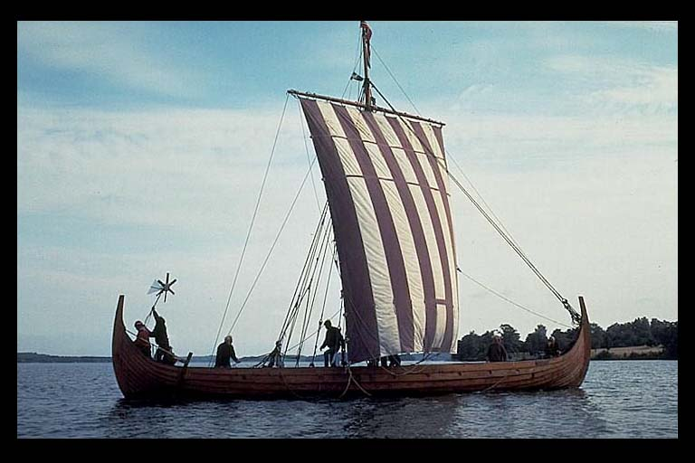
Then people started to leave Birka and move somewhere else, nobody really knows why but maybe it was a political decision or it was because the land rose and it was now more difficult to reach the town.
Today there is a museum and a viking village on the island where you can see how the vikings lived and worked.

