**Pablo Picasso**

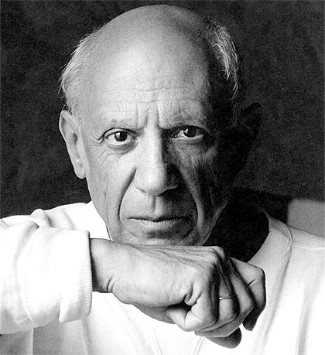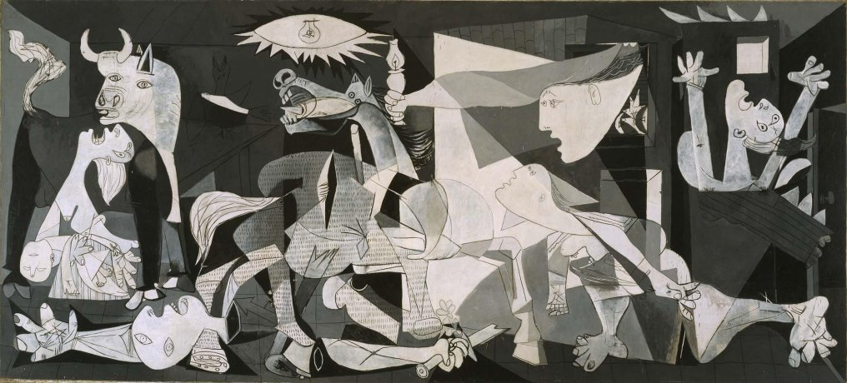

Pablo Picasso was an artist and painter born in Spain, who revolutionized not only painting, drawing, sculpture and ceramics, but the way in which the public would appreciate art.

Picasso was born in the city of Malaga in 1881. In his first children's drawings done in pencil, Picasso shows his wonderful childlike capacity of observation and a spontaneous and safe stroke, unusual for a child of his age.

Picasso is considered the most important artist of the 20th century and one of the most influential in the development of modern art. There are more than 1500 works of his in museums around the world.

He had several periods that marked his artistic career, among them are:

Blue Period: He made works in which he used blue tones, almost all of them. They denote much sadness.

Pink period: Picasso enters a more cheerful period and paints scenes of clowns and circuses, with a brighter coloring.

Cubist Period: He looked for a pure painting and began to observe the objects of his workshop, in an intellectual way, and painted them looking for the basic geometric figures.

Surreal Period: In this era, he uses the distorted forms, representing the monstrous and mythological; his sculptures were made of thread and sheet metal.

Expressionist Period: during the period of the civil war in Spain, Picasso painted one of his most famous paintings, Guernica, in which he shows his repudiation of the war and the terror inflicted on the civilian population during the aerial bombardment from Germany against the population of Guernica.