The King Mindaugas
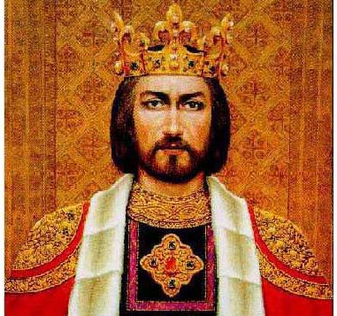
Let me tell you about the King Mindaugas.

The King Mindaugas was the first known Grand Duke of Lithuania and the only King of Lithuania

Little is known about the King Mindaugas. He was born around 1203.

His power in the Slavic and Baltic regions was built during the 1230s and 1240s.

In 1250 or 1251 he was baptized as a Roman Catholic. This enabled him to establish an alliance with the Livonian Order, a long-standing enemy of the Lithuanians.

He ruled between 300,000 and 400,000 heroes.

Mindaugas and his wife Morta were crowned during the summer of 1253.
The 6th of July is now celebrated as Sovereign State Day ( Valstybės diena).

Now he is considered the founder of the Lithuanian state.

