Vasil Levski

Vasil Ivanov Kunchev was born on July 18th, 1837 in Karlovo, Bulgaria, in the family of Gina Vasileva Karaivanova (his mother) and Ivan Kunchev Ivanov (his father) and their five children.
He was the most famous and important Bulgarian revolutionary, and is a Bulgarian national hero until today. He is the founder of the Internal Bulgarian Revolutionary Organisation, and he orchestrated a nationwide uprising through secret committees.

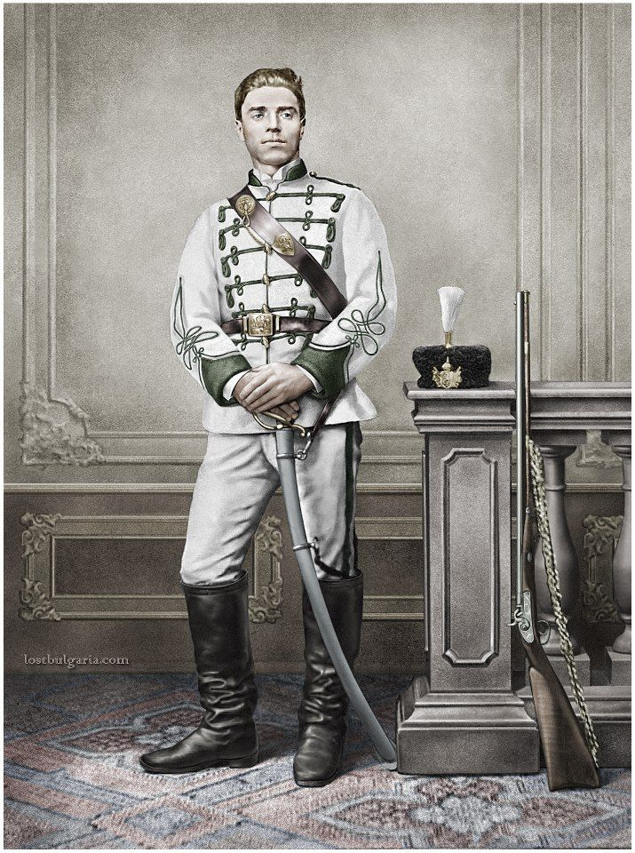
Unfortunately, he was caught on December 26th, 1872 by Kakrinsko Hanche near Lovech, Bulgaria. The Ottoman court sentenced him to death by hanging.
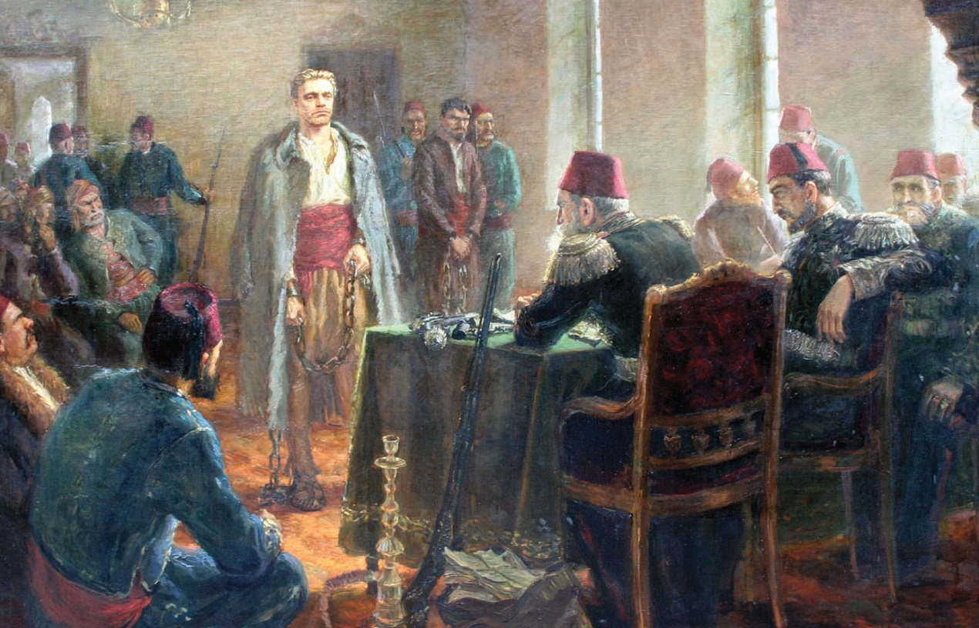

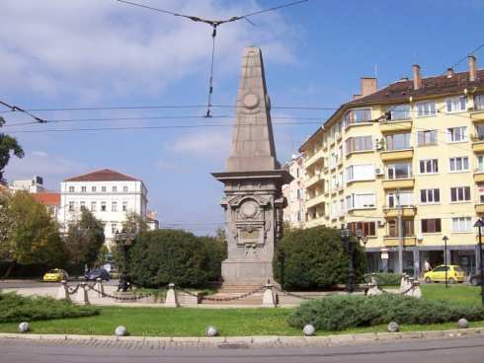
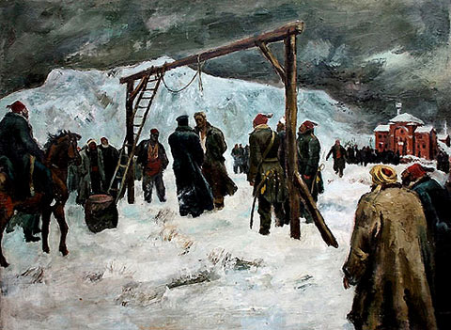
On the 18th February 1873 (6th February by old style) he was publicly hanged and exectuted in Sofia, the capital of Bulgaria. Today, in Sofia there is a big monument of Vasil Levski exactly on the place where the he was publicly executed.

Written by Sophia Sokolova, VIth grade, 122nd Primary school,Sofia,Bulgaria.

