Hristo Botev
We have chosen Hristo Botev. He was born with the name Hristo Botyov Petkov and was a very famous revolutionary poet. He played a key role in Bulgarian history and was considered a national hero.
He was born in Kalofer, Bulgaria. His father was a teacher and he influenced Botev during his youth a lot. He was deeply impressed by Russian poetry and because of this, his political views soon started to take shape.
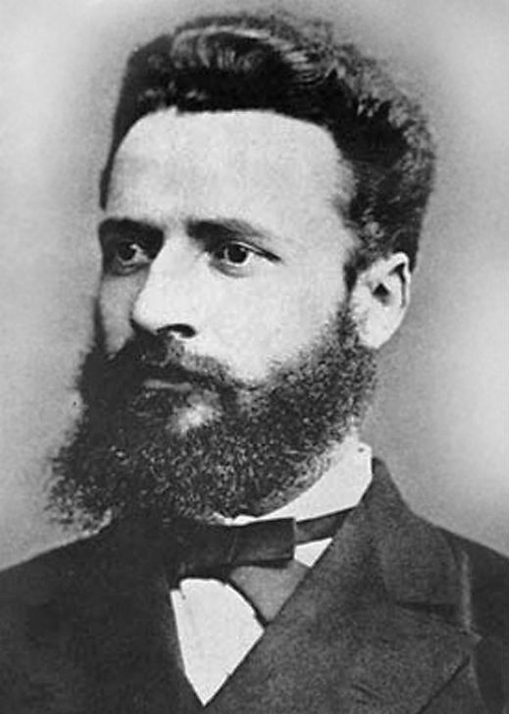

In 1875 Botev published his writings in a book called “Songs and Poems”. Here are his writings:
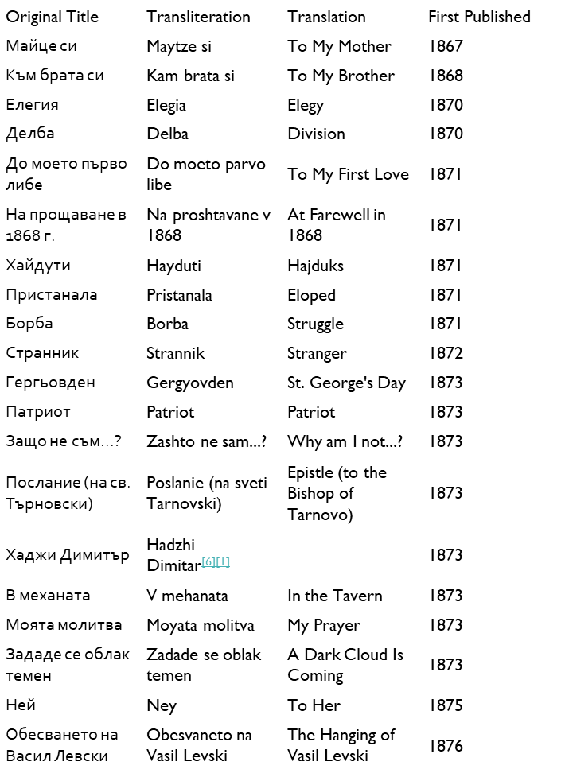

He organised a rebellious group that went by the name “The Botev Rebels” that fought for Bulgaria’s freedom and participated in many secret committees against the Ottomans. His monument is located on top of mount Okoltchitza in memory of him, his rebels and all who fell fighting.
